Instructor’s Manual to Accompany

Information Technology

Project Management

Second Edition

■  

Kathy Schwalbe, Ph.D., PMP

Augsburg College
Instructor’s Manual to accompany Information Technology Project Management, Second Edition is published by Course Technology.

Editorial Assistant Amanda Young
Manufacturing Alexander Schall
Elizabeth Martinez
Cover Designer Susannah Lean

©2001 Course Technology

All rights reserved. This publication is protected by federal copyright law. No part of this publication may be reproduced, stored in a retrieval system, or transmitted in any form or by any means, electronic, mechanical, photocopying, recording, or otherwise, or be used to make any derivative work (such as translation or adaptation), without prior permission in writing from Course Technology.

Trademarks
Course Technology and the open book logo are registered trademarks of Course Technology.

Some of the product names used in this book have been used for identification purposes only and may be trademarks or registered trademarks of their respective manufacturers and sellers.

Disclaimer
Course Technology reserves the right to revise this publication and make changes from time to time in its content without notice.

ISBN 0-619-03528-5

Printed in the United States of America.
10 9 8 7 6 5 4 3 2 1

Technical Support for Course Technology Products

Course Technology is committed to supporting professors who adopt our products. In addition to the supplemental materials you are now holding, we provide technical support by phone, by mail, and by fax.
Our telephone support staff are available to answer your questions about our products and their use in the classroom. While we do not provide direct support to student users of our products, we are happy to provide help to professors and to the staffs of campus microcomputer labs. Please encourage students to direct their questions to you or to the lab staff.
If you have a technical problem, we recommend the following:
• First, check the textbook that accompanies the software.
• Many software products include on-line help. If the answer is not available in the printed materials, try using the Help feature of your software.
• Feel free to call Course Technology's technical support lines during business hours (9 AM to 5 PM Eastern Time), Monday through Friday. Be prepared to describe which product you're working with, the hardware you're using, and the problem you're having.
We also encourage you to call or write us and report on how you've been using our products in the classroom. We'd also be glad to share techniques that other instructors have used.

Note: For Course Technology products that include software, support is available only from Course Technology. Your software license does not entitle you to support from the original developer of the software. We will do everything we can to answer your questions, including, when necessary, contacting the original software developer for you.

Technical Support Addresses and Phone Numbers
Main support help line: (800) 648-7450
E-mail address: tech_support@course.com
Available business hours (Eastern Time) Monday through Friday.
FAX: (617) 621-3078
Mailing address: Technical Support
Course Technology
One Main St.
Cambridge, MA 02142

Table of Contents

Contents of Instructor’s Manual ………………………………………………………………………......…v

Preface……………………………………………………………………………………………………….vi

Sample Class Survey……………………………………………………………………………………..…viii

Sample Syllabus 1……………………………………………………………………………………………ix

Sample Syllabus 2…………………………………………………………../.…………………………..….xiv

Chapter 1 Introduction to Project Management 1

Chapter 2 The Project Management Context and Processes 7

Chapter 3 Project Integration Management 15

Chapter 4 Project Scope Management 23

Chapter 5 Project Time Management 33

Chapter 6 Project Cost Management 46

Chapter 7 Project Quality Management 53

Chapter 8 Project Human Resource Management 64

Chapter 9Project Communications Management 73

Chapter 10 Project Risk Management 80

Chapter 11 Project Procurement Management 89

Chapter 12 Initiating 96

Chapter 13 Planning 102

Chapter 14 Executing 107

Chapter 15 Controlling…………………………………………………………………………….….……113

Chapter 16 Closing……………………………………………………………………………………..…..119

Appendix A Guide to Using Microsoft Project 2000…………………………………………………...….124

Appendix B Advice for the PMP Exam and Related Certifications.……………………………………….129
.

Contents of the Instructor’s Manual

This Instructor’s Manual is designed to provide a starting point for your teaching effort. For each chapter in the Information Technology Project Management textbook, this manual provides the following:

Learning Objectives: These brief statements from the textbook describe the key goals for the material in a particular chapter. This list will help the instructor prioritize topics and organize lecture formats.

Chapter Outline: The chapter is presented in outline form to provide a way to quickly determine the contents of each section.

Lecture Notes: Suggestions for teaching each chapter and additional items of interest are provided as lecture notes. PowerPoint slides are provided separately in the Course Presenter.

Quick Quiz: These questions can be posed to the class to determine if they are understanding and mastering the material. If the class cannot answer the quick quiz questions, the concepts need more explanation. These quizzes are meant to be an informal oral quiz to ensure that students are grasping the material.

Discussion Topics: This section provides topics appropriate for classroom discussion.

Extra Cases or Case Problems: These extra cases or case problems reinforce the concepts and ideas presented in the main textbook and can be used as quizzes, exams, assignments, or to stimulate classroom discussion.

Teaching Tips: Several activities are suggested to help engage the students.

Further Readings or Resources: Additional readings or resources are provided.

Team/Group Activities: A number of ideas are presented that enable the instructor to use group interaction to enhance the learning environment. Several suggestions are provided for having students work in small groups during and outside of class.

Solutions: At the end of each chapter of the textbook are a number of discussion questions, exercises, and minicases. This manual provides answers and extensions to this material.

Preface

Suggestions on Teaching a Project Management Course

Running a course in project management as a project itself is a great way for students to understand, apply, and reflect on the material. This technique adds variety to each class by using the students as resources. Several teaching strategies to promote this approach include surveying students in class, using student presentations, group projects, a class Web site, and other forms of technology to enhance teaching and learning, and encouraging outside reading.

Class Survey
Have students introduce themselves and fill out a survey with contact information and their expectations for the course, their strengths, and their weaknesses. You can refer to the sample survey on pg. vii. Knowing basic information about each student enables you to take advantage of the contributions each student can make to the class.

Student Presentations and Group Projects
Students should give presentations and work on group projects during the course. Group presentations and projects help them understand and apply the concepts they are learning. Two sample syllabi are provided to help you plan your course to include these student presentations and projects. Syllabus 1 shows one approach taken to teaching a one-semester project management course to college juniors and seniors. Syllabus 2 shows another more traditional approach you could take to teaching the course. Try experimenting with different ways to teach the material, and use students as a resource to help develop and test new ideas.

If possible, try to find real-world projects for students to work on in groups as part of class. It is a good idea to have a few project ideas before the course starts. Many projects can provide services for the instructor, his or her department, the college, or local community groups or companies. Many organizations need Web pages, databases, systems analysis, and computer training. Students can also do group projects based on the discussion questions, exercises, and minicases in the textbook and create Web pages with their answers.

Using Other Technology to Enhance Teaching and Learning
Since the textbook focuses on information technology projects, it is very effective to apply information technology to teach the course. The Web is a great tool for organizing information. You can keep copies of lecture notes, the course syllabus, student presentations, and links to course-related web sites on a class Web site. Students appreciate receiving hardcopies of PowerPoint lecture slides to use for notes during class. You can also require students to use the computer when giving their presentations, providing group project status information, and to communicate outside of class time with you and each other.

Most students want to enhance their knowledge of software, and they enjoy learning Microsoft Project 2000. Students get a 120-day copy of this software with the textbook, and you should expect them to go through most of Appendix A on their own. You could require students to use Project 2000 for each group project and give them a take-home exercise using this software or make a Project assignment part of their final exam. Try to spend some time in class providing hands-on instruction in Project 2000 to get the students started in using this powerful software.

Encouraging Outside Reading
Encourage students to read books and articles related to the course. For example, you could require students to read Stephen Covey's The 7 Habits of Highly Effective People as part of their reading requirement. This best-selling book provides a good basis for discussing human resources management and communications. Students could give short presentations on each habit and relate how it applies to project management. Several other books that you can use in a similar fashionare mentioned in the list of suggested readings at the end of each chapter and in this Instructor Manual. For example, other texts related to the people side of project management include Frederick Brook's "The Mythical Man-Month," Vijay Verma's "Organizing Projects for Success," and David Keirsey's "Please Understand Me II." You could also assign more technical books such as Eliyahu Goldratt’s “Critical Chain,” or have students find several references on a specific topic for a presentation or paper.

Contact the Author
Feel free to share your suggestions at any time by e-mailing me at schwalbe@augsburg.edu. My personal web pages are available at www.augsburg.edu/ppages/~schwalbe. My home page includes a link to information related to project management, including my personal lecture notes, links to articles about project management, sample student projects, and so on.

Class Survey

Name: _________________________ E-mail address: ______________________
Major: _________________________ Minor: _____________________________
Daytime Phone: _________________ Employer: __________________________
Brief job description:

- In this class, all students are resources. What are some of your abilities/strengths as they might relate to this class?

- What are some of your weaknesses or areas you would like to improve?

- You are expected to give three oral presentations throughout the course of this semester.

a. Briefly describe your speaking/presentation experience.

b. What do you want to improve in this area?

4. What are you most interested in learning from this class?

5. Several group projects in the past have involved creating Web pages. Do you know how to create Web
pages? Please describe.

- Do you have any ideas for class projects or presentations? List them below. Also list if you are interested in any of the projects mentioned in the syllabus.

7. Do you have any special learning needs I should know about? Please describe.

ACADEMIC HONESTY:
I have read and understand the policies of ___________ regarding academic honesty. I understand how they apply to this course, and I pledge myself to abide by the policies and work to create an atmosphere of academic integrity on the campus.

Signature: _____________________________ Date: ____________________

Sample Syllabus 1

This syllabus is based on a semester-long course and assumes students will give presentations and do group projects. This syllabus also includes time to read an additional book such as Stephen Covey's The 7 Habits of Highly Effective People. Note: You can find copies of syllabi I use in my classes on my personal web pages.

INSTRUCTOR:

OFFICE HOURS:

PHONE: E-MAIL:

WEB SITE:

TEXTS: Required: Kathy Schwalbe, Information Technology Project Management, Second Edition, Course Technology, 2001.
Other texts and articles, such as Stephen Covey’s The 7 Habits of Highly Effective People, and the Project Management Institute’s, A Guide to the Project Management Body of Knowledge, available from PMI’s Web site at www.pmi.org. PMI members receive a copy on CD/ROM. Links to many articles are available from my web site. Students will use these other texts and articles as part of their individual presentations.

OBJECTIVES: The student who successfully completes this course must:

- Understand the genesis of project management and its importance to improving the success of information technology projects
- Demonstrate knowledge of project management terms and techniques such as
- The triple constraint of project management
- The project management knowledge areas and process groups
- The project life cycle
- Tools and techniques of project management such as
- Project selection methods
- Work breakdown structures
- Network diagrams, critical path analysis, and critical chain scheduling
- Cost estimates
- Earned value management
- Motivation theory and team building
- Apply project management concepts by working on a semester-long group project as team leader or active team member
- Use Microsoft Project 2000 and other software to help plan and manage a small project
- Appreciate the importance of good project management
- Share his/her own examples of good and bad project management
- Prepare a journal throughout the course for personal reflection
- Use knowledge and skills developed in this class in other settings
- Study Covey's The 7 Habits of Highly Effective People or related texts/articles and relate them to project management
- Demonstrate competence in giving oral presentations.

APPROACH: Active participation, student presentations of project management concepts, and projects will be used to aid in understanding and application of project management.

EVALUATION: 1. Individual Presentation 15%
2. Team Project and Presentation 25%
3. Midterm Exam 25%
4. Final Exam 25%
5. Lessons Learned and Self Assessment 10%

Final grades will be based on overall percentages with 93% required for a 4.0, 88% for a 3.5, etc.

POLICIES:
Assignments:
The main homework for this class will be reading, studying for exams, preparing presentations, and working on group projects. The class will actively participate in deciding what presentations and projects each student will do. Each student should decide on presentations/projects by the second week of class. An updated schedule will be distributed at that time.

Participation:
Students are expected to actively participate in class by asking questions and sharing personal experiences. Any student missing more than 6 hours of class without an approved excuse will receive a grade reduction.

Makeup Tests and Assignments:
Requests for makeup tests and assignment changes must be made in advance with the instructor. Either leave a phone message or send an e-mail message in case of a last minute emergency.

Honesty:
Plagiarism and cheating are serious offenses and may be punished by failure on an exam or assignment, failure in the course, and/or expulsion from the college. For more information, refer to the “Academic Honesty” policy in the student catalog.

Presentations:
Each student will prepare and present three presentations. Each student is responsible for:

- A 15-minute individual presentation, using at least three outside references. A hard copy of presentation slides or notes should be submitted prior to the presentation. Students should focus their individual presentations on a part of one of the textbook chapters or on a group project status report. Students are encouraged to use a minicase as a topic for a presentation, also. See the sample dates and topics for presentations in the class schedule. Students must sign up for a topic and date by the 4th week of class.

- A presentation as part of the final group project. Each group will present a 30-minute final presentation on their group project.

- A short presentation as part of class discussion. This presentation will not be formally graded.

Presentations will be evaluated based on content, delivery, and audience response.

Group Projects:
The purpose of the group project is to use a structured approach to project management in a team setting. As a class, we will select projects, groups, and group project managers. Each group (3-4 people per group) will prepare a project charter (in the form of a letter of agreement), a WBS, a Gantt chart in Project 2000, project status reports, lessons learned reports, and a final group project report and presentation. Sample templates for these documents can be found in Kathy Schwalbe’s Information Technology Project Management, Second Edition, Chapter 9.

Each group will hand in a project notebook that includes the following:

- Cover page and detailed table of contents. List the project name, team members, date, and project web site url on the cover page of the notebook. Be sure to number all pages, which should provide a reference for the table of contents. You may include tabs or dividers between major sections of the notebook, too.
- A single-spaced 3-4-page project report. This report should include a project description, referrals to the work produced (provided as an attachment), and an explanation of the project management process used. Students should also describe what was done in project initiation, planning, executing, controlling, and closing and discuss the tools and techniques of project management that they used.
- Project management documentation. Include a final Gantt chart (created in Microsoft Project 2000) reflecting actual work done on the project, including task dependencies and resource assignments. You may use the tracking tool to compare your planned and actual progress. Project documentation should also include a project charter, communications plan, responsibility assignment matrix, status reports, and so on.
- Attachments with hard copies of all product-related materials (i.e. Web pages, databases, training materials, reports, presentations, etc.).
- A reference page including a bibliography of any materials used for the project

Students are required to put as much of their group project information as possible on the web and use a team web site to facilitate communications. Several projects for this class may involve service learning for the college or community. Students are strongly encouraged to think of projects that will benefit the local community.

50% of the grade for the group project will be based on the group’s final presentation, web site, and progress reports, and 50% will be based on the project notebook. Group project managers will earn a small amount of extra credit for successfully leading their project teams. These project managers are also expected to give their project status reports for their individual presentations.

Lessons Learned Report and Self Assessment:
Students will make private learning journal entries to help them reflect on their learning. This journal should be a dated record of each student’s learning related to project management, working in groups, and giving presentations.

The following questions should be answered in each student journal at least every two weeks:

- What key concept about project management did you learn about? Explain it in your own words and try to relate it to your group project or other experiences.
- How is your group project going? What is going well and why? What isn’t going so well and why? What have you done to help your project team?
- What have you learned about improving your own presentation style?
- Do you have suggestions for improving the class or how the material was presented?

Students should submit all journal entries on the last day of class, accompanied by a typed “lessons learned” report, summarizing some of the key comments made in their journals.

Students are also required to write a one to two-page self-assessment based on their group project, answering the following questions:

- What were your roles and responsibilities on the group project? How were they decided?
- What did you learn about project management by doing the group project?
- What did you learn about teamwork by doing the group project?
- What would you have done differently? What will you remember to do on the next project you work on after this experience?
- Briefly assess each team member’s performance. If you had to give them a grade, what would it be? If you had 100 points to allocate to your team, how would you allocate them?

CLASS SCHEDULE:

DATE | TOPIC | READING
Week 1 | Introductions  Introduction to Project Management | IT Project ManagementChapter 1
Week 1 | The Project Management Context and  Processes | IT Project Management Chapter 2
Week 2 | How to Give a Great Presentation  Using PowerPoint for Presentations  Discuss group projects, form teams  Team formation and team building
Week 2 | Project Integration Management | IT Project Management Chapter 3
Week 3 | Project Scope Management  Student presentations (Minicase 2, Minicase 3,  team building, giving presentations, etc.) | IT Project Management Chapter 4
Week 3 | Project Time Management  Student presentations (Minicase 4,  preventing scope creep, etc.) | IT Project Management Chapter 5
Week 4 | Project Time Management,  Microsoft Project 2000 | IT Project Management Appendix A
Week 4 | Group Status Reports
Week 5 | Time management and Project 2000, continued.  Student presentations (Minicase 5, PM  software, etc.)
Week 5 | Project Cost Management  Student presentations (Minicase 6,  estimating, earned value, etc.) | IT Project Management Chapter 6
Week 5 | Project Quality Management  Student presentations (Minicase 7, six sigma,) | IT Project Management Chapter 7
Week 6 | Project Human Resource Management  Student presentations (Minicase, etc.) | IT Project Management Chapter 8
Week 6 | Project Communications Management  Student presentations  Review for midterm | IT Project Management Chapter 9
Week 7 | Midterm Exam
Week 8 | Break – Read Covey text or other readings
Week 9 | Project Risk Management  Student presentations | IT Project Management Chapter 10
Week 9 | Project Procurement Management  Student presentations | IT Project Management Chapter 11
Week 10 | Covey Intro (or other readings)  Habit 1: Be proactive  Habit 2: Begin with the end in mind | 7 Habits Introduction  7 Habits Chapter 1  7 Habits Chapter 2
Week 10 | Habit 3: Put first things first  Habit 4: Seek first to understand  Habit 5: Think win/win | 7 Habits Chapter 3  7 Habits Chapter 4  7 Habits Chapter 5
Week 11 | Habit 6: Synergise  Habit 7: Sharpen the saw  Applying Habits to Project Management | 7 Habits Chapter 6  7 Habits Chapter 7  Ross article.
Week 11 | Initiating  Student presentations | IT Project Management Chapter 12
Week 12 | Planning  Student presentations | IT Project Management Chapter 13
Week 12 | Executing  Student presentations | IT Project Management Chapter 14
Week 13 | Controlling  Student presentations | IT Project Management Chapter 15
Week 13 | Closing  Student presentations | IT Project Management Chapter 16
Week 14 | Advice for the PMP Exam  Student presentations | IT Project Management Appendix B
Week 14 | Group presentations
Week 15 | Group presentations
Week 15 | Group presentations  All reports and journals due  Review for final exam
Week 16 | Final exam

Sample Syllabus 2

This syllabus could serve as a template for teaching a class in a more traditional format based on the textbook. It does not include an additional textbook, group projects, journals, or student presentations. Assessment is based on exams and assignments from the textbook.

INSTRUCTOR:

OFFICE HOURS:

PHONE:

E-MAIL:

WEB SITE:

TEXTS: Required: Kathy Schwalbe, Information Technology Project Management, Second Edition, Course Technology, 2001.

OBJECTIVES: The student who successfully completes this course must:

- Understand the genesis of project management and its importance to improving the success of information technology projects
- Demonstrate knowledge of project management terms and techniques such as
- The triple constraint of project management
- The project management knowledge areas and process groups
- The project life cycle
- Tools and techniques of project management such as
- Project selection methods
- Work breakdown structures
- Network diagrams, critical path analysis, and critical chain scheduling
- Cost estimates
- Earned value management
- Motivation theory and team building
- Use Microsoft Project 2000 and other software to help plan and manage information technology projects
- Appreciate the importance of good project management
- Share his/her own examples of good and bad project management
- Use knowledge and skills developed in this class in other settings

EVALUATION: 1. Exam 1 20%
2. Exam 2 20%
3. Exam 3 20%
4. Final Exam 20%
5. Assignments 20%

Final grades will be based on overall percentages with about 95% required for a 4.0, 90% for a 3.5, etc.

POLICIES:

Participation:
Students are expected to actively participate in class by asking questions and sharing personal experiences. Any student missing more than 6 hours of class without an approved excuse will receive a grade reduction. If a student misses a class, it is his responsibility to get lecture notes from a classmate.

Makeup Tests and Assignments:
Requests for makeup tests and assignment changes must be made in advance with the instructor. Either leave a phone message or send an e-mail message in case of a last minute emergency. Assignments are due on the date shown in the class schedule. Late submission of assignments will be assessed a penalty of 10% per day. No exceptions are made.

Honesty:
Plagiarism and cheating are serious offenses and may be punished by failure on an exam or assignment, failure in the course, and or expulsion from the college. For more information refer to the "Academic Honesty" policy in the student catalog.

CLASS SCHEDULE:

DATE | TOPIC | READING | ASSIGNMENT
Week 1 | Introductions  Introduction to Project Management | Chapter 1
Week 1 | The Project Management Context  And Processes | Chapter 2
Week 2 | Project Integration Management | Chapter 3
Week 2 | Project Integration Management | Chapter 3 | Minicase 3, Part 1
Week 3 | Project Scope Management | Chapter 4
Week 3 | Project Scope Management | Chapter 4 | Minicase 4, All
Week 4 | Exam 1 | Review Ch. 1-4
Week 4 | Project Time Management | Chapter 5
Week 5 | Project Time Management | Chapter 5
Week 5 | Project Time Management | Chapter 5
Week 6 | Microsoft Project 2000 | App A | Minicase 5, All
Week 6 | Microsoft Project 2000 | App A
Week 7 | Project Cost Management | Chapter 6
Week 7 | Project Cost Management | Chapter 6 | Minicase 6, Part 1
Week 8 | Project Quality Management | Chapter 7
Week 8 | Project Quality Management. | Chapter 7 | Minicase 7, Part 1
Week 9 | Exam 2 | Chapters 5-7 Appendix A
Week 9 | Project Human Resources Management | Chapter 8
Week 10 | Project Human Resources Management | Chapter 8 | Minicase 8, All
Week 10 | Project Communications Management | Chapter 9
Week 11 | Project Communications Management | Chapter 9 | Minicase 9, Part 2
Week 11 | Project Risk Management. | Chapter 10
Week 12 | Project Procurement Management | Chapter 11 | Minicase 10, Part 1
Week 12 | Exam 3 | Chapters 8-11
Week 13 | Initiating | Chapter 12
Week 13 | Planning. | Chapter 13 | Minicase 12, Part 1
Week 14 | Executing. | Chapter 14
Week 14 | Controlling. | Chapter 15
Week 15 | Closing | Chapter 16 | Minicase 15, Part 2
Week 15 | Advice for the PMP Exam | App B
Week 16 | Final Exam | Chapters 12-16  All Chapters

CHAPTER 1
Introduction to Project Management

Learning Objectives

After reading this chapter you will be able to:

- Explain what a project is and provide examples of information technology projects

- Describe what project management is and discuss key elements of the project management framework

- Describe how project management relates to other disciplines

- Understand the history of project management

- Explain the growing need for better project management, especially for information technology projects

- Describe the project management profession, including recent trends in project management certification and software products

Chapter Outline

Introduction

What is a Project?

What is Project Management?

How Project Management Relates to Other Disciplines

History of Project Management

The Project Management Profession
Project Management Careers
Project Management Certification
Code of Ethics
Project Management Software

Lecture Notes

Introduction

To provide motivation for students to study information technology project management, mention the highlights of the Standish Group's CHAOS study on pg. 3.

- Only 16% of information technology projects were successful, according to their 1995 study.
- Over 31% of information technology projects were cancelled, costing the U.S. over $81 billion.

Good project management is very important to making effective use of information technology and people.

What is a Project?

Many people do not understand the basic characteristics of projects. Stress the definition of a project – a temporary endeavor undertaken to accomplish a unique purpose. The attributes of a project should be noted, as well. A project:

- has a unique purpose
- is temporary
- requires resources (often from various areas)
- should have a primary sponsor or customer
- involves uncertainty.

Describe several projects with which you are familiar. Students like to hear about their instructor's experiences.

Discuss the triple constraint of project management⎯balancing scope, time, and cost goals. Use a familiar example that will help students remember scope, time and cost (I describe a Far Side coffee mug I have with Einstein in thick spectacles, looking puzzled at an equation he wrote on a chalkboard. At the end of some complicated math proof is a conclusion that time = $.) Give examples of each constraint on various projects you are familiar with. Some of these examples should have a stronger emphasis on scope, and others should be more focused on time and cost. The project management course, itself, could be used effectively as an example of a project. Time and cost of the course are fairly inflexible, so the main constraint you can control is the scope.

What is Project Management?

There are several important concepts in this section. Project management is the application of knowledge, skills, tools, and techniques to project activities in order to meet project requirements. Note that this definition has changed in the PMBOK Guide 2000 to emphasize meeting project requirements, not stakeholder needs and expectations from a project. Figure 1-2 provides a great visual framework for discussing this definition. Review the other definitions. Students appreciate seeing a preview of what new tools and techniques they will learn in a class. Show the class examples of a WBS, Gantt chart, network diagram, and earned value chart as a few tools unique to project management that they will learn about.

How Project Management Relates to Other Disciplines

Explain that project management overlaps with general management knowledge and practice, as well as with the project's application areas, knowledge, and practice. Give examples to distinguish unique aspects of each discipline.

History of Project Management

Briefly summarize the history of project management and emphasize that many organizations and industries are still struggling to understand and apply good project management to their unique situations.

The Project Management Profession

Students are usually very interested in learning more about career options. Many may not have considered being project managers or their roles as project team members. Invite a guest speaker to come in and discuss what it is like to be a project manager. Many local chapters of PMI are available and members are glad to speak to students about the project management profession. The PMP certification and code of ethics are also important parts of the profession that should be discussed. Students should also be aware of the growth in project management software products in the past few years. Let them know that they do have a copy of Project 2000 in the back of the text and instructions on using it in Appendix A.

Quick Quiz

- What three knowledge areas comprise the triple constraint of project management?

ANSWER: scope, time, and cost

- Name two tools and techniques that are unique to project management.

ANSWER: Any of the following: project charter, WBS, Gantt chart, network diagram, critical path analysis, project cost estimates, earned value chart

- Modern project management began with what project?

ANSWER: The Manhattan Project

- What is the designation for people certified as project managers by the Project Management Institute?

ANSWER: PMP for Project Management Professional

Discussion Topics

- Why is the topic of project management getting more attention lately?

ANSWER: Several well-known people have mentioned the importance of good project
management⎯Tom Peters (co-author of In Search of Excellence, Warner Books, 1982, and The Project 50, Alfred A. Knopf, Inc., 1999), Thomas Stewart (author of Intellectual Capital, Doubleday, 1997), Bill Gates, and so on. Many professional societies, educational institutions, and companies are creating and selling more products and services related to project management.

- Can recent college graduates expect to be project managers right away?

ANSWER: Yes. Some companies will hire new college graduates to manage projects. Even if the
graduates are not the project managers, many will be part of project teams and need to understand the
field of project management.

Extra Cases or Case Problems

- Have students interview a real project manager. Your local PMI group is likely to provide some volunteers for this exercise. Before the interview, have students develop a list of at least five good interview questions. Have them write a one- to two-page summary of the interview.

- Certification is always a popular subject. Have students read information on project management certification from PMI's web site (www.pmi.org) and summarize their findings and opinions on the value of PMI certification in a one- to two-page paper. Students could also research other certification programs, such as CompTIA’s IT Project+ certification (www.comptia.org).

Teaching Tips

Strong starts are very important on projects and in classes. Project your own enthusiasm for project management and teaching. Take time to have students fill out a survey (sample provided in this manual) and introduce themselves. Include a fun topic to add to general introductions. For example, in addition to having everyone say what their major is, where they work, and so on, have students describe one thing that is unique about them that most people wouldn't know about. Other ideas would be to have students describe their favorite hobby, favorite food, and so on. When introducing yourself, provide your response to the additional introductory question, too.

Further Readings or Resources

www.pmi.org The Project Management Institute (PMI) has several articles online under publications, PM Network Online. PMI's Online Bookstore is also available under publications.

www.aipm.com The Australian Institute of Project Management Web site has links to other project management Web sites in several countries.

www.4pm.com The Project Management Control Tower also has some articles online.

Team/Group Activities

- Triple Constraint Exercise:

Have students form two-person groups and answer discussion question 4 from the end-of-chapter material. Explain in your own words what the triple constraint means. Give an example of it on a real project with which you are familiar. Assign roles to the students. One student should be the "player" who has to provide the answer to the question to his teammate. The other person is the "coach" who has to actively listen to his teammate, ask questions, take notes, and be ready to share information with the class. Give students 5-10 minutes for the exercise. Then ask for volunteers to describe a project they discussed that did not go well and why. Have them explain the scope, time, and cost constraints and how the project fared on each. The "coach" should do the talking, and the player can join in, if needed. Then ask for an example of a project that went very well. Continue getting examples as time and interest allow.

- Project Attributes Exercise:

Have students form 3-4 person groups to relate the project attributes listed on pp. 4-5 to their project management class. Then have them discuss their expectations as major stakeholders in the class. What do they expect to get out of the class? What do they expect from the instructor, their classmates, and themselves in order for the class to be a success? Have each group present their findings, and collect their recorded comments.

Solutions

Discussion Questions

- What is a project? How is it different from what most people do in their day-to-day jobs?

A project is a temporary endeavor undertaken to accomplish a unique purpose. A project has a unique purpose. A project is temporary. A project requires resources often from various areas. A project should have a primary sponsor or customer. A project involves uncertainty. Many people perform routine activities in their day-to-day jobs that do not have a unique purpose or a definite beginning and end.

- Give three examples of activities that are projects and three examples of activities that are not projects.

Activities that are projects include picking a college, planning a wedding, buying a new car, building a new classroom, hiring a new faculty member, or developing a new software program.

Activities that are not projects include getting dressed every morning (not unique), staying abreast in one's field (not temporary), maintaining an information system (not temporary), or answering customer service calls.

- How is project management different from general management?

There is overlap between project management and general management, but each has its unique characteristics. Project management focuses on managing specific projects. Since projects are unique, temporary, and involve various resources, project managers must focus on integrating all of the various activities required to successfully complete the project. Most of the tasks performed by a general manager or operations manager are repetitive, ongoing, and done as day-to-day activities.

- Explain in your own words what the triple constraint means. Give an example of it on a real project with which you are familiar.

The three dimensions of the triple constraint are scope, time, and cost. Scope is the work involved in
performing the project. What will the project produce? Time is how long it will take to complete the project. How long will the project take? Cost is how much it will cost to complete the project. How much money will the project cost? Examples that students provide as part of their answers will vary.

- Give an example of an information technology project that went well. Give an example of one that did not go so well.

Answers will vary. See examples of “What Went Right?” and “What Went Wrong” in later chapters.

- Why do you think so many information technology projects are unsuccessful?

Answers will vary, but the Standish Group's 1995 research suggests that the main reasons for information technology project failures are a lack of user input, incomplete requirements and specifications, changing requirements and specifications, lack of executive support, and technology incompetence. (See Table 4-4, pg. 109).

Exercises

Answers to all of these exercises will vary. The main purpose of these exercises is to have students begin doing some independent research to further explore the field of project management. You could have students discuss the results of these exercises in class to enhance participation. The exercises are provided here for your convenience.

- Read the 1995 "Chaos" article (the first suggested reading). Write a one-page summary of the article, its key conclusions, and your opinion of the article. If possible, also find a copy of the 1998, 2001, or any further follow-up studies by the Standish Group and include findings from them in your analysis.

- Read one of the other suggested readings. Write a one-page summary of the article, its key conclusions, and your opinion.

- Using three different search engines such as yahoo.com, altavista.com and excite.com, do an Internet search for the terms project management, project management careers, and information technology project management. Write down the number of hits that you received for each of these phrases. Find at least three good web sites that provide interesting information on one of the topics. In a 1-2 page paper, summarize key information about these three web sites and the Project Management Institute's web site at www.pmi.org.

- Scan information technology industry journals or Web sites such as Information Week, Computer World, Information World, and so on, and find one good article about information technology project management. Write a 1-2 page paper describing the article.

- Skim through Appendix A on Microsoft Project 2000. Write a 1-2 page paper answering the following questions: What functions does this software provide that cannot be done easily using other tools such as a spreadsheet or database? Does the software appear easy to learn? What are key inputs and outputs of the software?

CHAPTER 2

The Project Management Context and Processes

Objectives

After reading this chapter you will be able to:

- Understand the systems view of project management and how it applies to information technology projects

- Explain the four general phases in the project life cycle

- Distinguish between project development and product development

- Analyze a formal organization using the four frames of organizations

- Explain the differences among functional, matrix, and project organizational structures

- Explain why top management commitment to project management is critical for a project’s success

- List important skills and attributes of a good project manager

- Briefly describe the five process groups of project management, the typical level of activity for each, and interactions among them

- See how the project process groups relate to project management knowledge areas and how organizations can develop an information technology project management methodology.

Chapter Outline

A Systems View of Project Management
Project Phases and the Project Life Cycle
Product Life Cycles
The Importance of Project Phases and Management Reviews
Understanding Organizations
Organizational Structures
Stakeholder Management
Top Management Commitment

Suggested Skills for a Project Manager

Project Management Process Groups

Developing and Information Technology Project Management Methodology

Lecture Notes

A Systems View of Project Management

Most students in information technology fields have heard of a systems approach. It is still important to explain what it means to look at projects in the context of a larger system. Figure 2-1 provides an example of applying the three-sphere model of systems management to the opening case. Review the opening case and this figure with the class.

Project Phases and the Project Life Cycle

Most students in information technology fields have also heard of project life cycles. Stress that all projects follow a typical project life cycle composed of four phases⎯concept, development, implementation, and close-out. Contrast the project life cycle with product life cycles. Figure 2-3 shows Barry Boehm's spiral model of software development. Also stress the fact that many products are composed of several different projects.

Focus on the fact that an important part of project management is having management reviews after each project phase. The “What Went Right?” on pg. 32 illustrates the value of having specific deliverables and kill points at the end of project phases.

Understanding Organizations

There are many books and courses on organizational behavior. The four frames of organizations presented here provide a good reference for helping students think about various aspects of organizations. Most people focus too much on the structural frame and it is also important to address the human resources, political, and symbolic frames of organizations.

Organizational Structures

Many students with little work experience are not familiar with the various organizational charts shown in Figure 2-4. Provide examples of a functional, matrix, and project structure. Ask students in the class who are familiar with organizational charts what type of structure their company uses and have them explain how it affects project work. Table 2-1 summarizes the influence of organizational structure on projects.

Discuss the importance of identifying and working with various project stakeholders and the importance of top management commitment. The opening case provides a good context for explaining different stakeholders and their views of projects.

Suggested Skills for a Project Manager

Project management requires many different skills. Review Table 2-3 as an example of what project managers do. Also review Table 2-3 to compare characteristics of effective and ineffective project managers.

Project Management Process Groups

Project management process groups progress from initiation activities to planning activities, executing activities, controlling activities, and closing activities. Provide examples of each of these processes. Also be sure to emphasize that these are process groups and not the project life cycle phases. It is easy to confuse the two. Explain Figure 2-5 to show how the process groups relate to each other and the level of activity over time. Point out that, in general, the most time should be spent on executing processes followed by planning processes. Table 2-4 maps the project management knowledge areas to the process groups. Students studying to take the PMP exam should find this to be a useful table to study.

Developing an Information Technology Project Management Methodology

Talk about how important it is for organizations to figure out how to best use project management in their own organizations. Discuss the example provided in this section from Blue Cross Blue Shield of Michigan, emphasizing the changes they made to PMI’s general project management processes to meet their unique needs.

Quick Quiz

- What are the phases of the project life cycle?

ANSWER: concept, development, implementation, and close-out

- What are the project management process groups?

ANSWER: initiating, planning, executing, controlling, and closing

- What type of organizational structure gives the least amount of authority to project managers?

ANSWER: functional

- Name two significant characteristics of effective project managers?

ANSWER: Any of the following: lead by example, are visionaries, are technically competent, are decisive, are good communicators, are good motivators, stand up to upper management when necessary, support team members, and encourage new ideas

Discussion Topics

- Many people have a hard time taking a systems view when it comes to managing projects. Why do you think this is the case? What can be done to help people take a systems view?

ANSWER: People are most comfortable focusing on what they already know. Many people have education and experience in one particular area, so that is what they like to focus on. Having models like the three sphere model for systems management and management reviews of projects helps to broaden people's perspectives.

- Describe the project life cycle and the project process groups. Many people confuse the two. What is a key distinguishing feature of the two concepts?

ANSWER: The project life cycle consists of four phases: concept, development, implementation, and close-out. They are linear phases, meaning one must be completed before going on to the next. The project management process groups⎯initiating, planning, executing, controlling, and closing⎯are integrative in nature and overlap with each other. They are done in every phase of the project life cycle.

Extra Cases or Case Problems

- To illustrate key points in this chapter, describe a project you are familiar with that involved people from several different areas and with different interests.

ANSWER: Starting a new academic major or program or even getting a new course approved is a good example of a project that affects several areas of a college and has some stakeholders who are in favor, opposed, or neutral to the idea. Many students do not understand all of the politics involved on campuses and how much effort is involved in even getting one new course approved.

- Provide examples of good and bad project managers.

ANSWER: Draw on your personal experience to describe someone you know who was a good project manager and why. Compare his/her traits with those on pg. 38. For the bad example, Dilbert cartoons and the television show provide great examples of how not to do project management.

Teaching Tips

Have a student read the opening case out loud, then discuss whether or not this is a realistic scenario and whether it relates to your own campus. Ask the students what they would do if they were in Tom's shoes in the opening case. You'll see from the closing case what actually happened in this example.

Further Readings or Resources

Kerzner, Harold. In Search of Excellence in Project Management, Van Nostrand Reinhold, 1998.

Pinto, Jeffrey K, and Kharbanda, O.P. Successful Project Managers, Van Nostrand Reinhold, 1995.

Team/Group Activities

- Fill in the table:

Make a copy of Table 2-4 and cut out all of the activities. Have students put the activities under the appropriate project management knowledge area and process group without using their books.

- Project management skills:

Divide students into groups of 3 or 4. Ask them to develop their own list of 5-10 skills they think are important for good information technology project managers. Then ask them to rate themselves on each of these skills (on a scale of 1-10, 10 being high) and discuss how they can improve their weaknesses.

Solutions

Discussion Questions

- What doe s it mean to take a systems view? How does taking a systems view apply to project management?

Taking a systems view means looking at the big picture of how a particular project fits into the rest of the organization. It is important for project managers to understand the broader organizational environment to ensure their projects meet organizational needs.

- How does a project life cycle differ from the systems development life cycle (SDLC)? Describe several projects that could be done in each stage of the SDLC?

A project life cycle is a collection of project phases⎯concept, development, implementation, and close-out. These phases do not vary by project. Product life cycles vary tremendously based on the nature of the project. For example, the Systems Development Life Cycle (SDLC) could follow the waterfall model, spiral model, incremental release model, or prototyping model. Using the general phases of the SDLC (information systems planning, analysis, design, implementation, and support) there could be a project to develop a strategic information systems plan; another project to complete a systems analysis for a new system; another project to create a detailed database design; another to install new hardware or software; and another to provide new user training.

- Briefly explain the difference between functional, matrix, and project organizations. Describe how each structure affects the management of the project.

Functional organizations have managers or vice presidents in specialties such as engineering, manufacturing, information technology, and so on. Their staffs have specialized skills in their respective disciplines. Project organizations have project managers instead of functional managers reporting to the CEO. Matrix organizations represent the middle ground between functional and project structures. Personnel often report to both a functional manager and one or more project managers. Project managers have the most authority in project organizational structures followed by matrix, and then functional.

- Discuss the importance of top management commitment and the development of standards for successful project management. Give examples of projects that failed due to a lack of top management commitment and a lack of organizational standards.

Answers will vary.

- Which skills do you think are most important for an information technology project manager? Can they all be learned, or do you think some are innate?

Answers will vary. Research shows that strong leadership is a very important skill. Some people believe you can learn to be a leader, while others believe the ability to lead is more innate.

- Briefly describe what happens in each of the five process groups (initiating, planning, executing, controlling, and closing). On which processes should the most team members spend the most time? What are some of the deliverables of each process?

Descriptions of what happens in each of the five process groups are listed below:

- Initiating includes actions to commit to begin or end projects and project phases. Some deliverables include defining the business need for the project, getting a project sponsor, and selecting a project manager.
- Planning includes creating workable plans for the entire project. Every knowledge area requires development of some plans.
- Executing involves coordinating everyone and everything to carry out the project plans. Deliverables are the actual work⎯ the products of the project or phase.
- Controlling ensures the project objectives are met. Deliverables include monitoring and measuring progress and taking corrective action.
- Closing involves bringing the project to an orderly end. Deliverables include getting formal acceptance for the project, creating project files, and documenting lessons learned.

Generally, the most time on projects should be spent in executing processes.

7. How do the project management process groups differ from the processes with which most information technology professionals are familiar? How are they similar? How are they related?

Many IT professionals are familiar with business process modeling or data flow diagrams. A process
is what happens between an input and an output and is represented by a certain symbol on a diagram. In project management, a process is a series of actions directed toward a particular result for the project. The meanings are similar, but the context is different. Process groups in project management have a broader meaning than a process on a data flow diagram.

Exercises

Answers to all of these exercises will vary. The exercises are provided here for your convenience.

- Apply the information on the four frames of organizations to an information technology project you are familiar with. If you cannot think of a good information technology project, use your personal experience in deciding where to attend college to apply this framework. Write a 1-2 page paper describing key issues related to the structural, human resources, political, and symbolic frames. Which frame seemed to be most important and why? For example, did you decide where to attend college primarily because of the curriculum and structure of the program? Did you follow your friends? Did your parents have a lot of influence in your decision? Did you like the culture of the campus?

- Search the Internet for information on software development life cycles. Find two good Web sites related to this subject. Do these sources mention project management at all? Write a 1-2 page summary of your findings.

- Read the suggested reading by Crawford, Posner, or Zimmerer and Yasin, or find another reference about the skills required for a good project manager. Write a 1-2 page paper describing the article.

- Search the Internet and scan information technology industry magazines or Web sites to find an example of an information technology project that had problems. Write a 1-2 page paper summarizing who the key stakeholders were for the project and how they influenced the outcome of the project.

- Write a one- to two-page summary of an article about the importance of top management support for project success. You may use the Wiegers article from the suggested reading list.

- Read the article by William Munro regarding Blue Cross Blue Shield’s information technology project management methodology. Write a one- to two-page summary of the article, its key conclusions, and your opinion of it. Do you think this methodology could be applied in many other organizations, or does each organization need to create its own methodology?

MINICASE

Answers will vary. Be sure students understand the difference between business, organizational, and technical issues for Part 2. For Part 2, be sure students can put together and give a convincing presentation to help sell the project. Below is one possible answer.

Part 1.
Business:
How much time is required to develop the site?
Will additional funds be needed for hardware or software?
Will the site help in finding or retaining employees?
Will the site help promote wellness at the company and reduce insurance costs?

Organizational:
Who will be the main sponsor for the site?
Who will provide inputs for the site?
Who will promote the site?
Who will provide training for the new application?
Will people participate in more sports because of the site?

Technology:
Will the new application be developed using existing hardware, software, and networks?
Will outside resources be needed to help in the site development?
Will new hardware or software be required for servers or client machines?
Will the new application negatively affect the current IT infrastructure?

Part 2.
Slide 1: Title Slide

Slide 2: Concept
- Intranet-based Web Site
- Information on after-hours recreation
  - Company teams and sports
  - How to get involved
  - Scores and statistics
  - Pictures
- Low Cost Way to Improve Employee Health and Morale

Slide 2: Benefits
- Builds Teams
- Promotes Wellness/Better Health/Better Productivity
- Increases Community Name Recognition
- Low Cost or No Cost for Basic System
Slide 3: Phase One
- Static web page
- Activity type, dates, location, contact
- Developed after hours by volunteers or as a class project

Slide 4: Phase Two
- Scores
- Pictures of events
- More information, such as driving directions to games
- One person part-time allocated to develop/maintain site

Slide 5: Phase Two Example
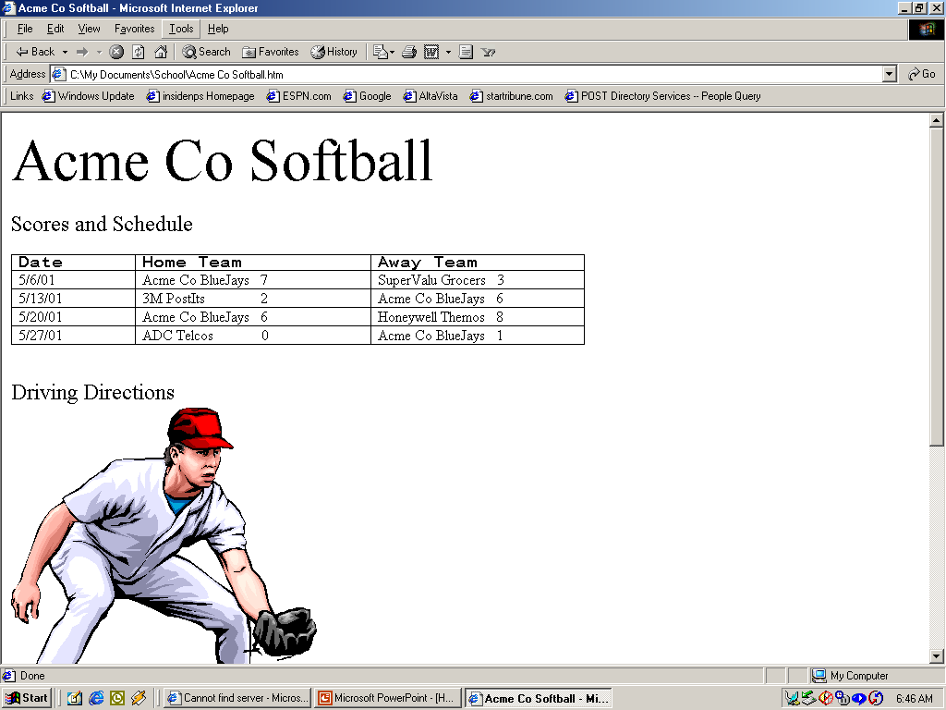
Slide 6: Phase Three
- Statistics
- Online Registration
- More resources required for site development/maintenance
- Potential outside sponsorship

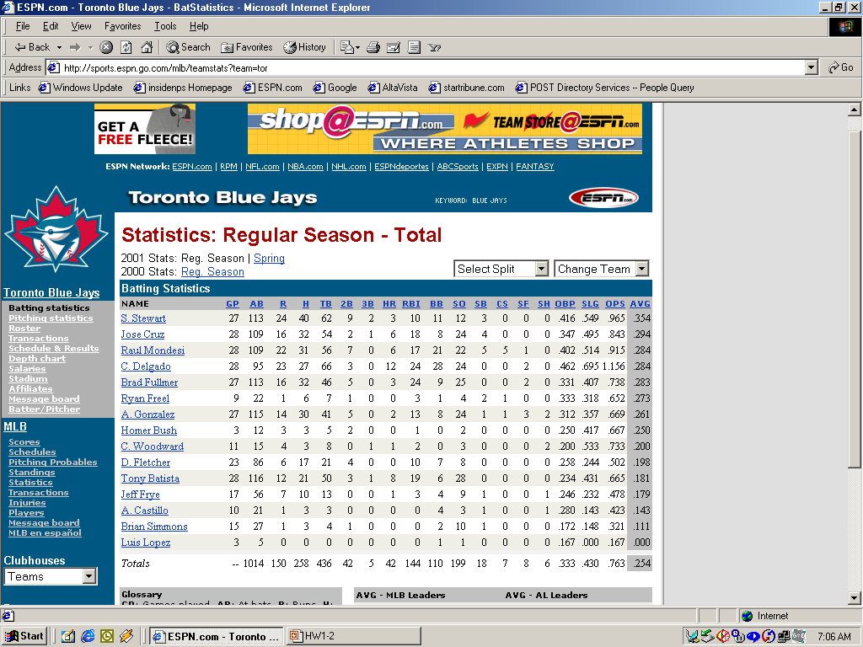
Slide 7: Phase Three Example

CHAPTER 3

Project Integration Management

Learning Objectives

After reading this chapter you will be able to:

- Understand the importance of project integration management

- Describe an overall framework for project integration management as it relates to the other project management knowledge areas and the project life cycle

- Describe project plan development and the key components of a good project plan

- Explain project plan execution and key aspects of getting work results

- Describe the integrated change control process and the creation of project plan updates, corrective action, and lessons learned

Chapter Outline

What is Project Integration Management?
Project Plan Development
Project Plan Execution

Overall Change Control
Change Control on IT Projects
Change Control System

Lecture Notes

What is Project Integration Management?

Many people confuse integration management with systems integration. Stress the definition of project integration management⎯the processes involved in coordinating all of the other project management knowledge areas throughout a project's life cycle. Figure 3-2 shows this concept in a graphical format. Also mention that this chapter covers the first of the nine project management knowledge areas. Figure 3-1 summarizes the inputs, tools and techniques, and outputs of each process for project integration management. The PMBOK Guide 2000 provides similar figures for each knowledge areas. Note that “integrated change control” was called “overall change control” in prior versions of the PMBOK Guide.

To be a good project manager, you must focus on performing integration management. It is especially difficult for people with technical backgrounds to delegate many technical tasks, so that they can focus on integration management and the “big picture” view of the project. The opening case illustrates this common problem and the need for project managers to communicate well with the project sponsor⎯in this case, senior management.

Project Plan Development

A project plan is very important in project management, in contrast to some plans written in other settings that are often exercises in bureaucracy. Stress that project plans, unlike other plans students may be familiar with, are written to guide project execution. Performance is based on how well the project team executes the plan.

Discuss key parts of a project plan and the fact that all plans are unique, just as all projects are unique. Table 3-1 provides an outline of a software project management plan from IEEE.

Discuss the importance of performing a stakeholder analysis. Table 3-2 provides a good example of how a fairly simple analysis can improve a project manager's understanding of whom is involved in or affected by a project and how to manage relationships with them.

Project Plan Execution

Project plan execution refers to managing and performing the work described in the project plan. The project team produces the project’s products during execution. Application area knowledge is very important for good project execution. The “What Went Right?” on pg. 70 provides a great example of a project manager who used his product knowledge to deliver projects more effectively. The “What Went Wrong?” on p. 69 illustrates that the main purpose of project plans is to guide execution, and project managers must practice what they preach.

Integrated Change Control

Very few projects go exactly as planned. It is important to plan for some changes, but not to let them get out of hand. Many successful project managers know when to say "No" to changes. Discuss that change control is a difficult yet very important part of being a project manager. Highlight the three main objectives of integrated change control⎯influencing factors that create changes to ensure that changes are beneficial, determining that a change has occurred, and managing actual changes as they occur. Many people only focus on the last objective. Figure 3-3 provides a nice visual of the integrated change control process. Change control, as well as a formal change control system, is very important on information technology projects. Table 3-3 provides suggestions for managing integrated change control.

Quick Quiz

- What are the three main processes of integration management?

ANSWER: project plan development, project plan execution, and integrated change control

- What is the main purpose of a project plan?

ANSWER: to facilitate action or guide project execution

- What project management tool can you use to help manage relationships with different people involved in your project?

ANSWER: a stakeholder analysis

Discussion Topics

- Why should you create a stakeholder analysis if it is not a part of the formal project plan?

ANSWER: Developing good relationships with key stakeholders are very important, because you must understand stakeholder needs and expectations for a project to be successful. A stakeholder analysis helps you identify key stakeholders and how to work with them.

- In the opening case, what actions should senior management have taken to show more support for Nick and the project?

ANSWER: Nick needed mentoring. A senior manager should have discussed what is involved in managing a project and what Nick needed to do to meet management expectations. Nick needed more guidance on how to prepare a project plan, status reports, and so on. Another person should have been assigned to the project to pick up some of Nick's technical work.

Extra Cases or Case Problems

- Develop a detailed outline for a project plan’s introductory section. The project could be the development of a new software product, or any other scenario you feel the class would be interested in. This case can be done as a large group exercise with the instructor as the facilitator, or students could work on it in small groups during or outside of class. Follow guidance on pp. 53-54 for the contents. To add an interesting twist, provide a very vague description of the project and see how differently groups respond. It is also important to reward groups that try to get more information to develop a better plan.

ANSWER: Answers will vary. Be sure that all of the bulleted items on pp. 63-64 are addressed. These items are repeated below for your convenience.

The introduction or overview of the project should include, as a minimum, the following information:
- The project name: Every project should have a unique name. Unique names help distinguish each project and avoid confusion among related projects.
- A brief description of the project and the need it addresses: This description should clearly outline the goals of the project and why it is being done. It should be written in layman's terms, avoid technical jargon, and include a rough time and cost estimate.
- The sponsor's name: Every project needs a sponsor. Include the name, title, and contact information of the sponsor in the introduction.
- The names of the project manager and key team members: The project manager should always be the key contact for project information. Depending on the size and nature of the project, names of key team members may also be included.
- Key deliverables of the project: This section should briefly list and describe the key products that will be produced as part of the project. Software packages, pieces of hardware, technical reports, and training materials are examples of deliverables.
- A list of key reference materials. Many projects have a history preceding them. Listing key documents or meetings related to the project helps project stakeholders understand this history. This section should reference the plans produced for other knowledge areas. For example, the overall project plan should reference and summarize key parts of the scope management plan, schedule management plan, cost management plan, quality management plan, staffing management plan, communications management plan, risk management plan, and procurement management plan.
- A list of definitions and acronyms, if appropriate. Many projects, especially information technology projects, involve terminology unique to a particular industry or technology. Providing a list of definitions and acronyms helps to avoid confusion.

2. Many project managers or CEOs are judged primarily on their ability to execute the project plan, or get the job done. This approach rarely focuses on technical skills. Have students write a 1-2 page paper describing what types of skills are most important in executing projects. They should include at least one outside reference to support their ideas. Refer students to the articles provided under further readings for suggested references.

ANSWER: Answers will vary.

Teaching Tips

Have a student read the opening case aloud to start off discussion of the chapter. Many students have technical backgrounds, so they often relate to and empathize with the main character in this case, Nick Carson. This case is based on a true story about one of the author's relatives.

Try to find examples or real project plans to show the class or describe to the class. Project plans vary tremendously, but their purpose is always the same⎯to guide project execution.

Further Readings or Resources

Charan, Ram and Colvin, Geoffrey, "Why CEOs Fail," Fortune, June 21, 1999, pp. 69-78

Rader, Ron and Vaughan, Cliff, "Relationship Building: A Key 'Technical' Skill," PM Network, June 1999, pp. 47-52

Team/Group Activities

- Opening case discussion: Have students form 3- or 4-person groups to discuss the opening case as an introduction to the chapter. They could answer the questions in Exercise 3 and report their answers to the class.

- Expand the first extra case (the plan for developing a new software product) by having students create a stakeholder analysis for this project.

Solutions

Discussion Questions

- Describe project integration management in your own words. Give an example of a project that was successful due to good project plan development, project execution, or integrated change control.

Project integration management means tying together all of the other aspects involved in a project to make it a success. Examples will vary.

- How does integration management relate to the project life cycle, stakeholders, and the other project management knowledge areas?

Integration management relates to the project life cycle in that it is done in all of the project life cycle phases. As the project progresses, integration management becomes more focused. Integration management relates to stakeholders because it requires the project manager to know all of the project stakeholders, to know their interests and concerns about the project, and to manage relationships with them. Integration management pulls together information from all of the other knowledge areas.

- What are some crucial elements of a good project plan? Describe what might be in a plan for a project to develop a Web-based information system for providing transfer credit information for all colleges and universities in the world.

A good project plan should include the following crucial elements: an introduction or overview of the project, a description of how the project is organized, the management and technical processes used on the project, and sections describing the work to be done, the schedule, and the budget. Answers to the second part of this question will vary. Students should comment that this would be a huge project if it included transfer credit information for all colleges and universities in the world. A good project manager would focus the scope in order to make it more realistic. For example, it might be more feasible to start with all public colleges in a certain state, then expand to include private colleges in that state, and so on.

- What are crucial elements of successful project plan execution? Describe a well-executed project you are familiar with. Describe a disaster. What were some of the main differences between these projects?

Crucial elements of successful project plan execution are strong project leadership, communication, and political skills. Product skills and knowledge are also important, as is senior management support. Answers to the rest of the question will vary.

- Discuss the importance of following a good integrated change control process on information technology projects. What do you think of the suggestions made in this chapter? Think of three additional suggestions for change control on information technology projects.

Answers will vary. One answer might be that it is important to follow a good overall change control process on information technology projects to avoid scope creep, incompatibility problems, and to make effective use of resources and new technologies. Additional suggestions for managing overall change control might include locating key project stakeholders, assigning users to project teams, and providing team-based incentives for effectively managing project changes.

Exercises

Answers to all of these exercises will vary. The exercises, and some possible solutions, are provided here for your convenience.

- Develop an outline (major headings and subheadings only) for a project plan to create a Web site for your class, and then fill in the details for the introduction or overview section. Assume that this Web site would include a home page with links to a syllabus for the class, lecture notes or other instructional information, links to the Web site for this textbook, links to other Web sites with project management information, and links to personal pages for each member of your class and future classes. Also include a bulletin board and chat room feature where students and the instructor can exchange information. Assume your instructor is the project’s sponsor, you are the project manager, your classmates are your project team, and you have up to one year to complete the project.

ANSWER: Answers will vary. A possible project outline might look like this:

- Introduction: The Project Management Class Web Site will enable current and future project management students and faculty to share information related to project management.

- Project Name: Project Management Class Web Site
- Project Description and Need: The growing interest in project management has caused the college to create more courses and offer more sections of project management. By creating a Web site for project management information, faculty and students can create a repository of useful information to enhance teaching and learning. This project will create a Web site for one section of Professor Y's project management course. The project will be completed in one year. Current hardware and software will be used, so we assume there are no additional costs Students and the instructor will work on the project as part of the class and on a volunteer basis.
- Sponsor: Professor Y, Department Chair or Dean
- Project Manager and Key Team Members: Student Y
- Project Deliverables: A Web site on the college server including a home page with links to Professor Y's class syllabus, lecture notes or other instructional information, links to the Web site for the textbook, links to other Web sites with project management information, and links to personal pages for each member of Professor Y's current class and future classes. There will also be a bulletin board and chat room available from the home page where students and the instructor can exchange information.
- Reference Materials: Current course information and textbook
- Definitions and Acronyms
- Project Organization
- Organization charts
- Project Responsibilities
- Other Organization-Related Information
- Management and Technical Processes
- Management Objectives
- Project Controls
- Risk Management
- Project Staffing
- Technical Processes
- Project Scope or Work to Be Completed
- Major Work Packages
- Key Deliverables
- Other Scope-Related Information
- Project Schedule
- Summary Schedule
- Detailed Schedule
- Other Schedule-Related Information
- Project Budget
- Summary Budget
- Detailed Budget
- Other Budget-Related Information

2. Read the IEEE Standard for Software Project Management Plans, one of the suggested readings. Write a one-page summary of this standard and your opinion of its contents.

ANSWER: Answers will vary. The IEEE Standard is written in a very formal style and lists many other standards that apply to creating software project management plans. It does not give any examples, so many students would have a difficult time interpreting how to use this plan.

3. Write a one- to two-page paper based on the opening case. Answer the following questions:

- What do you think the real problem was in this case?
- Does the case present a realistic scenario? Why or why not?
- Was Nick Carson a good project manager? Why or why not?
- What could Nick have done to be a better project manager?
- What should senior management have done to help Nick?

ANSWER: Answers will vary Make sure students justify their responses. For example, they could say that Nick was a good project manager because he got the job done. They could say he was not a good project manager because he was too technical and did not get along well with senior management.

4. Write a one- to two-page summary of an article about project control. You may use the Ward or Wideman articles from the suggested reading list.

ANSWER: Answers will vary.

5. Interview two to three different people to get their views on the differences between staying in a more technical career path and moving into project management. Ask them if they agree with findings in Johnson’s article stating that the best information technology people make the worst project managers. Write a one- to two-page summary of what you found, including your opinions on this subject.

ANSWER: Answers will vary.

MINICASE

Answers will vary. Be sure students follow the sample stakeholder analysis for Part 1. Check for thoroughness in the documents and processes produced for Part 2. Below is one possible answer.

Part 1:
Stakeholder Analysis
Key Stakeholders
jill fred governor donna

Organization External External Hardware State Dept. of
consulting firm consulting firm vendor Corrections
Role on Robin’s Legal expert Senior Sponsor, head of boss management Dept. of Corrections
Unique facts Likes to give Knows law Doesn’t trust Knew business
challenging and state consultants, process, doesn’t
assignments corrections, questions value like computers,
doesn’t like of project, must old-fashioned
younger, female play politics boss
Level of Very high High High Very high
interest
Level of Very high High; hard to High Very high
influence replace
Suggestions Use as mentor, Let him know Keep informed, Let her head the
on managing keep informed, you value his emphasize value meetings concerning
relationship invite to key expertise, show of new system business processes,
meetings him you’re ease her into new technologies competent with help from her assistant, Jim

In the memo to her boss, Robin should emphasize the importance of top management support for this project. Robin should ask Jill or other senior members of her firm to attend important meetings and perhaps set up a special meeting with her senior management and the Governor and other senior officials on the project. Other suggestions might include having weekly meetings over coffee so Robin can share experiences and ask for advice from Jill.

Part 2:
The draft documents describing the processes for status review meetings and change control will vary but should include key concepts described in the chapter. Figure 3-3 can serve as a guide for the change control process. Templates for key documents will vary. Chapter 9 provides a template for a monthly progress report on p. 287.

CHAPTER 4

Project Scope Management

Learning Objectives

When you have completed this chapter you should be able to:

- Understand the importance of good project scope management

- List the reasons why most firms invest in information technology projects

- Describe the strategic planning process and how it relates to information technology project selection

- Apply different project selection methods such as a weighted scoring model and net present value analysis

- Explain the purpose of a project charter, scope statement, and work breakdown structure

- Construct a work breakdown structure

- Describe tools and techniques to assist in scope verification and change control on information technology projects

Chapter Outline

What is Project Scope Management?
Project Initiation: Strategic Planning and Project Selection
Identifying Potential Projects
Methods for Selecting Projects
Focusing on Broad Organizational Needs
Categorizing Information Technology Projects
Net Present Value Analysis, ROI, and Payback Analysis
Weighted Scoring Model
Project Charters Scope Planning and the Scope Statement
The Scope Statement

Scope Definition and the Work Breakdown Structure
The Work Breakdown Structure
Approaches to Developing Work Breakdown Structures
Using Guidelines
The Analogy Approach
The Top-Down and Bottom-Up Approaches

Scope Verification and Scope Change Control
Suggestions for Improving User Input
Suggestions for Reducing Incomplete and Changing Requirements

Lecture Notes

What is Project Scope Management?

Many people are not familiar with the term scope management. Scope refers to all the work involved in creating the products of the project and the processes used to create them. Project scope management includes the processes involved in defining and controlling what is or is not included in a project. Many projects fail due to poor scope management. Scope management is difficult because people have different understandings of what should be done on projects. It is very important to ensure that the project team and stakeholders have the same understanding of what products will be produced as a result of a project and what processes will be used in producing those products.

Project Initiation: Strategic Planning and Project Selection

Many students studying information technology or management have had some exposure to strategic planning. Review what strategic planning is and how it relates to selecting what projects an organization should work on. Some students may confuse strategic information systems with strategic planning, or think that only strategic information systems projects should be done. Be sure to clarify the difference between strategic planning and strategic information systems. Not all projects produce strategic information systems, and a lot of strategic planning does not refer to information technology.

An important part of ensuring project success is to pick important projects to work on in the first place. Table 4-1 shows the main reasons why firms invest in information technology projects. Even though students may have heard of the importance of addressing business needs, emphasize the fact that information technology should support explicit and implicit business objectives and provide strong financial returns. The least cited reason firms invest in information technology projects is to introduce new technology. Students often like to learn new technologies just for the sole purpose of learning the new technologies. Stress that information technology should support business needs first and foremost.

Figure 4-1 provides a good summary of the relationship between strategic planning and project selection. Review the various methods for selecting projects. Focus discussion on broad organizational needs, categorizing information technology projects, net present value analysis, return on investment, payback analysis, and weighted scoring models. Provide examples of projects that fit in each category.

Depending on students' backgrounds, time could be spent reviewing the calculations for determining NPV, ROI, payback period, and weighted scoring models. Most students enjoy learning new techniques or refreshing their understanding of them. Many companies use these techniques, and even though students think they understand them, they often have difficulty performing the actual calculations and interpreting the results.

A project charter is a very important tool in project management. Review the purpose of a charter⎯to formally recognize the existence of a project and provide direction on the project's objectives and management. Review the sample charter on pg. 97.

Scope Planning and the Scope Statement

Emphasize that after a project charter is done, many projects require additional documentation to determine the scope. A scope statement is a document used to develop and confirm a common understanding of the project scope. A Statement of Work (SOW) is a type of scope statement used in many government projects. Scope statements vary depending on the nature of the project.

Scope Definition and the Work Breakdown Structure

Understanding and creating work breakdown structures (WBS) are a very important part of project scope management. Show the class the examples provided in the textbook. You could also open some of the sample files in Project 2000 to show the students other WBSs. The tasks you enter in Project 2000 should follow a WBS format.

Mention the different approaches to developing WBSs, and include at least one class exercise to reinforce the fact that there are different ways to create WBSs for the same project. Stress the fact that it is difficult to create a good WBS. Review the basic principles for creating a good WBS listed at the bottom of pg. 107.

Scope Verification and Scope Change Control

Review the definitions of scope verification and scope change control. Stress the importance of having project stakeholders formally accept the project scope through scope verification. Show Table 4-4 and stress that the first three factors causing information technology project problems⎯lack of user input, incomplete requirements and specifications, and changing requirements and specifications⎯all relate to scope verification and change control. Review the suggestions for improving these three problem areas and include your own suggestions based on your experiences.

Quick Quiz

- What is the main reason why firms invest in information technology projects?

ANSWER: to support explicit business objectives

- If you have three independent projects with NPVs of $100, $400, and -$100, which project(s) would you recommend based solely on the NPV?

ANSWER: Recommend the project with an NPV of $100 and the one with an NPV of $400. Both are profitable. If you must choose one project, recommend the project with the highest NPV⎯$400 in this example.

- What document formally recognizes the existence of a project?

ANSWER: a project charter

- What is the main output of the scope definition process and is also an outcome-oriented analysis of the work involved in a project that defines the total scope of the project?

ANSWER: a WBS

Discussion Topics

- List three different projects. Which method for selecting projects would each fit under?

ANSWER: Answers will vary. One example would be a project to purchase a new home computer. A weighted decision matrix could be used as the selection method. Another example would be a project to provide mandatory training on a new intranet at a company. The method for selected that project could be the will of the CEO.

- Project charters seem fairly simple. Why do you think many projects do not have them?

ANSWER: Project charters require a sponsor who must develop a clear statement of the project's objectives and initial scope, time, and cost goals. It also requires signatures of key stakeholders. Some people and organizations might not like the formal nature of charters or want to be held accountable to producing the expected results.

- Why is it difficult to find good examples of WBSs?

ANSWER: Many projects have been done without using a WBS, and many have used poor WBSs. Organizations with good WBSs often do not want to share them with others.

Extra Cases or Exercises

- Event Planning WBS: A sample Event Planning file (Event planning.mpt) comes with Project 98. Give students just the tasks from this file and have them put the tasks into a WBS format. Then have them check their work using the solution below. You may need to give them a hint to help them get started, such as identifying the three main WBS categories (pre-planning, event preparation, and event wrap-up). Discuss what was difficult about this exercise and whether or not the WBS is a good one.

ANSWER:

1.0 Pre-planning
1.1 Initial planning meetings
1.1.1 Determine budget
1.1.2 Invitation list
1.2 Selection
1.2.1 Theme
1.2.2 Date
1.2.3 Site
1.2.4 Costumes
1.3 Hire
1.3.1 Caterer
1.3.2 Entertainment
1.3.3 Keynote speaker
1.4 Public relations
1.4.1 Alert community
1.4.2 Press release
1.5 Rent Equipment
1.5.1 Rent tents
1.5.2 Rent audiovisual equipment
1.5.3 Rent tables and chairs
1.6 Meet with Caterer
1.6.1 Menu selection
1.6.2 Drink selection
1.7 Hire Personnel
1.7.1 Bartenders
1.7.2 Security
1.7.3 Photographer
1.7.4 Cleanup crew
1.8 Arrangements
1.8.1 Transportation for speaker
1.8.2 Event transportation
1.8.3 Flowers
1.8.4 Table decorations
1.8.5 Lighting
2.0 Event Preparation
2.1 Buy room decorations
2.2 Buy party favors
2.3 Setup equipment for event
2.4 Decorate
2.5 Special Event
3.0 Event Wrap-up
3.1 Cleanup
3.2 Pay bills
3.3 Write thank you letters
3.4 Write event summary
3.5 Vacation

- Weighted Decision Matrix: A fun way to illustrate this technique is to apply it to finding a roommate. Let students suggest 4 to 5 criteria they would use in choosing a roommate. Then decide on the weight for each criterion, being sure the weights add up to one hundred. Have the class pick 3 potential roommates, then add a fourth choice that is one of the students' actual roommates. Evaluate each potential roommate using the suggested criteria, add the scores, then determine the weighted scores. It is interesting to see what criteria students come up with and who they suggest as potential roommates.

ANSWER: Answers will vary, but here is an example.

Criteria | Weight | Roommate #1 | Roommate #2 | Roommate #3 | Roommate #4
Neat | 30% | 100 | 100 | 80 | 10
Respectful | 20% | 90 | 100 | 95 | 95
Quiet | 30% | 40 | 20 | 10 | 100
Independent | 10% | 70 | 10 | 20 | 100
Friendly | 10% | 50 | 10 | 20 | 100
Weighted Scores |  | 72 | 58 | 50 | 72

Teaching Tips

Use Excel to demonstrate how to do some of the financial techniques shown in this chapter. If students have computers in class, they could recreate Figure 4-2 (the Net-Present Value Example). If only the instructor has a computer, information could be entered by the instructor and then discussed with the class.

Include an activity in which students get some hands-on practice creating a WBS. If they will be doing real projects as part of the class, give them class time to start working on the WBS for their group projects. Refer them to the Gantt chart template for a class project (Figure 9-3 ) on pg. 290. It includes a generic WBS that students can use as a starting point.

Further Readings or Resources

Cabanis, Jeannette, "Standards: The Rallying Cry of a Growing Profession, PM Network, May 1999, pp. 39-42

Project Management Institute Standards Member Advisory Group, "Work Breakdown Structure Practice Standard", draft available late 1999

Team/Group Activities

Have students form groups to practice creating a WBS. This activity will give students an opportunity to create a WBS in a group setting and realize how difficult it can be. You could have them do Exercise 2 or 3 in class, or start creating the WBS for their group project if they are doing one for class.

Both extra cases could be done as group activities.

Solutions

Discussion Questions

- What are the main reasons for investing in information technology projects? Do you believe your organization uses similar reasons?

The main reasons for investing in information technology projects are provided in Table 4-1 on pg. 87 and include:

- Supports explicit business objectives
- Has good Internal Rate of Return (IRR)
- Supports implicit business objectives
- Has good net present value (NPV)
- Has reasonable payback period
- Used in response to competitive systems
- Supports management decision making
- Meets budgetary constraints
- High probability of achieving benefits
- Good accounting rate of return
- High probability of completing project
- Meets technical/system requirements
- Supports legal/government requirement
- Good profitability index
- Introduces new technology

Answers will vary on the second part of the question.

- Give examples of information technology projects and why they were or were not selected for implementation. What type of project selection process did the organization use?

Answers will vary. The “What Went Right?” on pg. 95-96 provides one example.

- Develop a list of criteria for categorizing information technology projects. Apply these criteria to a few systems you are familiar with.

Answers will vary. You could use some of the criteria provided in the solutions to Discussion Question 1 or in Figure 4-5.

- Discuss the theory and practice behind using project charters, scope statements, and WBSs.

Project charters formally recognize the existence of a project. Although project charters are typically just one page in length, they play an important role in setting the stage for the project. The scope statement provides more details on the work involved in performing the project. Scope statements can be very long and require strong user input. A WBS is a list-like structure to help organize how the work will be accomplished. It is the basis for creating a project schedule and assigning resources.

- Describe a project that suffered from scope creep. Could it have been avoided? How? Can scope creep be a good thing? When?

Answers will vary. The “What Went Wrong?” on pg. 108 provides an example of scope creep at FoxMeyer Drug that resulted in the company going bankrupt. The problem could have been avoided by focusing on business needs and not grandiose technology. Scope creep is usually not beneficial, unless you are the company getting paid to perform the additional work.

Exercises

Answers to all of these exercises will vary. The exercises, and some possible solutions, are provided here for your convenience.

- Use spreadsheet software to create the weighted scoring model presented in this chapter. Make sure your formulas work correctly. Then create your own criteria and project scores for a project selection scenario of your choice.

ANSWER: The Excel file (Fig4-5.xls) is provided for you on the Instructor’s Resource Kit CD. Answerswill vary for the second part. See the example in the extra case section for this chapter.

- Create a WBS in chart form (similar to an Organizational chart – see intranet sample in Figure 4-6a) for the information technology upgrade project described in the opening case of this chapter. Break down the work to at least the third level for one of the WBS items. Make notes of questions you had while completing this exercise.

ANSWER: Answers will vary somewhat. The WBS in tabular form for the Event Planning file is provided in the extra case for this chapter. The WBS in chart form could look like this:

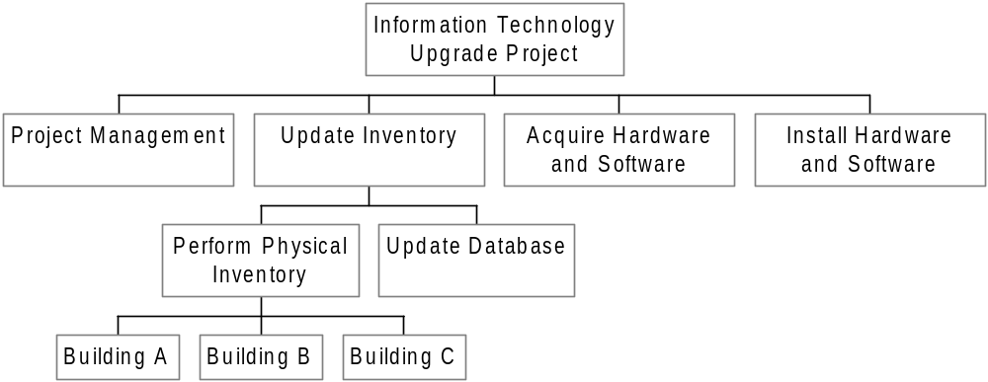

- Create a WBS for one of the following projects:

- Building your dream house
- Planning a traditional wedding
- Creating a new information system for your school or company

Break down the work to at least the third level for one of the items on the WBS. Make notes of questions you had while completing this exercise.

ANSWER: Answers will vary. The WBS for building your dream house could look like this

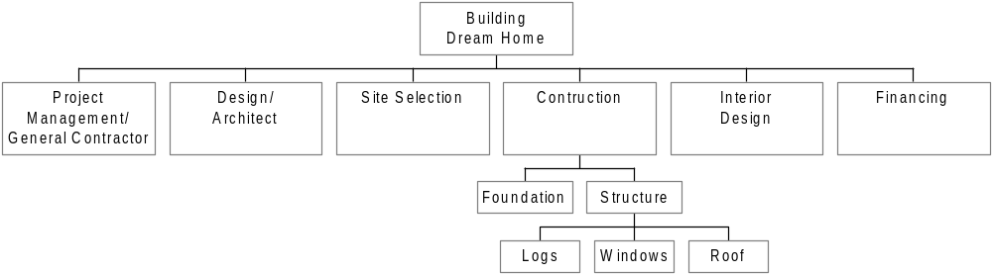

- Review the files in the MS Project 2000 templates folder. What do you think about the WBSs for them? Try drawing a WBS in chart form for one of the sample templates.

ANSWER: Answers will vary. The structure for the Intranet sample file is provided in the textbook in Figure 4-6B. The format should be similar to Figure 4-6a or 4-6b.

- Perform a financial analysis for a project similar to those found in Figures 4-3 and 4-4. Assume the projected costs and benefits for this project are spread over four years as follows: Estimated costs are $1,500,000 in Year 1 and $300,000 each year in Years 2, 3, and 4. Estimated benefits are $0 in Year 1 and $1,000,000 each year in Years 2, 3, and 4. Use a 10% discount rate. Create a spreadsheet to calculate and clearly display the NPV, ROI, and year in which payback occurs. Also write a paragraph explaining whether or not you would recommend investing in this project based on your financial analysis.

ANSWER: The spreadsheet below shows the correct answers.
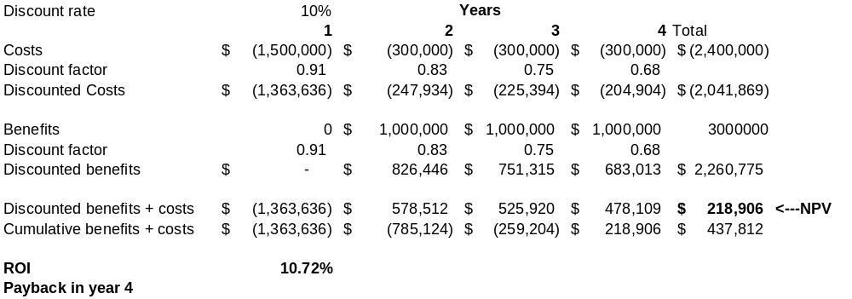
Since the project has a positive NPV, it can be viewed as a good investment. However, the ROI could be higher (10.72% is good but not great), and the payback is not until year 4.

6. Read one of the suggested readings. Write a one- page summary of the article, its key conclusions, and your opinion.

ANSWER: Answers will vary

MINICASE

Part 1:
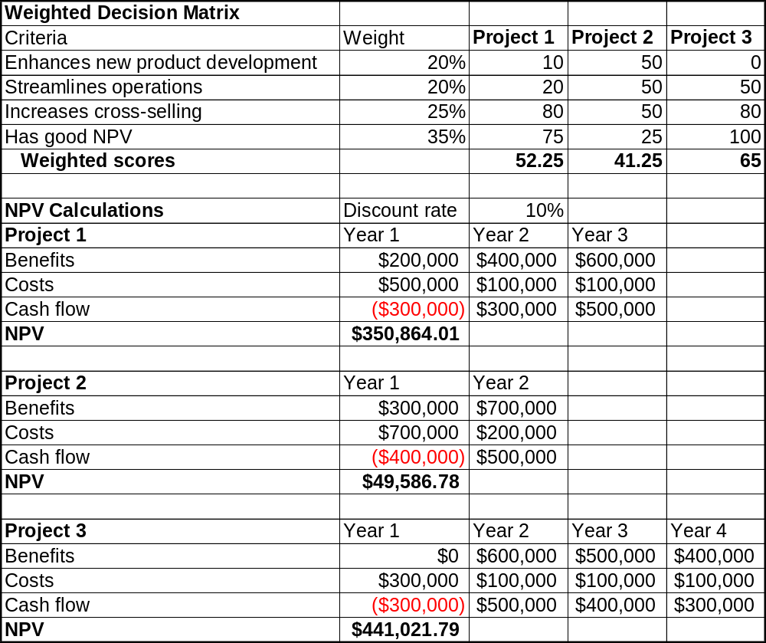
Part 2:
- Initiating
- Planning
- Executing
  - Analysis
  - Design
  - Prototyping
  - Testing
  - Implementation
  - Support
    - Training
    - Documentation
    - User support
    - Enhancements
- Controlling
Closing

Three potential deliverables under the executing tasks could be a test plan, training plan, and training materials.
CHAPTER 5

Project Time Management

Learning Objectives

After reading this chapter you should be able to:

- Understand the importance of good project time management

- Explain the basic process for developing project schedules

- Describe how various tools and techniques help project managers perform activity definition, activity sequencing, activity duration estimating, schedule development, and schedule control

- Use a Gantt chart for schedule planning and tracking schedule information

- Construct a project network diagram and understand its importance for determining overall project completion dates

- Understand and use critical path analysis

- Describe several techniques for shortening project schedules

- Explain the basic concepts behind critical chain scheduling

- Discuss reality checks and people issues involved in project schedule management and control

- Describe how software can assist in project time management

Chapter Outline

Importance of Project Schedules
Where Do Schedules Come From? Defining Activities
Activity Sequencing
Project Network Diagrams
Activity Duration Estimating
Schedule Development
Gantt Charts
Critical Path Method
Using Critical Path Analysis to Make Schedule Trade-Offs
Techniques for Shortening a Project Schedule
Importance of Updating Critical Path Data
Critical Chain Scheduling
Program Evaluation and Review Technique (PERT)
Controlling Changes to the Project Schedule
Reality Checks on Scheduling
Working with People Issues
Using Software to Assist in Time Management
Words of Caution On Using Project Management Software

Lecture Notes

Importance of Project Schedules

Many people view project time management as one of the most important and most unique aspects of project management. This chapter includes many terms, tools, and techniques that are unique to project management. Stress the importance of understanding and studying this chapter, particularly if students plan to take the PMP exam.

Many projects that are completed are finished late. The 1995 CHAOS report found that the average time overrun was 222 percent. Schedule issues are the main reason for conflicts on projects. Students can often relate to problems with time since many of them are juggling work, school, families, and so on. Stress the importance of developing realistic schedules and then adhering to these realistic schedules in order to help improve project time management.

Where Do Schedules Come From? Defining Activities

Emphasize that many other knowledge areas and process groups come into play when creating a project schedule. There must be a strong scope definition before creating a schedule, as well as good information concerning cost, quality, human resources, and so on. The WBS highlighted in the previous chapter is very important for further defining activities and creating a project schedule. Stress the importance of documenting WBS activities and making sure the project team understands each activity before doing activity sequencing or duration estimating.

Activity Sequencing

The concept of creating dependencies or relationships makes sense to most students. However, few students have experience creating these dependencies, or have even seen or heard of a PERT chart. Plan to spend a fair amount of time on this section. Walk through a simple example, such as the one shown using Project X in Figure 5-2 on pg. 124. It is often easier for students to read and create the activity-on-arrow network diagrams, even though project management software uses the precedence diagramming method. Show students the same project using both diagramming methods (Figure 5-2 and 5-4). Have students create a simple network diagram in class using just a few activities (see the extra cases section or Exercises 1-3 in the textbook). After covering this section, you should have students start using Project 2000. Make sure they can create a WBS and understand activity sequencing before they use the software. Many people misuse Project 2000 because they do not understand these important concepts.

Activity Duration Estimating

People often become confused when creating duration estimates. Unlike many cost estimates where you estimate the amount of time someone would work on an activity, the duration estimate includes that time, plus any elapsed time. Give a few examples to illustrate this concept. For example, the course you are teaching might include 28 to 42 hours of class time, but the duration of the class is much longer than 4 to 6 days. There is elapsed time between classes. Emphasize that people who will actually do the work should provide input into the duration estimates, and emphasize the importance of reviewing similar projects and seeking expert advice when preparing estimates. Many people are overly optimistic about how long it will take to complete activities.

Schedule Development

Emphasize that the ultimate goal of schedule development is to create a realistic project schedule that provides a basis for monitoring project progress. Schedules are an important part of project plans, and most people can easily understand schedules and see if work is being completed on time or not. Explain the important project management tools for schedule development: Gantt charts, network diagrams (formerly called PERT charts), and critical path analysis. Many students have seen a Gantt chart before, but they may not have referred to them by that name. Few people are familiar with network diagrams or critical path analysis, and most people haven’t seen the PERT weighted average formula before. Students often have a difficult time understanding these concepts. Review the concepts and examples in class and stress that these are important tools to learn particularly critical path analysis. Also highlight the basic approaches for shortening project schedules⎯fast tracking and crashing. The “What Went Wrong” on pg. 137 provides a good example of the dangers of unrealistic schedules. This chapter contains a new section on critical chain schedule. Discuss important concepts related to critical chain scheduling, including multitasking, resource constraints, and buffers. Depending on the nature of your course, you could have students read Goldratt’s Critical Chain text and write a detailed paper about this concept.

Controlling Changes to the Project Schedule

Mention the importance of reviewing project schedules to ensure that they are both reasonable and realistic. Many project managers and team members are pressured to create unrealistic time estimates. It is better to negotiate realistic schedules up front on most projects than to deal with schedule overruns later in the project. It is also important to remember the people issues involved in developing and maintaining project schedules. It takes good leadership to keep people on schedule. The “What Went Right?” on pg. 144 provides a good example of leadership in managing project schedules.

In your own course, you have definite time constraints. Discuss how you determine the schedule in your syllabus, and use it as an example of developing and controlling a schedule. There are often changes in a course that could affect the schedule. Discuss how you deal with those changes.

Using Software to Assist in Time Management

Project management software is most often used for time management. Unlike other software (spreadsheets, databases, and so on), project management software easily creates Gantt chart, network diagrams, and critical path information. Demonstrate some of the Project 2000 features related to project time management. Table 5-2 on pg. 146 lists several of these features.

Words of Caution On Using Project Management Software

Stress how complex project management software is and the importance of using it correctly. Many companies have Project 2000 or similar software, but they use it only to create Gantt charts. The textbook provides examples of senior managers wasting time by not understanding basic concepts such as linking tasks and establishing baselines in order to use project management software effectively.

Quick Quiz

- What is the most common type of task dependency?

ANSWER: Finish-to-start

- What is the critical path on a project?

ANSWER: The critical path is the series of activities in a project network diagram that determines the earliest completion date of the project

- What is PERT?

ANSWER: PERT is a network analysis technique used to estimate project duration when there is a high degree of uncertainty about the individual activity duration estimates. The PERT weighted averages formula is on pg. 141.

- What is the first step in project time management?

ANSWER: Activity definition

Discussion Topics

- Explain the main items on a Gantt chart.

ANSWER: The tasks are WBS items. A milestone is the black diamond symbol and represents a significant event on a project with zero duration. The thick black bars with arrows at the beginning and end represent summary tasks. The light gray horizontal bars represent the duration of each individual task. The arrows connecting these symbols show relationships or dependencies between tasks.

- Discuss methods for shortening a project schedule.

ANSWER: Crashing compresses a schedule for the least incremental cost. Fast tracking involves doing activities in parallel that would normally be done in sequence.

- What is a milestone? Provide a few examples of milestones.

ANSWER: A milestone is a significant event on a project with zero duration. Examples include receiving project funding, getting customer sign-off on important documents, awarding a contract, and so on.

Extra Cases or Exercises

- Consider the following project network diagram. Assume all time estimates are in days.
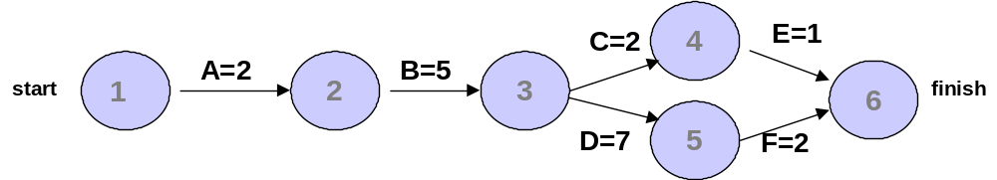

- How many paths are on this network diagram?

ANSWER: 2

- How long is each path?

ANSWER: A-B-C-E is 10 days, and A-B-D-F is 16 days

- Which is the critical path?

ANSWER: A-B-D-F is the critical path

- What is the shortest amount of time needed to complete this project?

ANSWER: 16 days

- Consider the following data for a small software development project (all times are in days; proceed from node 1 to node 10).

Activity Initial Node Final Node Estimated Time
A 1 2 2
B 1 3 4
C 2 4 5
D 2 5 6
E 3 5 2
F 3 6 3
G 4 7 2
H 5 8 2
I 5 9 4
J 6 9 6
K 7 8 1
L 8 10 3
M 9 10 4

- Draw a network diagram representing the project. Put the node numbers in circles and draw arrows from node to node, labeling each arrow with the activity letter and estimated time.

B=4

1
4
3
8
6
9
C=5
F=3

A=2
H=2
K=1
J=6
D=6
2
5
E=2

7
10
G=2
I=4
L=3
M=4
ANSWER

- Determine how many paths there are in this network diagram, and list the paths and their lengths. For example, a path might be written as A-B-E-F-L with a length of 12 days.

ANSWER:
A-C-G-K-L = 13 days
A-D-H-L = 13 days
A-D-I-M = 16 days
B-E-H-L = 11 days
B-E-I-M = 14 days
B-F-J-M = 17 days

- What is the critical path for this project and how long is it?

ANSWER: B-F-J-M is the critical path, and it is 17 days long.

- What is the shortest time in which this project can be completed?

ANSWER: 17 days, the same length as the critical path.

- Can the critical path ever change on a project?

ANSWER: Yes

- Can there be more than one critical path?

ANSWER: Yes

Teaching Tips

After explaining how to draw project network diagrams and what the critical path means, have students complete a simple exercise in class, such as the one provided in the first extra case, to test their understanding. Some people catch on to these two concepts quickly, but others have a difficult time understanding how to draw network diagrams and what the critical path means. After students master a simple example, challenge them with more complicated examples

After students develop a strong understanding of network diagrams, have them use Project 98 to recreate one or two they have done by hand. Show them how to switch from Gantt view to PERT view, and how to show the schedule table to see slack information. Refer to Appendix A for hands-on activities and exercises using Project 98.

Further Readings or Resources

Leach, Larry, "Critical Chain Project Management Improves Project Performance, Project Management Journal, June 1999, pp. 39-51

Lewis, James P. Project Planning, Scheduling & Control: A Hands-On Guide to Bringing Projects in on Time and on Budget, Probus Publishing, 1995

Team/Group Activities

- Project network diagram: After students create a practice network diagram in class, have them exchange their answers with another student. If students are having trouble grasping this concept, have them do another exercise in small groups and draw their solutions on the board.

- Project 98: Have students pair up to use Project 98 to create schedules and view PERT charts. If they are doing group projects, give them some class time to work on developing the schedules for their projects. Refer them to the Gantt chart template for a class project in Chapter 9, Figure 9-3.

Solutions

Discussion Questions

- Why do you think schedule issues often cause the most conflicts on projects?

Many people are juggling many different tasks, both related to their jobs and their personal lives. It is difficult to schedule good meeting times for all project stakeholders, and face-to-face meetings are still important in various aspects of projects. Many people also underestimate how long things will take and the degree to which certain tasks depend on other tasks being completed. People do not like wasting time, and poor time management often wastes time.

- Discuss the main processes involved in project time management.

Project time management includes activity definition, activity sequencing, activity duration estimating, schedule development, and schedule control.

- Activity definition involves identifying the specific activities that the project team
members and stakeholders must perform to produce the project deliverables.
- Activity sequencing involves identifying and documenting the relationships between project activities.
- Activity duration estimating involves estimating the number of work periods that are
needed to complete individual activities.
- Schedule development involves analyzing activity sequences, activity duration
estimates, and resource requirements to create the project schedule.
- Schedule control involves controlling and managing changes to the project schedule.

- Discuss diagrams you have seen that are similar to project network diagrams. How are they similar, and how are they different?

Several different diagrams are similar to project network diagrams. In transportation modeling, for
example, you try to find the shortest route between two points. In those diagrams, however, you only need to take one path. In a project network diagram, all activities must be completed in order to complete the project.

- Explain as clearly as possible what a critical path is and why a project manager should be concerned about it.

A critical path for a project is the series of activities that determines the earliest completion date for the project. It is the longest path through the project network diagram and the shortest time in which the project can be completed. A project manager should be concerned about the critical path because if any activity on it slips, the whole project will slip unless corrective action is taken.

- Explain the symbols on a Gantt chart and how to use this tool. Find examples of Gantt charts in other texts or from your work experience.

Gantt charts provide a standard format for displaying project schedule information by listing project
activities and their corresponding start and finish dates in a calendar format. Gantt charts are often used as a progress evaluation tool because they can display planned and actual project schedule information. Some of the symbols on a Gantt chart are:

- A milestone is the black diamond symbol and represents a significant event on a project with zero duration.
- The thick black bars with arrows at the beginning and end represent summary tasks.
- The light gray horizontal bars represent the duration of each individual task.
- The arrows connecting these symbols show relationships or dependencies between tasks.

See pg. 129-130 for a description and samples of Gantt charts. Answers to the second part of this question will vary.

- Explain the difference between critical path analysis and critical chain scheduling.

You can find the critical path for a project without considering resource allocation. An important part of critical chain scheduling is accounting for resource constraints. Critical chain scheduling also suggests that you limit multitasking of resources in creating project schedules and that you include project and feeding buffers to protect the project completion date.

- What are some of the important people issues involved in project time management?

Some of the people issues in project time management include conflict management, empowerment,
incentives, discipline, and negotiation. Schedule issues cause the most conflicts on projects, so it is important to do a good job of time management and be prepared to resolve conflicts. Good project managers empower people to take responsibility for completing their work on time and offer incentives to do so. It is also necessary to use discipline to keep most projects on schedule as well as negotiate when schedules simply cannot be met.

- What skills of a project manager described earlier do you think are most important for time management?

In order to perform well in project time management, project managers must have strong leadership skills and be able to get key project stakeholders actively involved in clearly stating project requirements, creating reasonable and realistic time estimates, and then meeting schedule dates. It is also important to have a good relationship with senior management to obtain support and resources to help meet dates.

Exercises

Answers to all of these exercises will vary. The exercises, and some possible solutions, are provided here for your convenience.

- Using Figure 5-2, enter the activities, their durations, and their relationships in Project 2000. Use a project start date of 6/02/03. View the network diagram. Does it look like Figure 5-2? It should be very similar, but appear in PDM form, as shown in Figure 5-4. Print out the network diagram on one page. Return to Gantt chart view. Select View, Table, Schedule from the menu bar to re-create Table 5-1. Write a few paragraphs explaining what the network diagram and schedule table show concerning Project X’s schedule.

ANSWER: The solution is for students to recreate Figure 5-2 and Table 5-1. The network diagram shows the relationship between project activities. In other words, it shows what tasks have dependencies. The critical path automatically displays in red in Project 2000 (B-E-H-J). If any activity on the critical path takes longer than planned, the entire project will be delayed.

- Consider Table 5-3, Network Diagram Data for a Small Project. All times are in days; the network proceeds from node 1 to node 9.

- Draw an AOA network diagram representing the project. Put the node numbers in circles and draw arrows from node to node, labeling each arrow with the activity letter and estimated time.

ANSWER:
D=4

2
6
5
8
7
9
E=2
C=3
B=2
I=5
H=2
K=2
G=6
F=3
3
4
1
A=2
J=1

b. Identify all of the paths on the network diagram and note how long they are.

ANSWER:

Path 1: A-B-E-H-K Length = 2+2+2+2+2 = 10 days
Path 2: A-B-E-I-J-K Length = 2+2+2+5+1+2 = 14 days
Path 3: A-C-F-H-K Length = 2+3+3+2+2 = 12 days
Path 4: A-C-F-I-J-K Length = 2+3+3+5+1+2 = 16 days
Path 5: A-D-G-J-K Length = 2+4+6+1+2=15 days

c. What is the critical path for this project and how long is it?

ANSWER: The critical path is A-C-F-I-J-K and it is 16 days long.

d. What is the shortest possible time it will take to complete this project?

ANSWER: The shortest possible time to finish this project is 16 days.

- Enter the information from Exercise 2 in Project 2000. View the network diagram and task schedule table to see the critical path and float or slack for each activity. Print out the Gantt chart and network diagram views and the task schedule table. Write a short paper that interprets this information for someone unfamiliar with project time management.

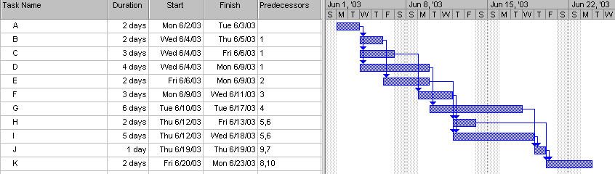
Gantt chart:

Network diagram.
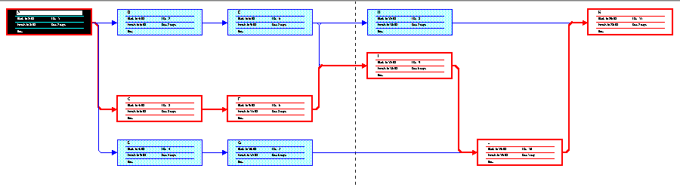

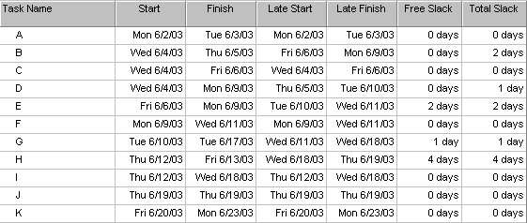
Task schedule table:

Answers for the short paper will vary. Students should note that the critical path is A-C-F-I-J-K. If any of these tasks take longer than planned, the entire project will be delayed. If they take less time than planned, the project could be finished early. The schedule table lists the amount of slack each activity has. The slack is the amount of time the activity can be delayed without delaying another activity (free slack) of the entire project (total slack).

4. a. Using the information technology Upgrade Project WBS you created in Chapter 4, Exercise 2,
create a rough Gantt chart for the project by hand. Make sure the project does not take more than nine months to complete. Document any assumptions you made in creating the Gantt chart.

- Next determine the relationships between activities listed on your WBS and the Gantt chart.
Build a network diagram for this project by hand. Estimate the duration of each activity, and then enter the data into Project 98. Make sure you can complete the project in nine months or less. Print out the Gantt and PERT charts and write a one-page paper interpreting the results.

ANSWER: Answers will vary. One possible solution is provided below.
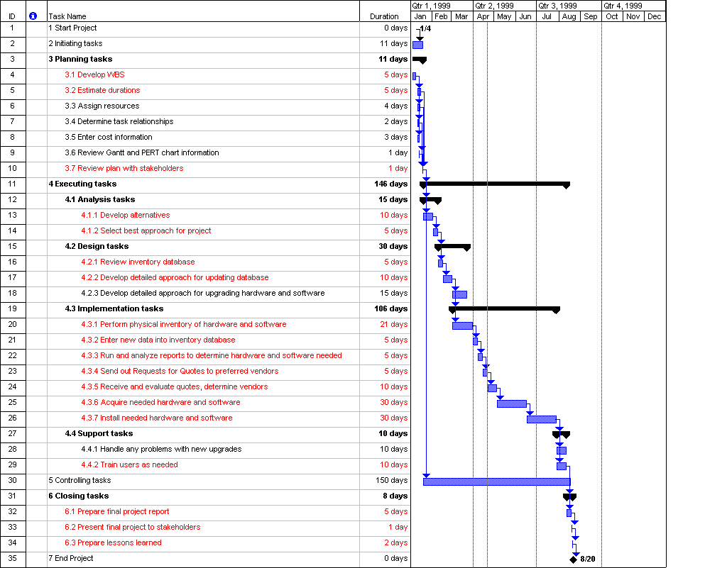

5. Do the project scope and time management parts of one of the exercises provided in Appendix A. Print out the Gantt and PERT charts and write a one-page paper interpreting the results.

ANSWER: Answers will varySee possible solutions in Appendix A.

6. Interview someone who uses some of the techniques discussed in this chapter. How do they feel about
network diagrams, critical path analysis, Gantt charts, using project management software, and managing the people issues involved in project time management? Write a paper describing their responses.

ANSWER: Answers will vary.

7. Read one of the suggested readings. Write a one-page summary of the article, its conclusions, and your opinion.

ANSWER: Answers will vary.

MINICASW
Part 1: Answers will vary. Below is one possible solution.
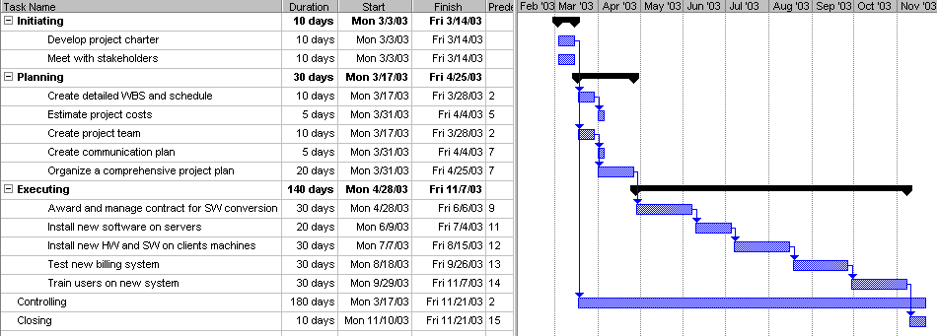
Part 2: Answers will vary. Potential milestones include the following:
- Initiating: Charter developed, project manager assigned, funding approved
- Planning: Draft WBS completed, baseline plan completed, cost estimate approved, project team assigned, communications plan distributed
- Executing: Contract awarded, server software installed, client hardware installed, client software installed, testing completed, training completed
- Controlling: Change control procedures established, change control board established
- Closing: Final project report completed, final project presentation completed, lessons learned distributed

CHAPTER 6

Project Cost Management

Learning Objectives

After reading this chapter you will be able to:

- Understand the importance of good project cost management

- Explain basic cost management principles, concepts, and terms

- Describe the resource planning, cost estimating, cost budgeting, and cost control processes

- Explain the different types of cost estimates

- Understand what is involved in preparing a cost estimate for an information technology project

- Perform calculations for earned value management

- Understand the benefits of using earned value management

- Describe how software can assist in project cost management

Chapter Outline

The Importance of Project Cost Management
Basic Principles of Cost Management
Resource Planning
Cost Estimating
Types of Cost Estimates
Cost Estimation Tools and Techniques
Typical Problems with Information Technology Cost Estimates
Sample Cost Estimates and Supporting Detail for an Information Technology Project
Cost Budgeting
Cost Control
Earned Value Management
Using Software to Assist in Cost Management

Lecture Notes

Importance of Project Cost Management

Cost management is another trouble spot for IT projects. It is usually not difficult for IT professionals to learn about project cost management; they just often are not interested in the subject. Emphasize the fact that most senior managers making IT project decisions know more about cost issues than they do about technology, and project managers need to learn to speak the language of cost management. If students have had previous courses in accounting or finance, ask them to help explain some of the basic principles of cost management or important concepts that all professionals should understand.

Basic Principles of Cost Management

Many students confuse profits and costs. Give an example to illustrate the difference between the two. See the quick quiz for one example. Also emphasize the importance of a project’s life cycle costs. Investment decisions for projects are usually based on projected life cycle costs and benefits. Since there are several important terms in this section, you might want to create a short quiz or matching exercise to help reinforce the meanings of the terms.

Resource Planning

Most students can relate to resource planning because they have worked in part-time or full-time jobs that included hiring and scheduling human resources. Many organizations do a poor job of resource planning. Ask students for some example of jobs they have had that did a good job of resource planning and some that did a poor job of resource planning. Emphasize the importance of developing a list of resource requirements for projects to provide the basis for cost estimates.

Cost Estimating

This section of this chapter is very important, but student interest may not be high since few students have been in a position in which they had to create cost estimates. Table 6-2 provides a good summary of the types of cost estimates. Summarize the cost estimating tools and techniques, and then show the sample estimate in Tables 6-3 and 6-4. If you have another sample cost estimate, show it to the students to help them understand what an estimate looks like and how it is prepared.

Cost Budgeting

Many students have heard of budgeting, but few have experienced the process of creating budget inputs or trying to spend money within budget guidelines. Share examples of cost budgeting. Table 6-5 provides one example based on the sample cost estimate. Also stress the fact that for a project, the cost baseline is a very important output of cost budgeting. Project cost performance is measured against this baseline. Project managers should have input into the budgeting process.

Cost Control

An important part of a project manager's job is controlling project costs. Mention overall change control systems described in Chapter 3, Project Integration Management, as well as standard reports showing a project’s budgeted and actual costs. Then plan to spend a fair amount of time explaining earned value management. Students may become confused by the many acronyms involved. Also note that the acronyms have changed from the PMBOK Guide – 1996 edition. Earned value used to be referred to as BCWP, but now it is EV. PV used to be BCWS, and AC used to be ACWP. Project 2000 still uses the 1996 acronyms. Help students memorize the formulas in Table 6-7, then work through a few examples. Several are provided in the textbook. Also discuss that even though this technique makes perfect sense, it is difficult to implement on most projects. The government is a strong proponent of earned value management.

Using Software to Assist in Cost Management

Demonstrate some of the cost-related features of Project 2000 as described in Appendix A. You could also demonstrate some features of Excel to help in preparing cost estimates, budgets, and earned value charts.

Quick Quiz

- According to the 1995 CHAOS study, what was the average cost overrun on IT projects? What was it in the 2001 study?

ANSWER: 169 percent in the 1995 study; 45 percent in the 2001 study

- Suppose you sell 10 widgets per day on average, and the average cost per widget is $10. If you sold 11 widgets one day, what would the affect on profits be?

ANSWER: There is not enough information to answer this question. You are given costs and asked to estimate profits. You do not know what the average profit is per widget. You might lose money by selling more widgets.

- What is another name for earned value?

ANSWER: BCWP or budgeted cost of work performed

Discussion Topics

- Assuming some students in your class have had an accounting or finance course, have them discuss which of the topics in this chapter were discussed in those courses. Which concepts are unique or explained in a different context?

ANSWER: Answers will vary, but many of the basic cost management terms should have been covered in other courses. Few students have heard of earned value analysis, and furthermore, many confuse it with estimated value added.

- Suppose you were asked to prepare a cost estimate for a project to purchase laptops for all faculty and staff at your college or university. How would you start? How long would it take you to prepare a good estimate?

ANSWER: You should first ask what type of estimate is required⎯rough order of magnitude, budgetary, or definitive. How you start and how long it would take depends on the answer.

Extra Cases or Case Problems

- Examples of real cost data: Find an example of a cost estimate or budget inputs. Describe your findings and document how the estimate or budgetary inputs were developed.

ANSWER: Answers will vary.

- COCOMO II: Review information about the COCOMO II cost model. A useful reference for COCOMO II is provided in Suggested Reading 5. Have students write a paper summarizing their findings. Depending on your course, you might want to make up an example where students would use this model to create an estimate.

ANSWER: Answers will vary.

Teaching Tips

Go through several examples in this chapter. Have students do earned value exercises during class and make sure they understand this concept of project cost management.

Students often want to do more hands-on activities, so let them use Excel or Project 2000 to prepare some cost estimates either in class or as an assignment. Project 2000 can be cumbersome with cost and human resources data, so review that section of the appendix with the class. Warn students that if you assign resources to a task, Project 2000 assumes they are full-time. Resources are often not assigned full time on many project tasks.

Further Readings or Resources

Christensen, David S. and James A. Gordon. "Does a Rubber Baseline Guarantee Cost Overuns on Defense Acquisition Contracts? Project Management Journal, September 1998, pp. 43-51

Horngren, Charles T. Cost Accounting : A Managerial Emphasis Prentice Hall, 1996

Team/Group Activities

Students could work in groups to do either or both of the extra cases. They could also work together on Exercises 3 and 4.

In class, you could have students work in teams to develop a short quiz to match important terms and their definitions from this chapter.

Solutions

Discussion Questions

- Discuss why many information technology professionals have a poor attitude toward project cost management.

Many information technology professionals have a poor attitude toward project cost management because they have had bad experiences in the past, they think it is a job for accountants, and they have not been trained on creating and adhering to cost estimates.

- Do most colleges and companies provide adequate education and training in cost management for information technology project managers? Give examples to support your answer.

Answers will vary, but in general there are not many project cost management-related courses available or required for information technology professionals.

- Give examples of rough order of magnitude, budgetary, and definitive cost estimates for an information technology project.

Answers will vary. A rough order of magnitude estimate for providing new laptops for 100 people might be $250,000. A budgetary estimate would break down the estimate to include hardware, software, detailed assumptions (for example, if the estimate is just for the purchase cost or is for a 2 to 4 year project life), and so on. A definitive estimate would be much more detailed and accurate than a rough estimate or budgetary estimate and would include vendor quotes.

- Give an example of using each of the following techniques for creating a cost estimate: analogous, parametric, bottom-up, and computerized tools.

Answers will vary. Using the example of providing new laptops for 100 people, one possible response is as follows:

Analogous estimate: You could research similar organizations that recently purchased about the same number and type of laptops.

Parametric estimate: You could decide on key factors, such as the basic category of laptop required and other requirements, and estimate costs using those parameters. For example, you might estimate that the laptops would cost about $2,000 each and that another $500 per unit would be required for support costs.

Bottom-up estimate: You could determine detailed hardware and software requirements, training, and support costs to create an estimate.

Computerized tools: You could use a spreadsheet to help prepare a cost estimate.

- What is earned value management? Why is it the preferred method for measuring project performance? Why isn’t it used more often?

Earned value analysis is a project performance technique that integrates scope, time, and cost data. It is the preferred method for measuring project performance because it includes all three dimensions of the triple constraint. It is not used more often because it is difficult to create a good baseline for cost, time, and scope estimates, and it is difficult to enter actual information (percentage of work complete and actual time and cost numbers) in a timely manner.

- What are some general rules of thumb for deciding if cost variance, schedule variance, cost performance index, and schedule performance index numbers are good or bad?

Negative variance numbers are bad. For example, a cost variance of -$1000 means it cost more than planned. A performance index below 100 percent is bad. For example, a schedule performance index of 80 percent means the project or activity is behind schedule.

Exercises

Answers to all of these exercises will vary. The exercises, and some possible solutions, are provided here for your convenience.

- Given the following information for a one-year project, answer the following questions:

PV = $23,000
EV = $20,000
AC = $25,000
BAC = $120,000

Recall that BCWS is the budgeted cost of work schedule, BCWP is the budgeted cost of work performed, ACWP is the actual cost of work performed, and BAC is the budget at completion.

- What is the cost variance, schedule variance, cost performance index (CPI), and schedule performance index (SPI) for the project?

ANSWER:

Cost variance = EV-AC=$20,000 - $25,000 = -$5,000
Schedule variance = EV-PV=$20,000-$23,000=-$3,000
CPI=EV/AC=$20,000/$25,000 =80% or .8
SPI=EV/PV=$20,000/$23,000=87% or .87

- How is the project doing? Is it ahead of schedule or behind schedule? Is it under budget or over
budget?

ANSWER: The project is over budget and behind schedule.

- Use the CPI to calculate the estimate at completion (EAC) for this project. Is the project performing better or worse than planned?

ANSWER: EAC=BAC/CPI=$120,000/.8=$150,000
The project is performing worse than planned since the new estimate to complete it is $30,000 more than planned.

- Use the schedule performance index (SPI) to estimate how long it will take to finish this project?

ANSWER: Estimated time to complete=12montsh/.87=13.8 months. The project is projected to take 1.8 months longer than planned.

- Using the data in Figure 6-2 for cumulative PV, AC, and EV, create an earned value chart similar to the one shown in Figure 6.3.

ANSWER: Answer should look like Figure 6-3 on pg. 165

- Create a cost estimate for building a new state-of-the art multimedia classroom for your organization within the next six months. The classroom should include twenty high-end personal computers with appropriate software for your organization, a network server, Internet access for all machines, a teacher station, and a projection system. Be sure to include personnel costs associated with the project management for this project. Document the assumptions you made in preparing the estimate and provide explanations for key numbers.

ANSWER: Answers will vary. Be sure students document assumptions and provide explanations for key numbers.

- Research online information, textbooks, and local classes for using the cost management features of Microsoft Project 2000. Ask three different people in different information technology organizations that use Microsoft Project 2000 if they use the cost management features and in what ways they use them. Write a brief report of what you learned from your research.

ANSWER: Answers will vary.

- Do the project cost management part of one of the exercises provided in Appendix A. Print out the reports mentioned and write a one-page paper interpreting the results.

ANSWER: Answers will vary See possible solutions in Appendix A.

MINICASE

Part 1: Spreadsheet layout may vary, but the profits for each scenario should be as shown below.
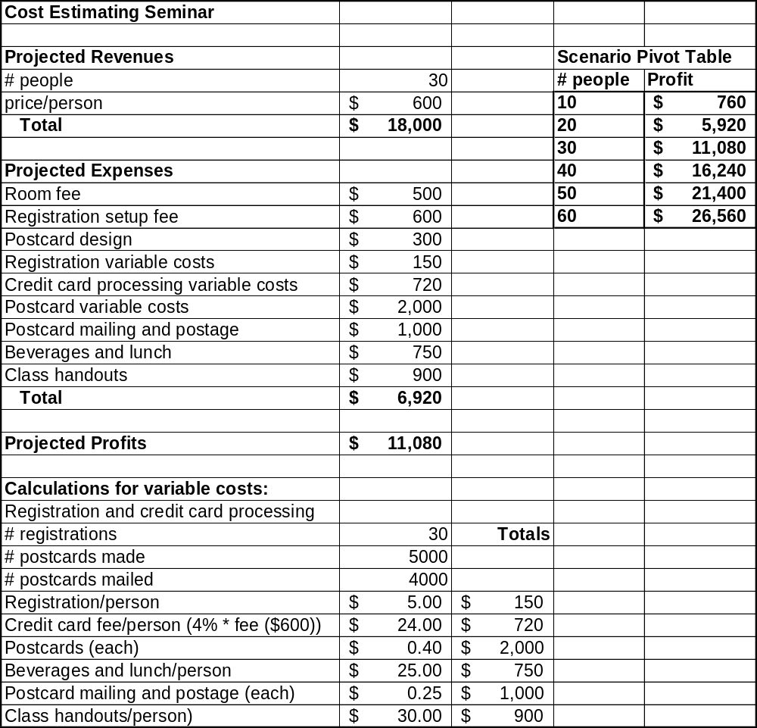
Part 2: Answers will vary. There has been tremendous growth in the number of seminars being offered by various companies, so students should have good justification if they think they offer profitable new seminars.

Chapter 7

Project Quality Management

Learning Objectives

After reading this chapter you will be able to:

- Understand the importance of project quality management and the role of the project manager in assuring quality

- Define quality and how it relates to various aspects of information technology projects

- Discuss quality experts’ view of modern quality management

- Describe what is involved in quality planning, quality assurance, and quality control on projects

- Explain quality control tool and techniques such as Pareto charts, statistical sampling, quality control charts, six sigma, and the seven run rule

- Compare the different types of testing for information technology projects and how they relate to quality

- Describe key issues relating to improving quality in information technology projects

Chapter Outline

Quality of Information Technology Projects
What is Project Quality Management?
Modern Quality Management
Deming
Juran
Crosby
Ishikawa
Taguchi
Feigenbaum
Malcolm Baldrige Award and ISO 9000
Quality Planning
Quality Assurance
Quality Control
Tools and Techniques for Quality Control
Pareto Analysis
Statistical Sampling and Standard Deviation
Quality Control Charts, Six Sigma, and the Seven Run Rule
Testing
Improving Information Technology Project Quality
Leadership
The Cost of Quality
Organizational Influences, Workplace Factors, and Quality
Maturity Models
Software Quality Function Deployment Model
Capability Maturity Model
Project Management Maturity Model

Lecture Notes

Quality of IT Projects

Students enjoy the joke at the beginning of this section. Read it aloud or ask a student to read it. Quality can be a dry subject to teach, so this joke helps to spark student interest. It is also beneficial to read aloud the opening to highlight some of the different issues involved in project quality management and potential reasons for quality problems. The “What Went Wrong” includes several examples of poor quality on information technology projects.

What is Project Quality Management?

Emphasize the key terms in this section⎯quality, conformance to requirements, fitness for use, quality planning, quality assurance, and quality control. Provide examples of how these terms relate to projects you are familiar with. For example, you may have worked on a project that the project team thought was of high quality, but it was not what the customer wanted. Project quality management emphasizes meeting or exceeding customer needs and expectations, so you must focus on understanding the customer's view of quality.

Modern Quality Management

Briefly summarize key contributions made by Deming, Juran, Crosby, Ishikawa, Taguchi, and Feigenbaum. Many students have heard of Deming and Juran. Ask them what they know about these experts’ work on quality management. Also discuss the Malcolm Baldrige Award and ISO 9000, since these are also important aspects of quality management.

Quality Planning

Emphasize the key terms in this section⎯design of experiments, functionality, features, system outputs, performance, reliability, and maintainability.

Quality Assurance

The PMBOK Guide refers to quality assurance as the management section of quality management. The project manager and senior management can have the greatest impact on the quality of projects by establishing a good quality assurance system. Benchmarking and quality audits are key terms in this section.

Quality Control

Plan to spend the most time on quality control and its tools and techniques. Although the focus is on quality control, it is important to emphasize the importance of proper planning and quality assurance to avoid having too much need for rework and process adjustments.

Tools and Techniques for Quality Control

Students always like learning new tools and techniques. Go over the examples in the textbook of Pareto analysis, fishbone diagrams, quality control charts, and testing programs. Most students do not like the material on statistics, but at least explain what standard deviation is. Students enjoy doing Exercise 2 on pg. 223 (rolling a pair of dice to illustrate a normal distribution). Remember to bring a lot of dice to class the day that you cover this topic. Or ask a student to find or write a simple program to let students simulate this activity on the computer for extra credit.

Improving Information Technology Project Quality

Highlight the importance of leadership, understanding the cost of quality, organizational influences on quality, and the use of different maturity models to help improve quality. Tom DeMarco's research on programmer productivity is very interesting (pg. 217-218). Many companies are using or researching different maturity models, so this is an interesting topic to students, as well.

Quick Quiz

- Define quality and what is meant by stated and implied needs.

ANSWER: Quality is the totality of characteristics of an entity that bear on its ability to satisfy stated or implied needs. Stated needs are formally communicated either verbally or in writing. Implied needs mean the product is fit for use or can be used as it was intended.

- Who created fishbone diagrams, and what are they used for?

ANSWER: Ishikawa developed fishbone diagrams, and they are used to trace complaints about quality problems back to the responsible production operations to find the root cause.

- Which is better, 3 sigma, 4 sigma, 5 sigma, or 6 sigma?

ANSWER: 6 sigma. There are less defective units as sigma increases. See Table 7-2 on pg. 209 for the relationship between sigma and the number of defective units.

Discussion Topics

- Provide examples of the cost of quality based on your own personal experience.

ANSWER: Answers will vary, but students can usually think of several ideas once someone gives one example. For example, if someone orders specific equipment (for a computer, kitchen remodeling, or whatever) and the wrong products are delivered, it costs the supplier money to receive and restock the wrong product and provide a new one. It also costs the consumer time to return the item and wait for the correct one. This is an example of an external failure cost.

- Do you think that people accept poor quality in information technology projects and products in exchange for faster innovation? What other reasons might there be for such poor quality?

ANSWER: Answers will vary.

Extra Cases or Case Problems

- Research information on different maturity models, such as the software quality function deployment model, capability maturity model, and the project management maturity model. Write a 2-3 page paper summarizing your findings and your opinion on how these models can improve quality.

ANSWER: Answers will vary. The footnotes on pp. 200-201 provide some references and are repeated here for your convenience:

Yilmaz, R.R. and Chatterjee, Sangit. “Deming and the Quality of Software Development.” Business Horizons, Foundation for the School of Business at Indiana University, 40, No. 6 (November-December 1997): 51 (8).

Humphrey, W.S. Managing the Software Process, Addison-Wesley, Reading, MA 1989.

Paulk, Mark C., Curtis, Bill, Chrissis, Mary Beth and Weber, Charles V.. Capability Maturity Model for Software, Version 1.1, Technical Report, CMU/SEI-93-TR-024, ESC-TR-93-177 (February 1993).

Enterprise Planning Associates, Project Management Maturity Model, Interactive Quick Look (1998).

- Use Project 2000 to create the Gantt Chart shown in Figure 7-7 on pg. 214 for building testing into a systems development project plan.

ANSWER: See in Figure 7-7 on pg. 214.

Teaching Tips

Ask students if they have discussed quality in any of their other classes or at work. Discuss similarities and differences between those other sources of information on quality and what is covered in this textbook. Ask students to discuss whether there are any aspects of quality control and quality management that are unique to project management or information technology.

Further Readings or Resources

Kuprenas, John A. "A Quality Management Case Study: Defects in Spacecraft Electronics Components, Project Management Journal, June 1999, pp. 14-21

Paulk, Mark C. The Capability Maturity Model : Guidelines for Improving the Software Process (SEI Series in Software Engineering), Addison-Wesley, Reading MA, 1995

Team/Group Activities

Exercise 2, on pg. 223, shaking a pair of dice to illustrate a normal distribution, works best in pairs. One student rolls the dice, while the other creates the graph. Students can switch roles after completing 15 rolls of the dice.

Ask students to form groups of 3 to 5 to discuss the questions provided in the textbook or the additional discussion questions listed here. Assign to each group a different question to discuss for about 5 minutes, assign a recorder, and then have the recorders share their group's ideas with the entire class.

Solutions

Discussion Questions

- Discuss some of the examples of poor quality in information technology projects presented in the “What Went Wrong?” section. Could most of these problems have been avoided? Why do you think there are so many examples of poor quality in information technology projects?

Many of these problems could be avoided by performing better quality management. One problem is that software and hardware is hitting the market too fast, so people selling these might be more concerned about money than safety or well being of the consumers or the company in the long term.

- Provide other examples of quality problems in information technology projects and discuss how these quality problems can be avoided.

Answers will vary. A project team can tell if their project has delivered quality if they receive positive feedback from users, meet or go beyond sponsor expectations, improve the company's productivity, or increase their company's profits.

- Discuss how a project team can know if their project delivers good quality.

- Discuss the history of modern quality management. How have experts such as Deming, Juran, Corosby, and Taguchi affected the quality movement?

These experts have made quality a visible criterion that companies strive to achieve. Awards have been established to seek quality and reward those who have achieved it. Quality projects have been used to meet customer expectations instead of only company needs. A wider scope of what quality is and isn't has been developed to provide benchmarking criteria for businesses. Pointing out the cost of poor quality will give motivation to companies and increase their desire for quality. U.S. businesses observed BOTH the emphasis on quality in other nations AND those nations' successes in the marketplace. It was the economic success attributable to the emphasis on quality that made U.S. companies sit up and take notice.

- Provide examples of improving information technology project quality through improved leadership, better understanding of customer requirements, the cost of quality, and improved testing.

Leadership can be improved by having management that is dedicated and enthusiastic about quality and a good work environment. Companies can also improve quality leadership by having a reward system for achieving quality goals. Understanding customer requirements can be improved by using research from customers to make needed changes in systems. Listening to what the customer wants to ensure that you are not providing them with too much or too little will also increase quality. The cost of quality should be lower if you handle your projects correctly the first time. Providing sufficient funds to improve project quality early will help reduce costs in the long run. Organizations can improve testing by developing and following a rigorous testing program throughout the project life cycle.

- What factors did DeMarco and Lister find to be correlated with improving productivity of programmers? Do these findings make sense to you?

Demarco and Lister found that programmer productivity varied by a factor of about one to ten across all participants, but productivity varied by only 21 percent between pairs of software developers from the same organization. They also found no correlation between productivity and the programming language used, years of experience, or salary. Furthermore, they discovered that providing a dedicated workspace and a quiet work environment were key factors in improving productivity. Answers to the second part of the question will vary, but most people are surprised by some of these results.

- Discuss three suggestions for improving information technology project quality that were not made in this chapter.

Answers will vary. Some ideas would be providing better training for people in information technology to produce better quality, providing incentives for meeting quality goals, establishing minimum quality requirements for specific IT products, and so on.

Exercises

Answers to all of these exercises will vary. The exercises, and some possible solutions, are provided here for your convenience.

- Research progress that has been made in improving the quality of information technology projects. Write a 1-2 page paper discussing your findings.

ANSWER: Answers will vary.

- To illustrate a normal distribution, shake and roll a pair of dice thirty times and graph the results. It is more likely for someone to roll a six, seven or eight than a two or twelve, so these numbers should come up more often. To create the graph, use graph paper or draw a grid. Label the x-axis with the numbers two through twelve. Label the y-axis with the numbers one through eight. Fill in the appropriate grid for each roll of the dice. Do your results resemble a normal distribution? Why or why not?

ANSWER: Answers will vary, but the results should have more occurrences of numbers between 5 and 9 and less of the other numbers. One solution from a former student follows:
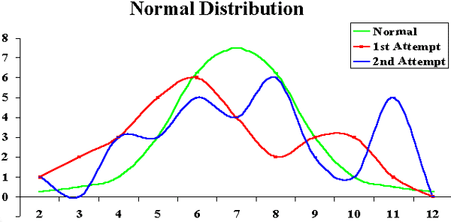

- Research the criteria for the Malcolm Baldrige National Quality Award. Investigate a company other than Motorola that has received this award. What steps did the company take to earn this prestigious quality award? What are the benefits of earning this award?

ANSWER: Answers will vary. The following solution is from a former student.

The Malcolm Baldridge National Quality Award has been created to emphasize quality as a national priority in a competitive world market. Winners are chosen for this award based on seven criteria that thoroughly investigate all companies that apply. The first of the criteria is leadership. This examines how senior executives guide the company as well as how the company addresses its responsibilities to the public by practicing good citizenship. Second is strategic planning which measures how the company sets strategic directions and how it determines key action plans. Customer and Market Focus criteria analyze how the company determines requirements and expectations of customers and markets. Information and Analysis tests management's effectiveness when using and analyzing data and information to support key company processes and the company's' performance management system. Fifth is Human Resource Development and Management. This examines how the company enables its work force to develop its company's objectives. Process Management measures the aspects of how key deliveries, production, and support processes are designed, managed, and improved. Finally, Business Results test the company's performance and improvement in key business areas.

In 1997 3M Dental Products won this prestigious award. 3M built their Dental division according to the standards the Malcolm Baldridge National Quality Award has set. Outstanding effort and achievement in all seven categories of award criteria led 3M's Dental division to its victory.

Leadership was accomplished by a detailed leadership system, which includes a strategic plan process, a business process management matrix, functional and operational reviews and teaming approach, and employee contribution and development plans. Leadership also aligns public responsibility with performance improvement and encourages employees to volunteer with support and recognition.

Strategic Planning at 3M Dental is supported by a "One Global Plan." This plan is developed by employees from branches all around the world to maintain the same focus and goals for all divisions. Strategic Planning is also successful at pulling together vast amounts of data and information for analysis, determining priorities, defining approaches, the assignment of responsibilities, resource allocation, and aligning activities toward 3M's vision.

Customer and Market Focus deal with customer segmentation, listening to the customer, relationship building, leveraging 3M corporate capability, and customer relations. Each of these elements work together to increase dentist usage of 3M products, rather than attracting new audiences. This system also handles all complaints directly and on the spot.

Information and Analysis deals with company information and data as well as company performance and review. The selection and use of company information has four steps: 1) monitor business performance for alignment with strategic planning, 2) identify improvement opportunities, 3) initiate and drive corrective action, and 4) feedback into the Strategic Planning Process. 3M's Customer Information Systems database includes: all purchases of 3M Dental and competitive products, contact activity, complaints by the segment market, and complaints by dentists. Competitive data is kept to aid in benchmarking and foreseeing improvements in performance.

Human Resources use a team approach and education and job satisfaction. The team approach gives employees a comprehensive training and skill development program, fairly designed recruiting programs, and properly established recognition and compensation programs. Education and job satisfaction enables employees to receive the proper schooling or training they feel they need to perform their best.

Process Management has three areas. Product and Services keep a product introduction checklist for each product to help with benchmarking. Management Support surveys internal, external, customer requirements, benchmarking and comparisons, and knowledge of available technology. Supplier Management maintains clear communication of requirements, certifies key suppliers, and provides performance feedback to suppliers.

Business Results have been clear. Because of the organization and quality focus of 3M Dental Products they have been able to deliver their promise, reach high levels of customer satisfaction, have continued financial success, and production efficiency. Each of these being key benefits for the company and the business they provide.

- Research ISO 9000. What is involved in earning ISO 9000 certification? Is it important to have this certification? Why or why not?

ANSWER: Answers will vary. You cannot do business with some organizations if your organization is not ISO-9000 certified.

The following is some information on ISO 9000 and links to related web sites from a former student.

The International Organization for Standardization (ISO) is a worldwide federation of national standards bodies. ISO has developed a series of standards relating to Quality Systems known as the ISO 9000 family standards. The selection and use of these standards is itself a formal standard: ISO 9000-1, entitled Quality Management and Quality Assurance Standards...Guidelines for Selection and Use.
http://www.bawtech.com.au/tp90.htm

How to Earn Certification
Steps needed to earn certification include:
· application to a registrar
· document review -- a review by the registrar of the applicant's quality system documents or quality manual
· pre-assessment to identify potential noncompliance (either by the registrar or through self-assessment)
· assessment, typically by 2 or 3 auditors who spend two to four days, leading to registration, or to a period of remediation, followed by a re-audit
· surveillance -- periodic re-audits to verify conformity with the practices and systems registered.

Feedback from assessment and surveillance processes includes a record of non- conformance with the specific requirements of the standards.
http://www.bawtech.com.au/baldrige.htm

Why is International Standardization Needed?
The existence of non-harmonized standards for similar technologies in different countries or regions can contribute to so-called "technical barriers to trade". Export-minded industries have long sensed the need to agree on world standards to help rationalize the international trading process. This was the origin of the establishment of ISO.

International standardization is well established for many technologies in such diverse fields as information processing and communications, textiles, packaging, distribution of goods, energy production and utilization, shipbuilding, banking and financial services. It will continue to grow in importance for all sectors of industrial activity for the foreseeable future.

The main reasons for standards are:

· Worldwide progress in trade liberalization
Today's free-market economies increasingly encourage diverse sources of supply and provide opportunities for expanding markets. On the technology side, fair competition needs to be based on identifiable, clearly defined common references that are recognized from one country to the next, and from one region to the other. An industry-wide standard, internationally recognized, developed by consensus among trading partners, serves as the language of trade.

· Inter penetration of sectors
No industry in today's world can truly claim to be completely independent of components, products, rules of application, etc., that have been developed in other sectors. Bolts are used in aviation and for agricultural machinery; welding plays a role in mechanical and nuclear engineering, and electronic data processing has penetrated all industries. Environmentally friendly products and processes, and recyclable or biodegradable packaging are pervasive concerns.

· Worldwide communications systems
The computer industry offers a good example of technology that needs quickly and progressively to be standardized at a global level. Full compatibility among open systems fosters healthy competition among producers, and offers real options to users since it is a powerful catalyst for innovation, improved productivity and cost-cutting.

· Global standards for emerging technologies
Standardization programs in completely new fields are now being developed. Such fields include advanced materials, the environment, life sciences, urbanization and construction. In the very early stages of new technology development, applications can be imagined but functional prototypes do not exist. Here, the need for standardization is in defining terminology and accumulating databases of quantitative information.

· Developing countries
Development agencies are increasingly recognizing that a standardization infrastructure is a basic condition for the success of economic policies aimed at achieving sustainable development. Creating such an infrastructure in developing countries is essential for improving productivity, market competitiveness, and export capability.

Industry-wide standardization is a condition existing within a particular industrial sector when the large majority of products or services conform to the same standards. It results from consensus agreements reached between all economic players in that industrial sector - suppliers, users, and often governments. They agree on specifications and criteria to be applied consistently in the choice and classification of materials, the manufacture of products, and the provision of services. The aim is to facilitate trade, exchange and technology transfer through:
· enhanced product quality and reliability at a reasonable price;
· improved health, safety and environmental protection, and reduction of waste;
· greater compatibility and interoperability of goods and services;
· simplification for improved usability;
· reduction in the number of models, and thus reduction in costs;
· increased distribution efficiency, and ease of maintenance.

Users have more confidence in products and services that conform to International Standards. Assurance of conformity can be provided by manufacturers' declarations, or by audits carried out by independent bodies.
http://www.iso.ch/infoe/intro.htm

- Research an information technology project that used a quality tool or technique (robust design, quality audits, Pareto diagrams, statistical sampling, quality control charts, and so on). Write a 1-2 page paper describing the technique and how it was used on the information technology project.

ANSWER: Answers will vary.

MINICASE

Part 1:
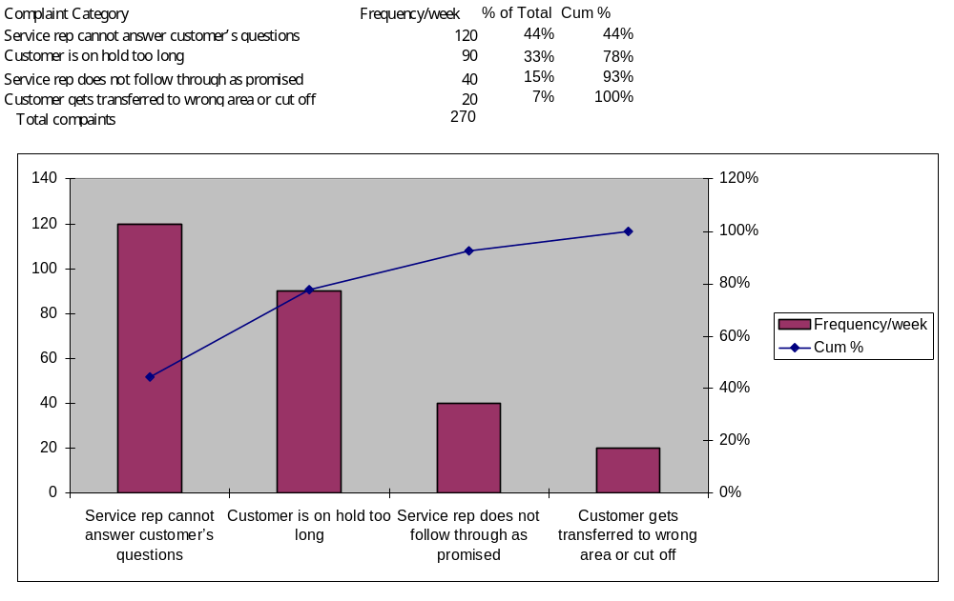
Part 2:
Answers will vary. Possible complaints about the new Web site include the following:
- Customers may want to talk to a service rep instead of looking up information on the Web.
- The Web site may be too hard to navigate.
- The information might be outdated or not what the customer expects.
- The Web site may be too slow to load.
- The Web site url may be too hard to remember.
Possible solutions will vary depending on the complaints listed.

Chapter 8

Project Human Resource Management

Learning Objectives

After reading this chapter you should be able to:

- Explain the importance of good human resource management on projects, especially on information technology projects for which experienced professionals are in high demand

- Define the major processes involved in human resource management

- Summarize crucial theories of human resource management, including the contributions of Abraham Maslow, Frederick Herzberg, and Douglas McGregor on motivation, H. J. Thamhain and D. L. Wilemon on influencing workers, and Stephen Covey on how people and teams can become more effective

- Discuss organizational planning and be able to create a responsibility assignment matrix

- Understand key issues involved in project staff acquisition and explain the concepts of resource loading and resource leveling

- Explain some of the tools and techniques that assist in team building

7. Describe how software can assist in project human resource management

Chapter Outline
Importance of Human Resource Management
Current State of Human Resource Management
Implications for the Future of Human Resource Management
What is Project Human Resource Management?
Keys to Managing People
Motivation Theories
Influence and Power
Improving Effectiveness

Organizational Planning
Issues in Project Staff Acquisition and Team Development
Staff Acquisition
Resource Loading and Leveling
Team Development
Training
Team Building Activities
Reward and Recognition Systems
General Advice on Teams

Using Software to Assist in Human Resource Management

Lecture Notes

Importance of Human Resource Management

This chapter should be fun to cover because there are many different topics involved, and it is less technical than the preceding chapters. It is the first of the four chapters on the facilitating knowledge areas⎯project human resource, communications, risk, and procurement management.

Tell students that although learning the technical aspects of project management is important, problems in the human resource and communications areas often demand the most attention. To further motivate students to do well in this course and their degree programs, highlight the IT labor shortage and the need for good IT project managers.

The opening and closing case are based on a true experience. You could discuss this case and how understanding techniques such as mirroring can help in dealing with people. Note that the author does not recommend yelling at others except in extreme circumstances like this one. The main point is that project managers must learn to deal with all types of people and focus on meeting project and business goals.

What is Project Human Resource Management?

Project human resource management deals specifically with organizational planning, staff acquisition, and team development. Although many topics in this chapter are similar to those covered in courses on human resource management, there are unique aspects of managing people in a project environment, such as resource loading and resource leveling.

Keys to Managing People

Although some items in this section may be a review to students, it is still important to analyze and discuss motivation theories, influence, power, and improving effectiveness. Not all students have had psychology or other courses that cover these topics, and there are some unique aspects of project management that make for interesting discussion. The “What Went Right?” on pg. 242 provides information on effective practices for ensuring partnerships between people in business and technology areas. Many students have heard of Covey's seven habits, but few have read his books. You might want to make The 7 Habits of Highly Effective People a required additional reading for the course or choose another book that highlights the “people side” of project management. In general, students in IT fields do not take many courses related to people issues.

Organizational Planning

Most students are familiar with organizational charts, but few have seen project organizational charts or heard of a responsibility assignment matrix. Review examples of these matrixes, such as the ones provided in Figures 8-4 and 8-5. Also discuss the sample resource histogram in Figure 8-6 and how this tool helps to ensure adequate staffing on projects. You may want to show a simpler resource histogram and stack the bars to show the total number of people needed for each time period.

Issues in Project Staff Acquisition and Team Development

Resource loading and leveling are important concepts in project human resource management. Most students can understand resource loading and interpret a resource histogram. Resource leveling, on the other hand, is more challenging to explain and understand. Discuss Figure 8-8 in class. Because of their familiarity with the Tetris game, most students are able to understand the goal of resource leveling. Make sure they understand that the project network diagram is a key input to resource leveling.

Team development should also be reviewed and discussed. If time permits, have students take the Myers-Briggs Type Indicator (MBTI) test. A free web-based version of this instrument is available from http://www.keirsey.com and several other sites. Several other instruments are available to help people better understand themselves and their teammates but the MBTI is currently the most popular. The social styles profile is also fairly popular. Share your experiences with team building exercises and your opinions of their helpfulness.

Using Software to Assist in Human Resource Management

Demonstrate some of the human resource features of Project 2000. Appendix A includes a section on human resource management. It features an example of using Project 2000 to create resource histograms and to assist with resource leveling. Most Project 2000 users, however, do not use the cost or human resource management features of Project 2000. Spreadsheets or other software are commonly used for project human resource management.

Quick Quiz

- Give an example of a hygiene factor, according to Herzberg.

ANSWER: Answers could include a more attractive work environment, training, or fringe benefits such as a good parking space or casual dress, and so on. Herzberg also says that money is a hygiene factor.

- What type of chart is used to show resource loading?

ANSWER: A histogram

- What do the letters RAM stand for as they relate to project human resource management?

ANSWER: Responsibility Assignment Matrix

- What ways to have influence are correlated with successful projects?

ANSWER: Expertise and work challenge

Discussion Topics

- Discuss the “What Went Wrong?” example on p. 244. Which organizational culture do you think is most common, or are both pretty extreme? In general, do you think there are too many managers and support staff on IT projects and not enough people who do the actual programming? Why or why not?

ANSWER: Both of these examples provide extreme scenarios. Smaller companies or projects often seem to be leaner and have fewer managers and support staff than larger companies or projects. In many organizations, line workers (such as programmers or faculty) feel there are not enough people in their positions and too many people in management or other staff positions.

- What do you think is more important for a good IT professional: strong technical skills or strong people skills?

Answers will vary. Some degree of technical competence is required to get into the IT field, but it is often a demonstration of strong people skills that enable people to advance in their careers.

Extra Cases or Case Problems

- Seven habits: Read Stephen Covey's The 7 Habits of Highly Effective People. Write a 2-3 page paper summarizing Covey's main points. Discuss how these habits can be or could have been used to improve the effectiveness of a project with which you are familiar.

ANSWER: Answers will vary. A brief summary of Covey's seven habits is found on pp. 240-241.

- Team building activities: Research team building activities. A web search on "team building" or "behavioral styles" should provide several references. Write a 2-3 page paper summarizing your findings.

ANSWER: Answers will vary.

Teaching Tips

Students usually can relate to the opening case in this chapter. Have a student read the opening case aloud to illustrate an example of how mature, well-educated adults can act in a childish fashion. This case is based on a true story. Ask students what they think happened.

Depending on how much time you have in your course, require an additional reading related to the people side of project management. The suggested readings in the textbook and in the further readings or resources provide several ideas.

Further Readings or Resources

DeMarco, Tom and Timothy Lister. Peopleware: Productive Projects and Teams, Dorset House Publishing Co., New York, 1999

Carbno, Collin. Optimal Resource Allocation for Projects, Project Management Journal, June 1999, pp. 22-31

Team/Group Activities

- Have students take the MBTI, then divide them into groups of four to discuss their profiles and how they might use this information if they were to work together on a project. If students are doing group projects as part of class, use their project groups for this discussion.

- Have students form pairs or small groups to review the Appendix A section on using Project 2000 for human resource management.

Solutions

Discussion Questions
Answers to all of these questions will vary, but most summarize key points found in the textbook.

1. Discuss the evidence pointing to a shortage of information technology workers. Why are there not more students majoring in computer science or MIS if there is such a labor shortage? Speculate about whether the information technology labor shortage will continue in the near future.
Answers will vary. Several statistics on the IT labor shortage are provided in the textbook, but new data should be available. The ITAA web site (www.itaa.org) provides updated information on IT workforce issues. For example, the following information was provided on their web site as of 8/25/99.

"ITAA has been the leader in focusing national attention on the IT skills gap," said ITAA President Harris Miller. "Our 1998 study found a shortage of 346,000 programmers, systems analysts and computer scientists. Validation of this research can be found in the recently released 1999 Staffing and Compensation Guide by the Meta Group, which estimates the vacancy rate at 400,000 for these same positions."

- Briefly summarize the work done by Maslow, Herzberg, McGregor, Ouchi, Thamhain and Wilemon, and Covey. How do their theories relate to project management?

The textbook provides information on Maslow, Herzberg, McGregor, Ouchi, Thamhain, Wilemon, and Covey to provide the basis for answers. Answers will vary on how these theories relate to project management.

- Give examples of different ways to have influence on projects. Which do you think would be most effective with you?

Thamhain and Wilemon suggested nine ways to have influence on projects – authority, assignment, budget, promotion, money, penalty, work challenge, expertise and friendship (pg. 238 of the textbook). Everyone is affected differently by these ways to have influence, but studies have found that work challenge and expertise are correlated with successful projects.

- Describe the work definition and assignment process.

See pp. 245-246 for information describing the work definition and assignment process.

- Discuss key issues related to staff acquisition and team building.

Some issues related to staff acquisition and team building include problems in recruiting and retaining good people, the need for training, personality conflicts between teammates, slackers on teams, and so on.

- How could you use resource loading and resource leveling to ensure that a project runs smoothly?

Resource loading helps you see what people are scheduled to work on projects and when they are scheduled to work. Resource leveling helps you to smooth out resource allocations. Both of these techniques make it easier to manage human resources.

Exercises
Answers to all of these exercises will vary. The exercises, and some possible solutions, are provided here for your convenience.

- Develop a responsibility assignment matrix for building a new state-of-the-art multimedia classroom for your university. Assume the faculty in the Computer Science/MIS Department received a grant to lead this project. The grant includes funds for all of the hardware and software plus some money for faculty and student labor. Also assume the university must match the funds provided by the granting agency. Key stakeholders are faculty who might use the facility, students, the Dean, the head of facilities, the head of finance, and the head of information technology. Major activities might include deciding where to put the classroom, defining the classroom configuration (number and type of computers, projections system software, layout, and so on), writing a request for proposal, evaluating proposals, overseeing the winning contractor, obtaining matching funds from the college, surveying faculty and students on the use of the classroom, providing training on using the classroom, and scheduling use of the classroom. Use the responsibility matrix in Figures 8-4 and 8-5 as models.

ANSWER:

Key Activities for the multimedia classroom project:
- Deciding where to put classroom
- Defining classroom configurations
- Writing a RFP
- Evaluating Proposal
- Overseeing Contractor
- Obtaining matching funds from college
- Surveying faculty and students
- Providing training
- Scheduling use of classroom

Responsibility Assignment Matrix (RAM)

OBS
MIS Students | 1.1 | 1.2 | 1.3 | 1.4 | 1.5 | 1.6 | 1.7 | 1.8 | 1.9
Shelley | P |  | P |  |  |  | A | P
Shanda | P |  | P |  |  |  | A | P
Christian | P |  | P |  |  | P | A
Chad | P |  | P |  |  | P | A

IT Faculty
Schwalbe | PR | I | R |  |  |  | IR | A | P

Staff
Head of Finance |  | RS |  | S |  | A
Head of Facilities | A | IR |  |  | A
Head of IT | PR |  | A |  | P | P | R | A | A
Deans |  | IS |  | A |  | S
A = Accountable P = Participant
R = Review Required I = Input Required S = Sign-off Required

- Research recent work on what motivates workers, especially in information technology. Summarize at least three articles on this.

ANSWER: Answers will vary.

- Read Douglas Ross’s article “Applying Covey’s Seven Habits to a Project Management Career” (see Suggested Readings). Summarize three of Covey’s habits in your own words and give examples of how these habits would apply to a project you are familiar with.
ANSWER: Answers will vary. One possible solution is provided here:

Begin with the end in mind.
It is helpful before starting a project to visualize the end results. A clear picture of the finished product will keep the group motivated. It would be hard to work on a project for which the end is not in sight.
By using software, such as Microsoft Project 98, our group assigned tasks and milestones that kept us motivated. We visualized the development of the Web page and the final presentation, even before our work began.

Put first things first.
A project team must keep in mind the large aspects of a project, but they have to be aware of the smaller tasks as well. It is helpful to establish the lesser tasks, (reading, discussion questions, and exercise questions) after the greater ones (WBS, Gantt chart, web page, final presentation) have been dealt with.
Our group divided the project into manageable elements by separating and assigning one chapter per group member. Then, each chapter was further divided into discussion questions and exercise questions. The discussion and exercise questions were assigned completion dates at group meetings.

Think win/win.
Typically, group members all want to be successful. Each person has his/her own motivation, but an overall motivation for the project team must also be highlighted. The group has to work together to achieve a win/win solution.

- Research recruiting and retention strategies at three different companies. What distinguishes one company from another in this area? Are strategies such as signing bonuses, tuition reimbursement, business casual dress codes, and so on standard for new information technology workers? What strategies appeal most to you?

ANSWER: Answers will vary. One possible solution is provided here:

Open Systems Accounting Software, Inc. Shakopee, MN
www.osas.com
Recruiting:
Hiring from within the company.
Bonuses are given to current employees who recommend family, friends, or other interested parties. A $1,000 bonus is given after the potential employee is employed 90 days.
Periodicals are used to advertise openings.
Resumes are accepted all the time via direct mail or the World Wide Web.

Retention:
Promotions
Promotions are given after furthering education (MBA).
Bonuses
Competitive salary
Tuition reimbursement
Casual dress code

West Publishing, Eagan, MN
www.westgroup.com
Recruiting:
Word of mouth
World Wide Web
Job Fair
Intern program
Hiring from within the company

Retention:
Competitive salary
Tuition reimbursement
Summer season casual dress code
Bonuses
Promotions

US Bank Corp Piper Jaffrey
www.usbankcorp.com
Recruiting:
Job Fair
Recruit from within
Intern programs
Well known training program
Retention:
Benefits
401k
Health Care
Stock Options
Training
Promotions
First year contract
Tuition reimbursement

Appealing Strategies:
Tuition reimbursement
All Benefits
Training
Ability to move around in the company
Promotions
Casual dress code
Profit sharing

- Write a paper summarizing the main features of Microsoft Project 2000 that can assist project managers in human resource management. Include your opinion on the usefulness of specific features.

Answers will vary. Appendix A contains a whole section on this topic. Most students don’t realize how much you can do with human resource management in Project 2000.

MINICASE

Part 1:
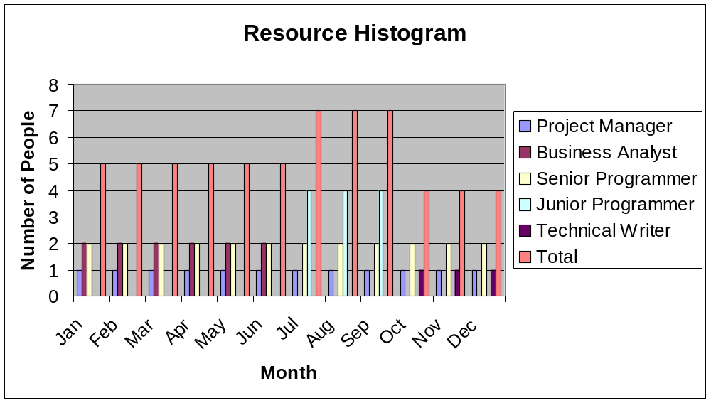

Part 2:
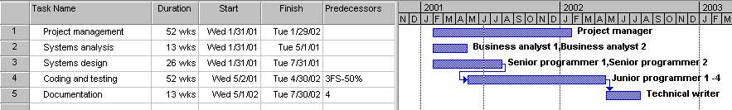

Chapter 9
Project Communications Management

Learning Objectives

After reading this chapter you will be able to:

- Understand the importance of good communication on projects and describe the major components of a communications management plan

- Discuss the elements of communications planning, including information distribution, performance reporting, and administrative closure

- Discuss various methods for distributing project information and the advantages and disadvantages of each

- Understand the relationship between the number of people involved in a project and the complexity of communications

- Discuss sources of conflict on projects and strategies for managing them

- Understand important aspects of verbal, non-verbal, and written communication and how to develop these skills

- Describe various types of project documentation and understand the value of using templates for aiding in project communications

- Describe how software can enhance project communications

Chapter Outline
Importance of Project Communications Management
Communications Planning
Information Distribution
Using Technology to Enhance Information Distribution
Formal and Informal Methods for Distributing Information
Determining the Complexity of Communications
Performance Reporting
Administrative Closure
Suggestions for Improving Project Communications
Using Communication Skills to Resolve Conflict
Developing Better Communication Skills
Running Effective Meetings
Using Templates for Project Communications
Developing a Communications Infrastructure
Using Software to Assist in Project Communications

Lecture Notes

Importance of Project Communications Management
Bring a copy of a cartoon (such as Dilbert) making fun of how poorly many technical people communicate. You cannot overemphasize how important it is to have good communications on projects. As discussed in Chapter 8, Project Human Resource Management, every person is unique in what motivates him or her. Everyone is also unique in how they communicate. Information technology professionals are not known for being particularly strong communicators, but stress that communication skills are critical and can definitely be developed. Most people agree that it is their communications skills that help them advance the most in their careers. Interviewers are often looking for communications skills at job interviews.

If students are doing group projects as part of the course, suggest that they read this chapter very early in the course. The chapter includes several samples and templates students can use for group projects.

Communications Planning
Most people have not heard of a communications management plan. Review the main components of this plan. It is also important to analyze project stakeholders' communications needs and preferences. Show the sample stakeholder analysis for project communications in Table 9-1.

Information Distribution
Students should be familiar with the topics in this section. Discuss various methods for distributing project information, using different forms of technology, and using informal and formal information distribution. Table 9-2 on p. 277 provides interesting information on when to use different communications media. Discuss your own experiences with how you send and receive project-related information.

It is often assumed that adding more people to a project will automatically help accomplish more work. Discuss the issue of the complexity of communications as the number of people involved in a project increases. Review the formula for determining the number of communications channels ((n(n-1))/2). Figure 9-2 illustrates this concept. If students have had a data communications and networks class, they should be familiar with this formula.

Performance Reporting
Stress the importance of performance reports and status review meetings in project management. Remind students of some of the topics discussed in Chapter 3, Project Integration Management, such as how important it is to align projects with organizational goals and to have top management support. Holding status review meetings is a powerful tool for accomplishing both, as well as an effective way to keep all stakeholders informed of what is happening on the project. Explain the difference between status reports, progress reports, and project forecasting. Remind students that earned value analysis is a tool for showing progress in terms of meeting project scope, time, and cost goals and can be used to estimate completion time and cost.

Administrative Closure
Administrative closure is done poorly on many projects. Stress how important it is to prepare project archives, obtain formal acceptance of projects, and document lessons learned on projects. You could use the analogy of completing a course. Students often write a final project report to archive what they have done; the instructor determines acceptance by assigning grades; and students should be required to document what they learned from the project or course.

Suggestions for Improving Project Communications
Several ideas are presented here, such as how to resolve conflict, develop better communication skills, run effective meetings, use templates for project communications, and develop a communications infrastructure. If students plan to take the PMP certification exam, make sure they understand the various conflict resolution modes. If students are doing group projects, point out the many templates provided in this section.

Using Software to Assist in Project Communications
Summarize the different types of software that can assist in project communications⎯e-mail, the Web, workgroup software, Project 2000, mobile computing software, and so on. Review some Project 2000 features, such as inserting comments and hyperlinks by specific project tasks and saving files as html documents, as described in Appendix A. Also mention the importance of keeping the latest project information up-to-date and avoiding information overload by using too much technology.

Quick Quiz

- What is the formula for determining the number of communications channels?

ANSWER: number of communications channels = (n(n-1))/2

- Which mode for handling conflicts is favored by project managers?

ANSWER: Confrontation mode, which is also known as problem-solving mode.

- What is the difference between a status report and a performance report? Give an example of each.

ANSWER: A status report describes where the project stands at a specific point in time. An earned value analysis is an example of a status report. A progress report describes what the project team has accomplished during a certain period of time. A weekly activity report is an example of a progress report.

Discussion Topics

- The concept of a communications management plan makes logical sense, yet many projects do not create or follow this type of plan. Why do you think this is the case?

ANSWER: Answers will vary. People may not know about creating this type of plan; organizations might assume that they would just continue using their normal communications approaches; or people might assume that the information is too obvious to document it in a formal plan.

- Which skills do you think are more important for information technology project managers to possess at various points in their careers⎯strong technical skills or strong communications skills?

ANSWER: Answers will vary. Most people would choose strong communications skills, assuming technical skills are adequate. Many project managers start by having stronger technical skills than communications skills and advance most by improving their communications skills. Other people became project managers because they were naturally good communicators, but they needed to develop their technical skills to manage larger or more technical projects.

Extra Cases or Case Problems

- Research information on conflict management. Write a one- to two-page paper describing at least three suggestions for dealing with conflicts. Include at least one outside reference and your opinion on this subject.

ANSWER: Answers will vary.

- Recreate the Gantt chart template for a class project shown in Figure 9-3 on p. 290. Include hyperlinks as shown, and create brief Word files, using the filenames indicated in the hyperlink column.

ANSWER: A hardcopy is shown in Figure 9-3 on p. 290. You can download this file and other templates from this chapter from the author’s web site.

Teaching Tips

If students are working on group projects, have them at least skim this chapter early in the course. Ask students to describe problems they have had communicating on past or current projects. Provide a way for students to share problems with you, without upsetting their classmates. For example, include a group and self-assessment for the group project and have each person allocate points to all team members. Have them reflect on what they could have done differently to improve project communications.

Further Readings or Resources

Laborde, Genie. Influencing with Integrity, Syntony Publishing, Palo Alto, CA, 1987

Siegel, David. Secrets of Successful Web Sites: Project Management on the World Wide Web, Hayden Books, 1997

Team/Group Activities

- Improving Project Communications: Divide students into groups of three to five to share examples of projects on which they have worked in which communications were good and some in which communications were not so good. Have them develop a list of five to ten things to do and five to ten things not to do to help improve communications. Assign a recorder to share the group's ideas with the entire class.

- Project Templates: Divide students into groups of three to five to work on Exercise 3, for which they pick a template provided in the chapter, apply it to a project, and make suggestions for improving the template. If students are working on a group project as part of the class, have them apply a template to that project.

Solutions

Discussion Questions

- Discuss examples of media that poke fun at the communications skills of technical professionals. How does poking fun at technical professionals’ communications skills impact the industry and educational programs?

ANSWER: Dilbert provides a great example of media poking fun at the poor communications skills of technical professionals. Some people argue, however, that this may cause people to shy away from entering a technical profession. Many educational programs still focus primarily on technical courses, although some have realized the need to require more speaking, writing, and listening skills as part of technical degree requirements.

- What are the key components of a project communications plan? How can a stakeholder analysis assist in preparing and implementing parts of this plan?

ANSWER: A project communications plan includes the following components:
- a description of a collection and filing structure for gathering and storing various types of information
- a distribution structure describing what information goes to whom, when it goes, and how it goes
- a format for communicating key project information
- a production schedule for producing the information
- access methods for obtaining the information
- a method for updating the communications management plan as the project progresses and develops
- a stakeholder communications analysis.

A stakeholder analysis shows which stakeholders should get which written communications and in what format. Stakeholders should assist in determining this information by clarifying their specific communications needs.

- Discuss the advantages and disadvantages of different ways to distribute project performance information.

ANSWER: Answers will vary. Electronic communications are often useful when it is important to send information quickly to a large group of people. Face-to-face communications are important for developing relationships and trust with project stakeholders. Formal written communications are important for documenting legal and other crucial information. Verbal communications are very important for many people who prefer to communicate verbally and ask specific questions rather than read information.

- What are some of the ways to create and distribute project performance information?

ANSWER: Project performance information can be distributed verbally, in written format, via e-mail, via the web, formally, and informally.

- Do you agree with some of the suggestions provided for improving project communications? What other suggestions do you have?

ANSWER: Answers will vary.

- How can software assist in project communications? How can it hurt project communications?

ANSWER: Answers will vary. Software can assist in project communications by helping to create and distribute project information. Project 2000 has several features to enhance project communications, and many other tools are available. Software can hurt project communications if people rely too heavily on using software alone to communicate. It is very important to have meetings and informal communications on projects, too.

Exercises
Answers to all of these exercises will vary. The exercises, and some possible solutions, are provided here for your convenience.

- Create a stakeholder analysis for project communications. Assume your organization has a project to determine employees’ training needs and then provide in-house and external sources for courses in developing communications skills for its employees. Stakeholders could be various levels and types of employees, vendors, the HR Department in charge of the project, and so on. Determine specific stakeholders for the project. List at least one type of project communications for each stakeholder and the format for disseminating information to each. Use Table 9-1 as an example.

ANSWER: Answers will vary. One possible solution is provided below.

Stakeholders | Document Name | Document Format | Contact Person | Due
Training Manager | Weekly Status Report | E-mail | Bobby Matthews | Start of week
Project Manager | Weekly Status Report | Hard Copy | Brady Lilly | Start of week
HR Management | Monthly Status Report | Hard Copy | Chelsea Homan | 1st of month
Executive Management | Monthly Status Report | Hard Copy | Nick Vanderhyden | 1st of month
IT Director | Monthly Status Report | Intranet | Alexis Jones | 1st of month
Teaching Subcontractor | Implementation of Course Skills | E-mail | Lori Lohman | 8/1/03
Training Subcontractor | Training Plan | Hard Copy | Karen Penkar | 7/1/03

- How many different communications channels does a project team with six people have? How many more channels would there be if the team grew to ten people?

ANSWER: Number of communications channels = (n(n-1))/2. For 6 people, there would be (6(6-1))/2 =15 communications channels. If the team grew to 10 people, there would be (10(10-1))/2=45 communications channels.

- Review the templates for various project documents provided in this chapter. Pick one of them and apply it to a project of your choice. Make suggestions for improving the template.

ANSWER: Answers will vary.

- Write a lessons learned report for a project of your choice using Table 9-7 as a guide. Do you think it is important for all project managers and team members to write lessons learned reports? Would you take the time to read them if they were available in your organization?

ANSWER: Answers will vary. It is important to write a lessons learned report to help yourself and others learn from past projects to do a better job on future projects.

- Research software products that assist in managing large projects. Write a 1-2 page paper summarizing your findings. Include Web sites for software vendors and your opinion of some of the products.

ANSWER: Answers will vary.

- Write a 1-2 page paper summarizing one of the suggested readings.

ANSWER: Answers will vary.

MINICASE

Part 1: Answers will vary. Some of the survey questions might include the following:

On a scale of 1-5 with 1 being the lowest and 5 the highest, rate the following requirements for a project Web site:
- Loads quickly
- Easy to navigate
- All team members can access all information
- Security controls access to and updating of information
- Site can only be accessed by project team
- Site can be accessed by others
- Site includes downloadable template files
- Site is updated daily
- Site is updated weekly
- Site contains links to useful sites

There can also be several open-ended questions concerning security, content, maintenance etc.

Part 2: Solutions should resemble Table 9-8. Below is a sample of a more creative project web site from former students. Note how the home page resembles a physical project notebook. More student project web sites are available from my personal web site.

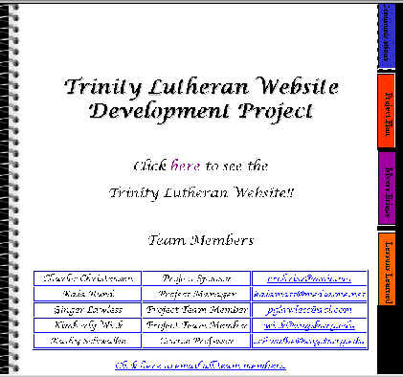

Chapter 10
Project Risk Management

Learning Objectives
After reading this chapter you will be able to:

1. Understand the importance of good project risk management
2. Understand what risk is and describe different tolerances for risk
3. Describe each of the processes involved in project risk management, including risk management planning, risk identification, qualitative risk analysis, quantitative risk analysis, risk response planning, and risk response control
4. Identify common sources of risk on information technology projects and develop strategies for reducing them
5. Describe common risk conditions that occur in each project management knowledge area and techniques for identifying potential risks on specific projects
6. Use tools and techniques for qualitative risk analysis, such as probability/impact matrices and the Top 10 Risk Item tracking approach, and quantitative risk analysis, such as expected monetary value and simulation.
7. Describe how software, such as Monte Carlo simulation software, can assist in project risk management
8. Explain the results of good project risk management

Chapter Outline
The Importance of Project Risk Management

Risk Management Planning
Common Sources of Risk on Information Technology Projects
Risk Identification
Qualitative Risk Analysis
Calculating Risk Factors Using Probability/Impact Matrixes
Top 10 Risk Item Tracking
Expert Judgment
Quantitative Risk Analysis
Decision Trees and Expected Monetary Value
Simulation
Risk Response Planning
Risk Monitoring and Control
Using Software to Assist in Project Risk Management
Results of Good Project Risk Management

Lecture Notes

Importance of Project Risk Management
Many people ignore risk management on projects, and a few people over emphasize it. Define risk, risk utility or risk tolerance, and the difference among people who are risk-averse, risk-seeking, and risk-neutral. Emphasize that risk management should be done during the entire project life cycle. It is especially important to consider risk when selecting projects to work on, as illustrated in the opening and closing case.

Note the study results in Table 10-1 pointing out that most industries are least mature when it comes to project risk management. Also note that this knowledge area has changed a fair amount from the 1996 edition of the PMBOK Guide.

Risk Management Planning
Emphasize the importance of creating a risk management plan for projects when it makes sense to do so. Table 10-2 includes questions addressed in a risk management plan. Give examples of contingency plans, fallback plans, and contingency reserves.

Common Sources of Risk on Information Technology Projects
Several studies show common sources of risk. Table 10-3 highlights the importance of user involvement, executive management support, and clear requirements in order to reduce risk on information technology projects. Describe projects you have worked on and what risks they faced.

Risk Identification
Discuss potential risks by knowledge area, as described in Table 10-5. Also describe the tools and techniques for identifying risks such as information-gathering techniques, checklists, and diagramming. Remind students that fishbone diagrams (from Chapter 7, Project Quality Management) can also be used to help in identifying potential risks.

Qualitative Risk Analysis
Emphasize the importance of considering the likelihood of an identified risk occurring and its impact if it does occur. Give examples of using a probability/impact matrix. The example in the text is from a real project, but it may be too complicated for some students to understand. You could have the class identify potential risks for getting a good grade in your class, then put each item on a chart where the x-axis is the impact of the risk occurring and the y-axis is the probability of the risk occurring. Also discuss the Top 10 Risk Item Tracking tool and mention that Microsoft uses this tool in their Solutions Framework. Remind students of the importance of consulting experts to help in qualitative risk analysis, too.

Quantitative Risk Analysis
Plan to spend some time reviewing different methods for quantifying risk. Students who are strong in math will like this section, and students who are less inclined towards math may be intimidated by some of the techniques presented. Explain the concept of decisions trees and determining the expected monetary value (EMV) of a project. Figure 10-3 provides a good example of how to calculate EMV. Stress that calculations are done from left to right, and the probabilities for outcomes must add up to one. Give students a few minutes to practice using EMV in class. You could do Exercise 4 in the textbook or the extra case provided in this instructor's manual.

Review other risk quantification methods such as PERT estimations, and simulation. Monte Carlo simulation is an important concept, but students may have a difficult time understanding it. Figures 10-4 and 10-5 in the section on using software to assist in project risk management provide examples on how to use and interpret the results of a Monte Carlo simulation.

Risk Response Planning
Explain the difference between risk avoidance, risk acceptance, risk transference, and risk mitigation. Table 10-8 provides general mitigation strategies for technical, cost, and schedule risks on projects. Discuss items included in a risk response plan, including residual risks and secondary risks.

Risk Monitoring and Control
Discuss the importance of responding to risk events. Also emphasize that risk management is an on-going activity performed by the entire project team throughout the entire project.

Using Software to Assist in Project Risk Management
Discuss some of the different software tools that can assist in project risk management. Remind students what PERT estimates are and then suggest Monte Carlo simulation as a better method for using probabilistic estimates. If you have any risk analysis software, you could demonstrate how to use it. Demonstrating risk analysis software might not be appropriate, however, for an undergraduate class, as it may be too advanced for them to understand it.

Results of Good Project Risk Management
Briefly discuss that although good project risk management is very important, good crisis management sometimes receives more attention. An outstanding project manager and team will perform good project risk management in order to avoid needing to attend to crises.

Quick Quiz

- What are the most important success criteria for information technology projects, according to the Standish Group?

ANSWER: User involvement, executive management support, and a clear statement of requirements.

- If a project has a 50 percent probability or making $100 and a 50 percent probability of making no money at all, what is its expected monetary value?

ANSWER: $50

- What does risk mitigation mean? Provide an example of how to mitigate risk on a project.

ANSWER: Risk mitigation means reducing the impact of a risk event by reducing its probability of occurrence. An example of mitigating risk on a project would be to assign a very experienced project manager to a project to mitigate the risk of poor management.

Discussion Topics

- Read the opening and closing case. What would you do if you were Cliff? What would you do if you worked for Cliff?

ANSWER: Answers will vary. How students respond depends on their own risk tolerance.

- Discuss the last sentence in this chapter on pg. 329 before the Case Wrap-up. Do you think project managers should strive to make their jobs look easy? Justify your answer.

ANSWER: Answers will vary.

Extra Cases or Case Problems

- Write a 1-2 page paper explaining the three basic responses to risk⎯avoidance, acceptance, transference, and mitigation. Provide an example of each response based on your personal experiences.

ANSWER: Answers will vary. Pg. 323-324 describes the three responses to risk as follows:

Risk avoidance involves eliminating a specific threat or risk, usually by eliminating its causes. Of course all risks cannot be eliminated, but specific risk events can be. For example, a project team may decide to continue using a specific piece of hardware or software on a project because they know it works. Other products that could be used on the project may be available, but if the team is unfamiliar with them, they could cause significant risk. Using familiar hardware or software eliminates this risk.
Risk acceptance means accepting the consequences should a risk occur. For example, a project team planning a big project review meeting could take an active approach to risk by having a contingency or backup plan if they cannot get approval for a specific site for the meeting. On the other hand, they could take a passive approach and accept whatever facility their organization provides them.

Risk transference is shifting the consequence of a risk and responsibility for its management to a third party. A project may have expensive equipment and decide to take out insurance for the equipment, thus transferring the risk to the insurance company.
Risk mitigation involves reducing the impact of a risk event by reducing the probability of its occurrence. Suggestions for reducing risks related to common sources of risk on information technology projects were provided at the beginning of this chapter. Other examples of risk mitigation include using proven technology, having competent project personnel, and using various analysis and validation techniques.

- Suppose you are deciding which of two projects to work on. Project 1 has a 70 percent chance of earning $500,000 and a $30 percent chance of losing $100,000. Project 2 has a 20 percent chance of earning $2 million, a 20 percent chance of earning $1 million, and a 60 percent chance of losing $500,000. What is the EMV for each project? Which project would you rather work on?

ANSWER: Project 1: 70% * $500,000 – 30% * $100,000 = $320,000
Project 2: 20% * $2,000,000 + 20% * $1,000,000 – 60% * $500,000 = $300,000.

The EMV for Project 1 is slightly higher than the EMV for Project 2, but Project 1 has a much higher chance of earning money. Individual risk tolerance would play a role in choosing between these projects.

Teaching Tips

If your school has Monte Carlo simulation software, it would be most effective to run it in class (or ask a student to run it) to help the class understand how this software works. The Top 10 Risk Item Tracking is much easier to understand than Monte Carlo simulation. Depending on the nature of your class, you should decide how much to emphasize the quantitative aspects of project risk management. If students are preparing for the PMP exam, they should know how to do the EMV calculations.

Further Readings or Resources

www.projectgear.com, the web site for ProjectGear, Inc. maker of Risk+ software, an add-on for Project 2000

www.sei.cmu.edu, the web site for the Software Engineering Institute, which has several articles on project risk management and other topics related to project management

Team/Group Activities

- Estimated monetary value: Have students pair up to work on Exercise 4 in the textbook to calculate EMV.

- Determining personal risk tolerance: Divide students into groups of three to five to discuss what they believe to be their own personal tolerance for risk. After students pick the category they believe they fall under (risk-seeking, risk-averse, or risk-neutral), have them create a list of criteria to help determine risk tolerance. For example, they could list five to ten questions and determine risk tolerance based on the answers. The group could also research the availability of tools that help determine risk tolerance. Many financial planners offer such tools.

Solutions

Discussion Questions

- Discuss the risk utility function and risk preference chart in Figure 10-1. Would you rate yourself as being risk-averse, risk-neutral, or risk-seeking? Give examples of each approach from different aspects of your life, such as your current job, your personal finances, romances, and eating habits.

ANSWER: Answers will vary.

- What is your organization’s (your employer’s or your college’s) risk preference when it comes to information technology projects? Give evidence to support your position.

ANSWER: Answers will vary.

- Discuss the common sources of risk on information technology projects and suggestions for managing them. Which suggestions do you find most useful? Which do you feel would not work in your organization? Why?

ANSWER: Answers will vary. Tables 10-1 and 10-3 provide some potential risk conditions. These tables are shown here for your convenience.

Table 10-1. Information Technology Success Potential Scoring Sheet
Success Criterion | Points
User Involvement | 19
Executive Management support | 16
Clear Statement of Requirements | 15
Proper Planning | 11
Realistic Expectations | 10
Smaller Project Milestones | 9
Competent Staff | 8
Ownership | 6
Clear Visions and Objectives | 3
Hard-Working, Focused Staff | 3
Total | 100

Table 10-3. Potential Risk Conditions Associated with each Knowledge Area
Knowledge Area | Risk Conditions
Integration | Inadequate planning; poor resource allocation; poor integration management; lack of post-project review
Scope | Poor definition of scope or work packages; incomplete definition of quality requirements; inadequate scope control
Time | Errors in estimating time or resource availability; poor allocation and management of float; early release of competitive products
Cost | Estimating errors; inadequate productivity, cost, change, or contingency control; poor maintenance, security, purchasing, etc.
Quality | Poor attitude toward quality; substandard design/materials/workmanship; inadequate quality assurance program
Human Resources | Poor conflict management; poor project organization and definition of responsibilities; absence of leadership
Communications | Carelessness in planning or communicating; lack of consultation with key stakeholders
Risk | Ignoring risk; unclear assignment of risk; poor insurance management
Procurement | Unenforceable conditions or contract clauses; adversarial relations

- Describe the Top 10 Risk Item Tracking approach. How could you use this technique in your organization?

ANSWER: Top 10 Risk Item Tracking is a tool for maintaining an awareness of risk throughout the life of a project. It involves establishing a periodic review of the project’s most significant risk items with management and, optionally, with the customer. The review begins with a summary of the status of the top 10 sources of risk on the project. The summary includes each item’s current ranking, previous ranking, number of times it appears on the list over a period of time, and a summary of progress made in resolving the risk item since the previous review. Answers will vary on how to use this technique in one's organization.
- Discuss the various techniques for quantifying risk. Give an example of how you could use each on an information technology project.

ANSWER: Techniques for quantifying risk include decision tree analysis and simulation. Decision trees can be used to decide which projects to pursue, as shown in the expected monetary value examples in Figure 10-3. Monte Carlo simulation can be used to see what is driving cost or schedule risk on a project. The What Went Right? Provides an example of using Monte Carlo simulation to help a company decide where to invest R&D funds to reduce risk for an aircraft project. Student’s examples will vary.

- Provide examples of risk avoidance, risk acceptance, risk transference, and risk mitigation as responses to risks.

ANSWER: Answers will vary. Below are the descriptions and examples listed in the text on 323-324.
Risk avoidance involves eliminating a specific threat or risk, usually by eliminating its causes. Of course, all risks cannot be eliminated, but specific risk events can be. For example, a project team may decide to continue using a specific piece of hardware or software on a project because they know it works. Other products that could be used on the project may be available, but if the team is unfamiliar with them, they could cause significant risk. Using familiar hardware or software eliminates this risk.
Risk acceptance means accepting the consequences should a risk occur. For example, a project team planning a big project review meeting could take an active approach to risk by having a contingency or backup plan and contingency reserves if they cannot get approval for a specific site for the meeting. On the other hand, they could take a passive approach and accept whatever facility their organization provides them.
Risk transference is shifting the consequence of a risk and responsibility for its management to a third party. For example, risk transference is often used in dealing with financial risk exposure. A project team may purchase special insurance or warranty protection for specific hardware needed for a project. If the hardware fails, the insurer must replace it within an agreed upon period of time.
Risk mitigation involves reducing the impact of a risk event by reducing the probability of its occurrence. Suggestions for reducing risks related to common sources of risk on information technology projects were provided at the beginning of this chapter. Other examples of risk mitigation include using proven technology, having competent project personnel, using various analysis and validation techniques, and buying maintenance or service agreements from subcontractors.

7. Describe the tools and techniques for performing risk monitoring and control.

Exercises
Answers to all of these exercises will vary. The exercises, and some possible solutions, are provided here for your convenience.

- Suppose your college or organization is considering a new project that would involve developing an information system for all employees and students/customers to access and maintain their own human resource-related information, such as address, marital status, tax information, and so on. The main benefits of the system would be a reduction in human resources personnel and more accurate information. For example, if an employee, student, or customer had a new telephone number or e-mail address, he or she would be responsible for entering the new data in the new system. The new system would also allow employees to change their tax withholdings or pension plan contributions. Identify five potential risks for this new project. Provide a detailed description of each risk and propose strategies for mitigating each risk.

ANSWER: Answers will vary. Potential risks might include employee resistance to the new system; opposition to the new system from the human resources department (since some of their people might lose their jobs); technical risks in developing or implementing the system; operational risks if people do not use the system or update their information; and security risks if users provide false information or give their passwords to others. Strategies for mitigating risks will vary.

- Review a project risk management plan. Did the organization do a good job of answering the questions that should be addressed in a risk management plan? If you cannot find a risk management plan, write one of your own for an information technology project your organization is considering.

ANSWER: Answers will vary.

- Research risk management software. Are many products available? What are the main advantages of using them? What are the main disadvantages? Write a paper discussing your findings and include at least three references.

ANSWER: Several risk management software products are available. Answers will vary concerning what products are available and what their advantages and disadvantages are. Risk+ for Project 98 is a popular one, as is Crystal Ball, an add-on for Excel.

- Suppose your organization is deciding on which of four projects to bid. Information on each is in Table 10-7. Assume that all up-front investments are not recovered, so they are shown as negative profits. Draw a diagram and calculate the EMV for each project. Write a few paragraphs explaining on which projects you would bid. Be sure to use the EMV information and your personal risk tolerance to justify your answer.

ANSWER: The table below shows the calculations for EMV. Project 1 has the highest EMV at $35,000. Answers will vary on which project to select based on risk tolerance.

 | Change of Winning | Estimated Profits/Losses | Product
Project 1 | 50% | $120,000 | $60,000
 | 50% | ($50,000) | ($25,000)
 |  | EMV | $35,000
Project 2 | 30% | $100,000 | $30,000
 | 40% | $50,000 | $20,000
 | 30% | ($60,000) | ($18,000)
 |  | EMV | $32,000
Project 3 | 70% | $20,000 | $14,000
 | 30% | ($5,000) | ($1,500)
 |  | EMV | $12,500
Project 4 | 30% | $40,000 | $12,000
 | 30% | $30,000 | $9,000
 | 20% | $20,000 | $4,000
 | 20% | ($50,000) | ($10,000)
 |  | EMV | $15,000

- Find an example of a company that took a big risk on an information technology project and succeeded. Also find an example of a company that took a big risk and failed. Summarize each project and situation. Did anything besides luck make a difference between success and failure?

ANSWER: Answers will vary. Examples could be found at many large IT companies. Bill Gates dropped out of Harvard to take the risk of starting his own business, which succeeded beyond anyone's expectations. Steve Jobs took a risk on the Apple Lisa, which failed in the marketplace. Most people would argue that hard work has more to do with success than luck.

MINICASE

Part 1: Answers will vary. Some potential alternatives to addressing the problem of eligible users not using the system include the following:
- Offer a reward for new users, such as a free meal in the company cafeteria or a gift certificate of some sort. A residual risk may be that employees want rewards for similar new systems, and costs could be high.
- Create a policy to penalize people who do not use the new system. For example, each division boss could get a list of people not using the system and post their names somewhere for people to see. Another penalty might be charging employees for using HR staff members’ time to do what they can do with the new system. A residual risk could be decreased employee morale.
- Promote the new system more. Some people may not be using the new system because they don’t know enough about it or need training on how to use it. A residual risk might be that people are taking up too much time and money promoting the new system or training others on how to use it.
Answers on how long each alternative would take, what it would cost, potential residual risks, etc. will vary.

Part 2: Answers will vary. The policy statement should clearly state security and usage of the new system and how risk of inappropriate risk will be transferred to a third party. For example, if someone is caught giving out their password to someone else, that employee could be fired or penalized in some other way. The company might hire a security firm that would be responsible for preventing severe security breaches.

Chapter 11
Project Procurement Management

Learning Objectives

When you have completed this chapter you should be able to:

- Understand the importance of good procurement management and the increasing use of outsourcing for information technology projects

- Describe the main processes and deliverables of procurement management

- Perform a simple make-or-buy analysis

- Explain the various types of contracts, the risks involved in using each, and provide examples of when each might be used for an information technology project

- Describe the basic contents of a Request for Proposal

- Create and use a proposal evaluation worksheet

- Understand the importance of having good contracts and managing them well

Chapter Outline
Importance of Project Procurement Management
Procurement Planning
Procurement Planning Tools and Techniques
Types of Contracts
Statement of Work
Solicitation Planning
Solicitation
Source Selection
Contract Administration
Contract Close-out

Lecture Notes

Importance of Project Procurement Management
Highlight the statistics on outsourcing to help emphasize the importance of this knowledge area. Many textbooks and people tend to ignore project procurement management, but it is an important part of project management. Many people use the term purchasing or outsourcing instead of procurement. Try to use examples students can relate to when describing the importance of good procurement management. For example, most people have had a variety of experiences purchasing clothing or basic household goods, as well as more expensive items such as automobiles or housing.

Procurement Planning
Procurement planning means deciding what to procure, when to procure it, and how to procure it. Performing a make-or buy analysis is a procurement planning technique to help decide if an organization should produce its own goods or services or purchase them from someone else. If students are unfamiliar with this concept, provide a few examples in class. The decision is often based on finances and fit in the organization. For example, if you can make your own wedding gown exactly as you'd like it for $100 in materials and have the time and talent to do it, you might prefer to make it than spend a lot of time shopping and over $1,000 to buy it. However, if you need to buy an expensive sewing machine and give up a well-paying job to find time to make the dress, it would probably end up costing you more than $1,000 to make it. See the exercises on make-or-buy analysis for further examples. Also stress the importance of seeking expert advice on major procurement decisions.

Other important topics in this section include contract types and statements of work. Figure 11-2 on pg. 307 summarizes the types of contracts and the level of risk of each, from a buyer or seller perspective. Provide examples of each type of contract, as is done in the textbook. Most students are not familiar with contract types.

Solicitation Planning
If an organization decides to procure goods or services from an outside entity, it must perform solicitation planning. This section also includes terms with which most students may be unfamiliar. RFPs and RFQs are commonly used. Try to bring in a sample RFP or RFQ or ask a student to share one with the class. Your college may have documents you can use as examples for projects they may have done, such as constructing new buildings, upgrading computer equipment, hiring consultants, and so on. A Web search on RFPs should provide some examples, also. Stress that it is very difficult to prepare and to respond to an RFP.

Solicitation
The main output of solicitation is the receipt of proposals or bids. Discuss the various methods for soliciting proposals or bids. Share your own experiences in this area or ask students to share theirs.

Source Selection
Source selection is an important part of project procurement management. Review the sample proposal evaluation sheet and detailed criteria for selecting vendors in Figures 11-5 and 11-6 on pg. 314. Remind students of the weighted scoring model described in Chapter 4, Project Scope Management. Many proposal evaluations use this technique. Stress the importance of including non-technical criteria in evaluating proposals for information technology-related goods and services.

Contract Administration
Stress that contracts are legally binding, so it is very important to administer contracts well. Mention the suggestions for ensuring adequate change control on projects that involve outside contracts⎯having key people review, approve, and document contract changes; performing an impact analysis before approving any changes; and documenting changes in writing.

Contract Close-out
Contract close-out involves product verification and several administrative activities to update records and archive information for future use. Outputs of contract close-out include a contract file and formal acceptance and closure. Some organizations simply do not pay vendors if they have not delivered the goods or services as described in the contract. If the contract states that payments are based on performance as described in the contract, then it is legal to withhold payment for poor performance. Stress the importance of using legal advice in all contract matters, including close-out.

Quick Quiz

- Approximately how big (in dollars) is the information technology outsourcing market expected to be in the year 2000?

ANSWER: $100 billion

- What type of contract has the least amount of risk for the buyer?

ANSWER: Firm fixed price

- What do the letters RFP stand for?

ANSWER: Request for Proposal

Discussion Topics

- Why do you think that the many books on project management and the people studying project management do not spend much time on the topic of procurement management?

ANSWER: Many organizations have experts who handle procurement matters for the company, especially since it involves several legal issues. Even so, project managers must understand what is involved in procurement and make sure procurement is handled well for their projects.

- Some experts recommend working with preferred vendors, even if their prices may be higher than other vendors. Why do you think this is the case?

ANSWER: Answers will vary. If you have a good relationship with a vendor, it is often in your organization's best interest to continue working with them. Deming believed that quality was improved by staying with good vendors. You should look into using other vendors, however, to avoid becoming complacent or missing good opportunities to save money or find better products.

Extra Cases or Case Problems

- Suppose you are trying to decide if you should develop an in-house training program or have employees take courses from outside vendors. Assume you would need about 50,000 hours of training and the average cost per hour for outside vendor training is $100. If you did the training in-house, assume you would have an up-front investment of $100,000 plus $200,000 in personnel costs. Would it be more economical to outsource the training or provide it in-house? What other factors should you consider in this decision?

ANSWER: The cost to outsource the training would be 50,000 hours * $100/hour or $500,000. The cost to provide the training in-house would be $100,000 + $200,000 or $300,000. Based on this information, it would be more economical to provide the training in-house. Other factors to consider include the ability to provide the training in-house and the quality of the training.

- Recreate Figure 11-5 (on pg. 314) in a spreadsheet package such as Excel. Assume the ratings for Proposal 1 were all 90 percent for the technical approach, management approach, past performance, and price. Assume Proposal 2 received scores of 95 percent, 90 percent, 80 percent, and 85 percent, respectively, and Proposal 3 received scores of 70 percent, 90 percent, 100 percent, and 100 percent. Enter formulas to calculate the total weighted score for each proposal. Based on this criteria and weighting, which proposal would you choose?

ANSWER:
 |  | Proposal 1 |  | Proposal 2 |  | Proposal 3
Criteria | Weight | Rating | Score | Rating | Score | Rating | Score
Technical Approach | 30% | 90 | 27 | 95 | 28.5 | 70 | 21
Management Approach | 30% | 90 | 27 | 90 | 27 | 90 | 27
Past Performance | 20% | 90 | 18 | 80 | 16 | 100 | 20
Price | 20% | 90 | 18 | 85 | 17 | 100 | 20
Total Score | 100% |  | 90 |  | 88.5 |  | 88

Proposal 1 should be chosen because it has the highest score, although all of the total weighted scores are very close.

Teaching Tips

Procurement is not the most exciting topic for students. Try to do a few activities to engage the students, such as the extra cases provided above or exercises from the textbook.

Further Readings or Resources

Barry, Ann Marie and Pascale, Steven. Web Management and Integrative Procurement Communications, Project Management Journal, March 1999, pp. 6-11

Holtz, Herman. The Complete Guide to Consulting Contracts, Dearborn Trade, 1997, and other books by Herman Holtz

Team/Group Activities

- Proposal Evaluation Worksheet: Students could work in small groups to complete Extra Case #2. It would be best if the students had access to a computer with spreadsheet software to do this activity.

ANSWER: See Extra Case #2 in this instructor's manual.

- RFP Preparation: Students could work in groups of two to four to draft an RFP. Exercise 5 in the textbook provides one scenario for writing an RFP to provide laptops for your college or university. The team could then also complete Exercise 6 to create the source selection criteria they would use to evaluate proposals for providing the laptops.

ANSWER: Answers will vary. It is often very difficult for students with little work experience to draft an RFP.

Solutions

Discussion Questions

- Discuss the scenario in the opening case. Have you experienced similar situations? How did the parties involved handle them?

ANSWER: Answers will vary.

- Provide examples of information technology goods and services that were outsourced. Which were for information technology projects and which were parts of ongoing operations? Was it advantageous for the organization to use outsourcing?

ANSWER: Answers will vary.

- Discuss the make-or-buy process. What non-financial factors should be considered in make-or-buy decisions?

ANSWER: The make-or-buy process is a technique for helping an organization decide if it is in its best interests to make certain products or perform certain services inside the organization, or if it is better to buy them from an outside organization. Non-financial factors to consider in a make-or-buy decision include the quality of each option, the amount of time it will take to make versus buy the goods or services, and which organization is best suited to produce the goods or services for the particular project at that particular time.

- Suppose you decided to become an independent information technology consultant. What type of contract would your prefer for your services and why? Suppose you formed a business and had ten other consultants working for you. What type of contract would you use for your employees? What type of contract would you use for your customers? What are the advantages and disadvantages of each?

ANSWER: Answers will vary. Most independent consultants work under unit price contracts under which they are paid for time and materials. If you had several employees, you might have them also work under unit price contracts and add some mark-up to their rates. As projects grew, you might want to use other types of contracts. If you are confident you can make more money and win more projects using fixed price contracts, then that would be more appropriate.

- Do you think many information technology professionals have experience writing RFPs and evaluating proposals for information technology projects? What skills would be useful for these tasks?

ANSWER: Not many information technology professionals have experience writing RFPs and evaluating proposals. Important skills for doing each of these activities include having a broad understanding of the businesses, technologies, and organizations involved in the procurement. You must be able to write clearly to write a strong RFP and separate the wheat from the chaff in reading proposals. You normally work with many different types of people in preparing and evaluating proposals, so you must also be good at dealing with a variety of people.

- Discuss examples of source selection for information technology procurements and the contract administration process. Do you think that most organizations have good processes in place for these functions?

ANSWER: Answers will vary.

- How can software assist in procuring goods and services? What is e-procurement software?

ANSWER: Many types of software assist in procurement, including word-processing, spreadsheet, databases, and the Internet. E-procurement software is software that handles various procurement functions electronically. For example, many companies now auction off items or handle bids electronically.

Exercises
Answers to all of these exercises will vary. The exercises, and some possible solutions, are provided here for your convenience.

- Research information on information technology outsourcing. Find at least three articles and summarize them. Answer the following questions:

- What are the main types of goods and services being outsourced?
- Who are some of the largest companies that provide information technology outsourcing services?
- Why is outsourcing growing so rapidly?
- Have most organizations benefited from outsourcing? Why or why not?

ANSWER: Answers will vary.

- Interview someone who was involved in an information technology procurement process and have him or her explain the process that was followed. Write a paper describing the procurement and any lessons learned by the organization.

ANSWER: Answers will vary.

- Suppose your company is trying to decide whether it should buy special equipment to prepare some of its high-quality publications itself or lease the equipment from another company. Suppose leasing the equipment costs $240 per day. If you decide to purchase the equipment, the initial investment is $6,800, and operations will cost $70 per day. After how many days will the lease cost be the same as the purchase cost for the equipment? Assume your company would only use this equipment for thirty days. Should your company buy the equipment or lease it?

ANSWER: This is a variation of a make-or-buy analysis for which you need to figure out when the lease cost will be the same as the purchase cost for equipment. To find the solution, set up the equation as follows:
$6800 + $70 * x = $240 x, where x = the number of days you would use the equipment.
$6800 = $170 x
40 = x
Therefore, after 40 days, the lease cost will equal the purchase cost.

If your company would only use the equipment for 30 days, then it would be more economical to lease it.
Lease cost = $240/ day * 30 days = $7200, while purchase cost = $6800 + $70/ day * 30 days = $8900.

- Find an example of a contract for information technology services. Analyze the key features of the contract. What type of contract was used and why? Review the language and clauses in the contract. What are some of the key clauses? List questions you have about the contract and try to get answers from someone familiar with the contract.

ANSWER: Answers will vary. If students cannot find a sample contract, you may need to help them. Local independent consulting organizations would provide a good source of information.

- Draft an RFP for an information technology project to provide laptops for all students, faculty, and staff at your college or university. Use the outline provided in Figure 11-4. List the assumptions you made in preparing the RFP.

ANSWER: Answers will vary, but students should follow the outline for an RFP provided in the textbook.

- Draft the source selection criteria that might be used for evaluating proposals for providing laptops for all students, faculty, and staff at your college or university. Use Figure 11-6 as a guide. Include at least twenty criteria, and make the total scores add up to 100. Write a paper justifying the criteria and scores.

ANSWER: Answers will vary, but students should use a weighted matrix for the source selection criteria.

MINICASE

Part 1. Answers will vary based on the market for cellular telephone service. Large players in the market in 2001 include MCI, Sprint, and Verizon. Criteria for evaluating the supplier could include market share, price for phones, price for service, number of local minutes included, number of long-distance minutes included, corporate discounts, total estimated price for 1500 users, use in foreign countries, past performance, references, phone display size, phone size, and so on.

Part 2: The wording of clauses will vary. Possible wording is listed below:
- This contract provides a minimum commitment of one-year service for 1,000 cell phones. The contract is renewable on an annual basis. To ensure competitive pricing, the supplier will provide the same or lower prices for this contract as any other similar contract awarded during the time period of this contract.
- The purchaser will have the right and ability to limit special features, such as Internet access, to certain employees. The supplier will work with the purchaser to administer the availability and tracking of usage by individual and group of users under this contract.
- The supplier will provide access to special reports, including but not limited to reports noting charges over a specified amount for specific services to specific individuals or groups. The supplier will work with the purchase to create and provide access to these reports.

Chapter 12
Initiating

Special Note: The purpose of Chapters 12 through 16 is to demonstrate how various aspects of project management were done on a large, successful information technology project. All of the information is true and was gathered by the author in interviews with Northwest Airlines employees. All of the names are real, and the figures were taken from or generated from real project documents.

Learning Objectives

When you have completed this chapter you should be able to:

- Understand the importance of initiating projects that add value to an organization

- Discuss the background of ResNet at Northwest Airlines

- Distinguish among the three major projects involved in ResNet

- Appreciate the importance of top management support on ResNet

- Discuss key decisions made early in the project by the project manager

- Relate some of the early events in ResNet to concepts described in previous chapters

- Discuss some of the major events early in the project that helped set the stage for project success

Chapter Outline
What Is Involved in Project Initiation?
Background on Northwest Airlines
Background on ResNet
Selecting the Project Manager
Preparing Business Justification for the Projects
Beta Project
ResNet 1995 and ResNet 1996
Developing the Project Charter
Actions of the Project Manager and Senior Management in Project Initiation

Lecture Notes

What Is Involved in Project Initiation?
Remind students that you have now covered all of the nine project management knowledge areas in previous chapters, and the next five chapters focus on the project management process groups⎯initiating, planning, executing, controlling, and closing. Tell them that all of the information in these five chapters is based on a real project. Focus on the general processes and outputs of each process group, then discuss what Northwest Airlines did in each of these process groups. The first table in each of these chapters (Table 12-1 in this case), lists the knowledge areas, processes, and outputs of each process group.

Encourage students to find connections among other chapters and these and discuss some of the theory versus real practice of project management. For example, ResNet was initiated to meet an explicit business objective⎯to stop losing money in the reservations call center. This strategy is consistent with the research on why firms invest in IT projects presented in Chapter 4, Project Scope Management.

Background on Northwest Airlines
You could show the Northwest Airlines Web site, at www.nwa.com, to see the latest information on the company. Remind students that NWA's primary business is air transportation, not information systems development.

Background on ResNet
ResNet was broken into three distinct projects, which follows suggestions for reducing risk and making projects manageable. Table 12-2 summarizes the scope, time, and cost goals for each of these projects. Also show the before and after ResNet screens in Figures 12-1 and 12-2. Many students may not be familiar with older information systems that used dumb terminals. Explain what dumb terminal means to a user and a developer (for example, cryptic commands, inflexible, difficult to modify systems, and so on).

Selecting the Project Manager
Discuss how Peeter was selected to be the project manager. Also discuss that there is often a high turnover of project managers working on a particular project, making it very difficult for new project managers. Peeter was the project manager for all three ResNet projects, and many of the people on the project team were also on all three projects. The continuity in staff helped ensure the success of the projects.

Preparing Business Justification for the Projects
The business justification for ResNet focused heavily on financial benefits such as net present value and payback period, as described in Chapter 5. Peeter also focused on using business terms to justify the need for ResNet. Show students Figure 12-3, the executive summary for justifying ResNet. This figure shows the actual summary Peeter prepared.

Developing the Project Charter
Northwest Airlines did not use project charters in the early 1990s. They did create a PR-2, which is more like a project plan. There were several people working on ResNet before it was officially approved as a project, which is often done in the real world.

Actions of the Project Manager and Senior Management in Project Initiation
Discuss actions taken in this section and how they helped to set up the ResNet project for success.

Quick Quiz

- True/False: Northwest Airlines used project charters to officially start the ResNet projects.

ANSWER: False

- What was the main reason for investing in ResNet?

ANSWER: To stop the financial drain in the reservations call center.

Discussion Topics

- Peeter convinced Fay that he should be the ResNet project manager. In many situations, senior management has to convince someone else to be the project manager. Do you think most projects have people dying to be the project manager, or do you think it's often hard to find project managers?

ANSWER: Answers will vary. Ideally the potential project manager will be involved in initiating the project, writing the justification, preparing the proposal, and so on.

- The new ResNet screen does not look that high-tech. What were the main advantages it provided?

ANSWER: The ResNet screen provided four different quadrants of information so agents could see more information on one screen and not have to go back and forth or jot down information. ResNet also provided prompts that told agents about special marketing promotions or gave them suggestions on how to close a sale. Note: More detail on functionality of ResNet is provided in Chapter 14, Executing (pg. 367).

Extra Cases or Case Problems

- Read one of the suggested books by Weiss or Sackman. What do they say about initiating projects? Summarize one of these books in a two-page paper.

ANSWER: Answers will vary.

- Review the tips and tricks pages from Bauhaus Consulting Group's web site at www.bcgrp.com. What suggestions do they have related to initiating projects? Summarize your findings in a 1-2 page paper.

ANSWER: Answers will vary.

Further Readings or Resources

The following two web sites provide several suggestions for initiating projects and provide information on other topics related to project management.

www.bcgrp.com.

www.processimprovement.com

Team/Group Activities

Team Discussion: Have students form three- to five-person groups. Assign each group one of the discussion questions in the textbook or in this instructors' manual. Give them five to ten minutes to discuss a question and assign a spokesperson. Then ask them to share their answers with the class.

Solutions

Discussion Questions

- What was Fay’s role in initiating ResNet? Why did she succeed when other NWA employees in the IS Department had similar ideas years earlier and failed?

ANSWER: Fay was the Vice President of Reservations and main sponsor for the ResNet projects. She succeeded in initiating the ResNet projects because she focused on using new technology to meet business needs, specifically to stop the financial drain of the call center. When the IS department looked into a similar project, they focused on introducing new technology, not saving money.

- What role did senior managers, Peeter, and Arvid have in initiating ResNet? Did they make good decisions? Explain your answer.

ANSWER: Senior management at NWA decided to fund ResNet, and they also decided to separate it into three distinct projects. Peeter was the project manager, and Arvid was the lead person in IS for ResNet. Peeter got everyone excited about the ResNet projects, recruited staff, and addressed stakeholders needs. Arvid was instrumental in preparing plans for ResNet and leading the technical team.

- What were some of Peeter’s strengths as a project manager? How do these strengths relate to concepts discussed in earlier chapters?

ANSWER: Peeter's main strengths as a project manager were his knowledge of the airline business, his understanding of IT, and his passion for making the project succeed. Peeter was also a very good leader and communicator, as evidenced by his ability to recruit people to work on ResNet and to write a strong justification for the projects. Earlier chapters discussed the importance of having project managers who understand the business and technology and who possess strong communications and leadership skills.

- Review the executive summary Peeter prepared to help justify investing in ResNet. What points were made to convince the finance committee to support the project?

ANSWER: In the executive summary to justify investing in ResNet, Peeter focused on the need to update 30-year-old technology to improve the reservations process and the fact that competitors were achieving financial benefits from using new technology. He also stressed the 5 year NPV of $37.7 million and the low risk involved in the project.

- Discuss the major differences between the three ResNet projects. What was the emphasis for each project? How might each be managed differently?

ANSWER: Table 12-2 on p. 328 summarizes the three ResNet projects. The Beta project emphasized developing new software and proving its benefits. The ResNet 1995 project installed the new ResNet PCs and software in three offices, and the ResNet 1996 project installed hardware and software in the remaining six offices. Since the Beta project involved a lot of creative work and software development, it would have been managed differently than the 1995 and 1996 projects. People would have needed a fair amount of freedom to be creative. In the 1995 and 1996 projects, most of the work involved installing hardware and software, so more detailed plans would have been needed.

- Describe a project you have seen initiated. Compare how it was handled to the ResNet project. What were the similarities and differences?

ANSWER: Answers will vary.

Exercises
Answers to all of these exercises will vary. The exercises, and some possible solutions, are provided here for your convenience.

- Review the actions taken by Peeter and other senior managers that helped get Resnet off to a good start. How do these actions compare to what earlier chapters presented as good project management practice? List each action and find specific statements in earlier chapters of this book that support (or do not support) each.

ANSWER: The actions of the project manager and senior management in project initiation were as follows:

- Quickly assembling a strong project team. The textbook suggests having a project charter (Chapter 4) early on to officially start a project, but NWA did not have a project charter. It is very important, however, to form a strong team early in a project.
- Getting key stakeholders involved in the project early. The textbook emphasizes the importance of understanding stakeholders’ needs and communicating well with stakeholders (Chapters 2 and 9).
- Preparing detailed analysis of the business problem and developing project measurement techniques. The textbook emphasizes the importance of focusing on using IT to solve business problems and to measure the benefits of projects (Chapter 3).
- Using a phased approach. The textbook stresses the importance of using a phased approach to projects (Chapter 2).
- Preparing useful, realistic plans for the project. The textbook also stresses the importance of planning (Chapter 3 and other chapters).

- Research information about how air travel and the airline reservation system process has changed over the past ten years. A recent article stated that electronic bookings in 1998 represented less than one percent of the total amount of travel transactions. How many people currently book flights directly through the airlines? How many people book flights through travel agents? How many people use Web-Based systems to book flights? What are the main differences between each approach? Do you see any trends developing? Do you think new services are better for customers? What are the potential disadvantages of increased Web-based bookings?

ANSWER: Answers will vary. Web bookings have already increased in 1999, but most people still go through travel agents.

- Research at least three different airline reservations systems available on the World Wide Web (nwa.com, other airlines, expedia.com, and so on). List the basic features of each, then compare them based on the following criteria: ease of use, availability of flights to various locations, costs for specific flights, convenience in travel times, related services such as car rental, hotel information, and so on, and payment process. Add additional criteria, if you wish. Which system do you prefer and why?

ANSWER: Answers will vary.

- Ask five people who have flown in the past year how they booked their flights. Be sure to talk to people of different ages and backgrounds (for example, your roommate, your parents, your grandparents, your boss, your teachers, and so on). Compare the methods they used and why. What is your personal preference for booking flights?

ANSWER: Answers will vary

MINICASE

Part 1. Answers will vary, but all charters should resemble Table 4-2. Below is a possible answer for the ResNet Beta project.

Project Title: ResNet Beta Project
Project Start Date: May, 1993 Projected Finish Date: August, 1994
Project Manager: Peeter Kivestu
Project Objectives: Write and test new reservation system software. Install system on sixteen personal computers. Develop and approach for measuring the new system’s ability to improve direct ticket sales and decrease call handle time.
Approach:
■ Meet with reservation agents to determine user needs
■ Develop interface software and back-end software
■ Test software using a random sample of agents
■ Measure performance with the new software (i.e. direct ticket sales and call handle time)
Roles and Responsibilities
Name Role Responsibility

Sign-off: (Signatures of all the above stakeholders)

Comments: (Handwritten comments from above stakeholders, if applicable)

Part 2:Ad for ResNet Project Manager: Northwest Airlines, a leading provider of air travel, has an opening for a Project Manager in Minneapolis.

Description: Conduct business analysis for an enhanced reservation system servicing 4,000 sales agents. Interface with business and technology partners to gather, analyze and document business requirement for enhancement. Analyze business problems, assess alternatives and propose solutions; identify, track and resolve issues. Lead project team in developing beta of new system and then lead implementation of new hardware and software on 3,000 workstations in multiple locations.
Requirements: Business project management with knowledge of airline reservation systems desired. Strong leadership and strong communication skills also needed. Bachelor’s degree and ten years work experience required. Master’s degree and PMP certification a plus.

Interview questions will vary. Most interviews pose behavioral questions, such as the following:
Describe a situation where you had to pull together a team of people to tackle a difficult problem?
Describe a situation where you modified your normal leadership style.
Describe a situation where you had to present highly technical information to senior management.

Chapter 13
Planning

Learning Objectives
When you have completed this chapter you should be able to:

- Discuss the project management planning processes and outputs and describe how they were used on ResNet

- Describe how Northwest Airlines organized the scope of work on ResNet using work breakdown structures

- Discuss how Microsoft Project was used to aid in project planning on ResNet

- Review and discuss real-world examples of work breakdown structures, cost estimates, staffing plans, and a project organizational chart for a large information technology project

- Discuss key decisions the project manager and team made in the planning process

- Relate some of the planning events in ResNet with concepts described in previous chapters

- Understand the contribution that good planning makes to project success

Chapter Outline
What Is Involved in Project Planning?
Developing the Project Plans
ResNet Beta Project Planning
ResNet 1995Planning
ResNet 1996 Planning
Determining Project Scope and Schedules
ResNet Cost Estimates
Human Resources and Communications Planning
Quality, Risk, and Procurement Planning

Lecture Notes

What Is Involved in Project Planning?
Discuss Table 13-1 on pg. 343 that lists all of the planning processes and outputs. Note that every knowledge area involves planning.

Developing the Project Plans
Discuss how NWA performed project planning on all three ResNet projects. Also discuss the important decisions made in planning the ResNet Beta project⎯planning at a fairly high level, getting strong user involvement, and developing a solid measurement tool. Have students analyze the differences in planning for the three distinct projects. For example, the plans for the office implementations in the 1995 and 1996 ResNet projects were much more detailed than the Beta project due to the nature of the work involved.

Determining Project Scope and Schedules
Show the figures and tables in this section to provide examples of WBSs and Gantt charts used on ResNet. Highlight the fact that NWA used Microsoft Project to create their Gantt charts, but they did not link any activities in the software. The Gantt chart for the ResNet 1996 office implementation had over 821 tasks, but the software development Gantt chart had only 27 tasks.

ResNet Cost Estimates
Show Tables 13-3 and 13-4 to provide examples of the departmental headcounts by year for ResNet and the total life cycle cost estimate. Discuss the categories in the cost estimates. Mention the fact that a large portion of the life cycle cost is labor cost, which is typical for many IT projects.

Human Resources and Communications Planning
Review Table 13-5 and discuss the staffing plan. Show Figure 13-4 and discuss the project organizational chart. Also mention all of the work involved in ensuring there were good communications on the ResNet projects. NWA created templates, shared network drives, and established regular meetings to communicate with various project stakeholders.

Quality, Risk, and Procurement Planning
NWA did not have separate plans for project quality, risk, and procurement management. They addressed these areas briefly in their PR-2 plan.

Quick Quiz

- True/False: Northwest Airlines used a more powerful project management software package than Microsoft Project to plan the ResNet projects.

ANSWER: False

- True/False: In their Microsoft Project files, NWA employees did not link any of the tasks.

ANSWER: True

- True/False: NWA did not consider the life cycle costs when creating cost estimates for ResNet.

ANSWER: False

Discussion Topics

- Recall that planning for projects provides the basis for project execution. Do you think the ResNet team took planning seriously? Justify your answer.

ANSWER: Answers will vary. As you'll see in the next chapter, the plans really did guide execution, and no dates were missed.

- Do you think it helped ResNet to have the PR-2 guidelines? Why or why not?

ANSWER: Answers will vary. It generally helps to have planning guidelines, but it seems that some areas were glossed over in the PR-2, such as quality, risk and procurement management. Glossing over some areas is typical on many projects, however.

Extra Cases or Case Problems

- Read one of the books recommended in the list of suggested readings. Write a 1-2 page paper summarizing key points the author makes about planning.

ANSWER: Answers will vary.

- If you could ask Peeter, Arvid, or Kathy some questions about how they planned the ResNet projects, what would they be? List at least five questions.

ANSWER: Answers will vary.

Teaching Tips

Spend time reviewing the actual WBSs, Gantt charts, and cost estimates used on ResNet. Students enjoy seeing some of the tools and techniques described in earlier chapters used in real-world examples.

Further Readings or Resources

Request a copy of NWA's annual report to see what some of their latest plans are for the future.

Porter, Michael. Competitive Strategy : Techniques for Analyzing Industries and Competitors, Free Press, 1998. Other books by Michael Porter are classics and relate to planning and strategy.

Team/Group Activities

Team Discussion: Divide students into groups of three to five. Assign each group one of the discussion questions in the textbook or in this instructors' manual. Give them five to ten minutes to discuss a question and assign a spokesperson. Then ask them to share their answers with the class.

Solutions

Discussion Questions

- Review the list of processes and outputs involved in project planning. Which outputs did NWA emphasize?

ANSWER: NWA emphasized having a project plan (the PR-2), creating a WBS, creating milestones for activities, developing realistic cost estimates, and developing a project organizational chart. Examples of all of these planning outputs are provided in the chapter.

- Discuss Peeter’s request for Arvid to create a plan for the ResNet Beta project in one week. How would you react to this request? Is it realistic to take only one week to plan a project that will last more than a year? How do you think Peeter made this request so that Arvid responded so well?

ANSWER: It is unusual to be asked to create a plan for a project the size of the ResNet Beta project in only one week. However, Peeter's charismatic personality and passion for the project convinced Arvid that it could be done. Since the Beta project involved hand-picked people and a lot of creative work, the plans did not have to be very detailed.

- What planning decisions were made on the ResNet Beta project that helped ensure successful completion?

ANSWER: Planning at a fairly high level, getting strong user involvement, and developing a solid measurement tool helped ensure successful completion of the ResNet Beta project.

- What made it easier for the ResNet team to develop plans for the 1996 ResNet project? What challenges did they face?

ANSWER: The ResNet team had information from the Beta and ResNet 1995 projects to help them prepare the plans for the ResNet 1996 project. They also had a lot of the same people still working on the project. One of the challenges they faced in planning the ResNet 1996 project was the political pressure related to the Iron Range Reservations Center in Hibbing. The implementation date was firm, and they had to use unskilled employees to staff the office. The ResNet team was overconfident in their initial planning, and several problems developed with the communications protocol and testing. (See "What Went Wrong?" on pg. 350).

- Review the Gantt charts for the ResNet 1996 application development and office implementation. Why do you think these were created as two separate Gantt charts? Why do you think the project team did not link activities in Microsoft Project? Do you think linking activities in project management software is often done on real projects? Why or why not?

ANSWER: The application development and office implementation were put in separate Gantt charts because a different group of people was working on each. The application development was planned at a fairly high level (only 27 tasks), but the 1996 office implementation Gantt chart had 821 tasks. The nature of the work was very different in these areas, too. The project team might not have linked activities in Microsoft Project because they focused on meeting milestone dates and would not let dates slip. They did not enter actuals or do critical path analysis, so they really did not need to link tasks. There could also have been some unfamiliarity in using the software. Many real projects do not link activities for some of these same reasons.

- Review the WBSs and cost estimates provided. Discuss any questions you might have about them.

ANSWER: Answers will vary.

Exercises
Answers to all of these exercises will vary. The exercises, and some possible solutions, are provided here for your convenience.

- Review the items NWA includes in their PR2 planning documents. Suggest other items that should be included. Create a new outline for a project plan based on your suggestions. Briefly describe what should be included in each area.

ANSWER: Answers will vary. Refer to chapter 3 for information on general contents of project plans.

- Compare the WBSs provided in this chapter with information in Chapter 4 on project scope management. Provide five suggestions for improving the WBSs for ResNet.

ANSWER: Answers will vary. Some suggestions might be to include work in performing project management related activities, holding meetings, and so on.

- Develop a list of questions for which you would need the answers in order to link tasks and create a network diagram for ResNet software applications development. Do the same for the office implementations.

ANSWER: Answers will vary.

- Review the project organizational chart for ResNet. List which groups you think had the main responsibility for each task in the Gantt charts. Create a responsibility assignment matrix as described in Chapter 8, Project Human Resources Management.

ANSWER: Answers will vary, and NWA did not provide a responsibility assignment matrix or enter resources in their Microsoft Project files.

MINICASE
Answers to parts 1 and 2 will vary somewhat, but the resulting Gantt charts should resemble those found in Figures 13-1 and 13-3. Be sure the revised Gantt charts include some links and milestones as listed in Table 13-2.

Chapter 14
Executing

Learning Objectives

When you have completed this chapter you should be able to:

- Understand the importance of good project execution to get work results

- Discuss the executing processes and outputs and how they were used on ResNet

- Describe Peeter's leadership style and how he developed the core team

- Discuss methods used to verify project scope and assure quality on ResNet

- Describe how the ResNet team disseminated information to project stakeholders and managed project procurement

- Explain NWA's rationale for having sales agents write some of the code for the ResNet system

- Relate some of the executing events in ResNet to concepts described in previous chapters.

Chapter Outline
What Is Involved in Executing Projects?
Providing Project Leadership
Developing the Core Team
Verifying Project Scope
Assuring Quality
Disseminating Information
Procuring Necessary Resources
Training Users to Develop Code

Lecture Notes

What Is Involved in Executing Projects?
Review Table 14-1 on pg. 364 to show the executing processes and outputs. Remind students that this is where the most time and money should be spent⎯in execution.

Providing Project Leadership
Peeter was definitely a strong leader. Review the three factors he mentioned as contributing to success⎯having clear goals, making the work fun, and sticking to schedules. The "What Went Right?" on pg. 366 shows some of the unique ways Peeter led his project team.

Developing the Core Team
Mention the importance of project team members like Arvid Lee and Kathy Christenson. Peeter was very good at delegating responsibility to them. Peeter also was a hands-on manager and took the time to know every person involved in ResNet and provide the resources they needed. The ResNet team was also very open to each other's ideas. IT people are very different from marketing people, but Arvid and Kathy had a definite respect and openness for each other.

Verifying Project Scope
Recall that Peeter and Fay decided to allocate a certain number of people to write enhancements to the ResNet software. This is a fairly unique approach to managing scope of software development, and is described further in Chapter 15, Controlling.

Assuring Quality
The work done by industrial engineers was very important for ResNet. These engineers analyzed the work-flow of the reservations process and helped in determining the best design for the system. The industrial engineers were also instrumental in developing measurement techniques to gauge the impact of ResNet on direct sales and reducing call handle time, key objectives of the project.

Disseminating Information
The ResNet team used a variety of methods for disseminating information. Show the report format for Figure 14-2 on pg. 370 as an example of a more creative way to communicate information.

Procuring Necessary Resources
Figure 14-3 on pg. 371 provides a ResNet data network overview schematic. Briefly explain the various types of hardware and software involved in ResNet and the various vendors involved. You could visit some of the web sites for some of the products mentioned, such as www.worldspan.com or www.qikaccess.com to show students more information about some of the outside resources used for ResNet.

Training Users to Develop Code
Training users to develop code was an important part of ResNet's success, and it is a fairly unique approach. Show an example of the scripting language used to develop the ResNet user interface, as shown in Table 14-2 on pg. 374. Also discuss how having the users develop the code helped solve the potential problem of not having enough user involvement. The quotes from sales agents on pg. 375 should be of interest to students who want to see feedback on the system.

Quick Quiz

- True/False: The majority of time and effort should be spent on project execution, since this is where work results are produced.

ANSWER: True

- True/False: The ResNet team had difficulty getting user involvement on the project, as is typical on most IT projects

ANSWER: False. There was a lot of user involvement, especially since the users helped to write code.

Discussion Topics

- Can you learn to be a good leader or are you born with specific traits that make you a good leader. What is your opinion on this subject?

ANSWER: Answers will vary.

- Peeter was adamant about sticking to schedules. What do you think about this approach to leading projects, especially IT projects that involve changing technology?

ANSWER: Answers will vary. Many IT project managers are finding that it makes sense to adhere to schedules and vary scope to avoid runaway projects.

Extra Cases or Case Problems

- Find a survey that assesses your personal leadership style. Take the survey, then write a 1-2 page paper summarizing the survey and your results.

ANSWER: Answers will vary.

- Experiment with the idea of making work more fun. Pick a project you are working on related to school, work, or your personal life. Think of ways to make the project more fun, then implement your ideas. Write a 1-2 page paper describing what happened.

ANSWER: Answers will vary.

Teaching Tips

Try some of Peeter's strategies in your class. For example, focus on having very clear goals for what you want to accomplish in a particular class, then discuss the goals to make sure the students understand them. Or experiment with making class more fun and see what happens. For example, try playing a game to help students understand the material. For example, you could have students get into groups, then call one person from each group to the front of the room at a time. Ask those students a question related to project management or the specific chapters you are studying that week. Have students grab a spoon or other object if they think they know the correct answer. Give their team one point for each correct answer, and take away a point for each incorrect answer. Ask 2-3 questions of each group of students, then have another member of their team come up for their turn. This type of game works well to help review for exams. You could provide extra credit points to the winning team or some other prize like a piece of candy. You can also increase class participation by throwing coins or candy to students who offer good ideas or answers in class.

Further Readings or Resources

www.worldspan.com

www.qikaccess.com

Team/Group Activities

Team Discussion: Divide students into groups of three to five. Assign each group one of the discussion questions in the textbook or in this instructors' manual. Give them five to ten minutes to discuss the question and assign a spokesperson. Then ask them to share their answers with the class.

Solutions

Discussion Questions

- What are the main knowledge areas, process, and outputs of project execution?

ANSWER: See Table 14-1, which lists the knowledge areas, processes, and outputs of project execution.
Table 14-1. Executing Processes and Outputs

Knowledge Area | Process | Outputs
Integration | Project Plan Execution | Work Results
 |  | Change Requests
Scope | Scope Verification | Formal Acceptance
Quality | Quality Assurance | Quality Improvement
Human Resources | Team Development | Performance Improvements
 |  | Inputs to Performance Appraisals
Communications | Information Distribution | Project Records
Procurement | Solicitation | Proposals
 | Source Selection | Contracts
 | Contract Administration | Correspondence
 |  | Contract Changes
 |  | Payment Requests

- Discuss how executing processes were done on ResNet and what the outputs of each process were. What were some of the unique ways that Peeter and his team handled project execution?

ANSWER: The main work results were writing code, installing hardware and software, and training the sales agents to use the new system. Some of the unique ways that Peeter and his team handled project execution were by making the work fun and having users help write the code.

- Describe Peeter’s leadership style. What made him an effective project leader? Would he be an effective project leader in a different organization? Why or why not? What role did organizational culture play in his leadership style?

ANSWER: Peeter was a very effective leader. He delegated well, but he also was a hands-on leader who talked to all stakeholders on the project, regardless of their level in the organization. He may not have been as effective in a different organization if it would not let him try innovative approaches such as letting workers have fun or having users write code. The organizational culture was important because Peeter was allowed to try out new ideas without too much resistance at NWA.

- What were the three main success factors for ResNet according to Peeter? Can these factors be applied to all large information technology projects? Explain your answer.

ANSWER: Peeter said that three important success factors for ResNet were having clear goals, making the work fun, and sticking to schedules. Yes, these factors can be applied to all IT projects to some degree. The organization's culture might make some factors more difficult to implement, such as making the work fun. Few senior managers would authorize funds to hire actors or create theme meetings like Peeter and his team did.

- What do you think about having users go to training classes to learn to write code to develop their own systems? Do you think this could or should be done on more information technology projects?

ANSWER: Answers will vary. With the shortage of good IT workers, more organizations may need to train users to help write their own code.

- How much impact do you think making the project fun had on project success? Do you think that most large information technology projects could copy this approach?

ANSWER: Answers will vary. Many people would like to work in an environment where they can have some fun, but others would not like this approach.

Exercises
Answers to all of these exercises will vary. The exercises, and some possible solutions, are provided here for your convenience.

- Review the ResNet Data Network Overview Schematic shown in Figure 14-3. Research the various technologies listed (WORLDSPAN, Airline Control Protocol (ALC), SNA, IBM MVS & VM, WorldPerks, and so on). Pick three of these technologies and write a brief paper describing each. Include the advantages and disadvantages of using each technology.

ANSWER: Answers will vary.

- Review research on project success factors, such as studies done by the Standish Group (www.standishgroup.com). Write a paper summarizing the research results, then compare those success factors with the three success factors mentioned by Peeter Kivestu.

ANSWER: Answers will vary. Peeter mentioned having clear goals, making work fun, and adhering to schedules as important success factors. The first factor mentioned, having clear goals, is consistent with factors mentioned by research studies, but the other two are unique.

- Find other examples of projects that took a fun approach to performing the work. Analyze these projects: Were they successful? Why or why not? Write a 1-2 page paper summarizing what you learned by examining examples of other projects.

ANSWER: Answers will vary.

- Review the sample progress report in Figure 14-2. Why do you think stakeholders liked this format so much? Find an example of another project status report. Try to make the report more visual and clear to users, like this example.

ANSWER: Answers will vary. The stakeholders liked the progress report (Figure 14-2) because it was very visual and easy to interpret. The completed installations were colored green, and there was a quick count of how many PCs were installed to date at the top of the report.

- Read one of the books mentioned in the Suggested Readings and write a summary of it.

ANSWER: Answers will vary. All of these books are great references.

MINICASE

Part 1. Presentations and scripts for the ResNet 1996 kickoff/strategy meeting will vary. Students should focus on clearly stating the goals of the project and motivating the team to complete the project successfully.

Part 2: Answers will vary. Students should enjoy this assignment.

Chapter 15
Controlling

Learning Objectives

When you have completed this chapter you should be able to:

- Understand the importance of good project control to keep things on track

- Discuss the controlling processes and outputs and how they were used on ResNet

- Describe the tools and techniques used for project control on ResNet

- Discuss challenges the ResNet team faced in controlling the project and decisions they made to manage these challenges

- Describe the use of change management on this project

- Relate some of the controlling events in ResNet with concepts described in previous chapters.

Chapter Outline
What Is Involved in Controlling Projects?
Schedule Control
Scope Change Control
Quality Control
Performance and Status Reporting
Managing Resistance to Change

Lecture Notes

What Is Involved in Controlling Projects?
Review Table 15-1 on pg. 381 to show the knowledge areas, processes, and outputs involved in controlling. Remind students that controlling overlaps with all of the other project management process groups.

Schedule Control
Peeter's strategy for schedule control was to not miss dates. This strategy may seem unrealistic or even naïve, but it was a very effective strategy in this case, and would be equally effective in many others. For example, in teaching a class, you really have no control over the schedule. If a class or two has to be cancelled due to illness or weather or whatever, you still finish the course. Mention the triple constraint again, and how schedule was the most important constraint for ResNet since they were willing to give up some scope and cost goals to meet schedules. Both the "What Went Right?" and "What Went Wrong?" examples are related to schedule control. Discuss these with the class to illustrate the pros and cons of strictly adhering to schedules.

Scope Change Control
Mention the importance of communicating scope to all stakeholders, as Peeter and his team did. Repeating scope goals at important meetings is an effective way to keep everyone on track. Also highlight the approach NWA took in handling software enhancements. They had over 11,000 enhancement requests, but they budgeted for a limited number of people to write these enhancements. The users had to prioritize their requests, and the software developers implemented as many as they could within the given time constraints. In this case, they implemented 38 percent of the 11,000 enhancement requests.

Quality Control
Highlight Arvid's comment that he had never seen as much statistical analysis done on a project as was done on ResNet (pg. 385). Most people do not like statistics, but ResNet provides a great example of how important good statistical analysis can be on a project. Show Figures 15-1 and 15-2 on pp. 385-386 to illustrate examples of charts used to help control project quality.

Performance and Status Reporting
Mention the focus on highlighting issues and numerical progress on the ResNet status reports. Show Figure 15-3 on pg. 387 as an example of a weekly status report. Focusing on issues helped keep senior management involved in and supportive of ResNet.

Managing Resistance to Change
NWA had a unique approach to managing change. They focused on managing resistance to change, not managing changes to scope, time, or cost goals. They had people in the organization that were experts at dealing with change management. ResNet had a full-time change control analyst on the project, and each sales office had a team of people working on change management. Highlight the fact that each ResNet sales agent received group training and at least thirty minutes of one-on-one training. This is unique for a large organization and shows their focus on people.

Quick Quiz

- True/False: The ResNet project did not miss any milestone dates, although they faced a few challenges along the way.

ANSWER: True

- True/False: Each ResNet agent⎯about 4,000 people in total⎯received one-on-one training on the new system.

ANSWER: True

- Most ResNet stakeholders were not interested in the quality control work and charts produced for the project.

ANSWER: False

Discussion Topics

- When asked about managing change on ResNet, the ResNet team started discussed their change management program. They did not think about changes to the project's scope, time, or cost. What does this emphasis on change management say about the organization's culture?

ANSWER: NWA stressed the importance of people, especially end users of new information systems. They put a fair amount of time and resources into helping people adjust to changes.

- Discuss the situation where Peeter and Fay wanted to change the sequencing of office installations after the problems in Hibbing. Why do you think Arvid and other project team members stood up to senior management on this issue?

ANSWER: Arvid and other team members knew that changing the sequencing of offices would totally disrupt their plans, including their travel schedules, vacations, and so on. They wanted to stick to the plan and put in extra time and money to meet planned installation dates.

Extra Cases or Case Problems

- Role play: Assign students to form groups of four to five people. Have one person take on the role of Peeter, one Fay, one a VP of operations, and one a senior manager of the sales agents. Students should prepare overheads and a script for a status review meeting that focuses on decision making and numeric progress. Afterwards, they should present their results in class.

ANSWER: Answers will vary. Students should focus on raising issues and numeric progress toward project goals.

- Group projects role play: If students are doing group projects, have them present the status of their projects, raising issues and showing progress toward goals.

ANSWER: Answers will vary.

Teaching Tips

A very effective tool for controlling projects and classes is having reviews. If students are doing class projects, be sure to have them give formal project status reports throughout the course. Another suggestion is to have a survey and discussion about how the course itself is going. Is it meeting students' goals and expectations? Is it meeting your goals and expectations? Discuss how controlling projects relates to controlling classes.

Further Readings or Resources

Pinto, Jeffrey, "Some Constraints on the Theory of Constraints: Taking a Critical Look at the Critical Chain," PM Network, PMI, August 1999, pgs. 49-51.

Sandhanwalia, Jeet, "Software Quality With Predictable Numbers," PM Network, PMI, July 1999, pgs. 61-66.

Team/Group Activities

Team Discussion: Divide students into groups of three to five. Assign each group one of the discussion questions in the textbook or in this instructors' manual. Give them five to ten minutes to discuss a question and assign a spokesperson. Then ask them to share their answers with the class.

Solutions

Discussion Questions

- Recall that the 1995 Standish Group study of information technology projects found that the average schedule overrun was 222 percent. Also recall that schedules are the main source of conflict on projects. Discuss Peeter’s decision to focus on meeting schedule milestones. Could this approach be taken on more information technology projects? Justify your answer.

ANSWER: Peeter's approach to meeting schedule milestones was that they should be met, period. Peeter knew that missing important milestone dates would cause chaos in many other aspects of the project, so he was adamant about meeting deadlines. This approach can be and is used on many other projects. It is important to set realistic milestone dates and provide the necessary resources to be able to meet dates.

- The ResNet group adopted a philosophy of giving up some system functionality to meet milestones. What do you think about this approach? Could this approach be taken on more information technology projects?

ANSWER: The approach of giving up some functionality in order to meet dates can be used on projects, but it does not always work. Answers will vary on what students think about this approach.

- Discuss the charts created for quality control (Figures 15-1 and 15-2). Do you think most users would understand and appreciate these types of charts? Do you think they influenced the reservation sales agents to work harder because they knew their progress on reducing call handle time and making direct sales was being tracked? Could this approach be taken on more information technology projects?

ANSWER: Answers will vary. The ResNet agents definitely understood Figure 15-1, but most did not understand or even see Figure 15-2. Many people are pushed to work harder when their performance is openly displayed, such as the learning curve chart in Figure 15-1. Agents were also very aware of how many direct sales they were making because they knew direct sales were being monitored closely, too. Other projects could benefit from openly monitoring important performance results.

- Discuss the format of the sample weekly status report. What do you like/dislike about it? Does emphasizing issues and decisions make sense? Could this approach be taken on more information technology projects?

ANSWER: Answers will vary. The format of the status report is typical, but many people do not focus on or even list issues.

- Discuss the use of a change management team on ResNet. Could this approach be taken on more information technology projects?

ANSWER: Answers will vary. NWA did an excellent job of managing people's resistance to change, and a similar approach could be used on other IT projects.

Exercises
Answers to all of these exercises will vary. The exercises, and some possible solutions, are provided here for your convenience.

- Read the article by Elton and Roe listed in the Suggested Readings. They provide and critique project management suggestions made by Eli Goldratt in his books The Goal and The Critical Chain. Write a paper summarizing the key points of this article and how it relates to the ResNet project. Be sure to address the authors’ point that measurements should induce the parts to do what is good for the whole. Also discuss Goldratt’s view that the fewer the milestones, the fewer the delays, and how it relates to ResNet.

ANSWER: Answers will vary. The following information was provided by a former student.

Author and business guru Eliyahu M. Goldratt has outlined his new theories in the book, "Critical Chain." He asserts that project delays and excessive costs are not inherent in organizations and can be avoided. While other consultants believe that the theory can be applied in situations where project managers work on individual projects, they place importance on managers' having a comprehensive view to manage problems.

The 3 key theories

1. Focusing on the Constraints
The ResNet will improve service (Performance), work effective (Time) and profit (Cost) in NWA.
The theory explains how to boost the performance of any process that involves a series of interdependent steps, the theory has managers focus on the bottlenecks, or constraints, that keep the process from increasing output.

2. Managing Projects as a Portfolio
The process of any individual project is limited by factors outside an individual manager's control. Goldratt would have presented a richer prescription for project management had he fully extended the theory of constraints to the portfolio level. He does so when he considers the issue of scheduling the resources bottleneck, but he does not address the issue of stagnation caused by running too many projects at the same time. Reducing the overall number of project relieves constraints on common resources.

3. Finding the Ultimate Constraint
A significant weakness of Critical Chain, therefore, is that it leads us to believe that project management can be successfully accomplished largely through the same rational approach that works for production management. But projects involve much higher levels of uncertainty than processes do and depend much more on the contributions of individuals.

- Find two examples of recent status reports for projects. Compare the information they contain with the example in Figure 15-3. Write a one- to two-page paper summarizing and analyzing your findings. Include the two examples you find as attachments. Include suggestions on how to prepare good status reports in your paper.

ANSWER: Answers will vary.

- Do an Internet search on “project control.” Summarize some of the many vendors that offer their services to help control projects. Try to find any read advice or information on what help control projects, especially in information technology.

ANSWER: Answers will vary.

- Research quality control techniques. Write a 2- to 3 page paper summarizing at least two different techniques and try to find examples of how they helped keep projects under control.

ANSWER: Answers will vary.

- Research books and articles on helping people deal with change, especially new technologies. Kanter’s book (see the Suggested Readings list) is a classic in this area. Summarize information from three good sources on change management and provide your opinion on their recommendations.

ANSWER: Answers will vary.

MINICASE

Part 1: Answers will vary. Arvid should call a special meeting with the ResNet team to discuss the possible change in sequencing of office installations. He should listen to everyone’s concerns, then work with them to develop an argument to convince senior management not to change the schedule. Arvid and the team should stress that they can still meet the main milestone dates without changing the sequencing.

Part 2: One possible weighted scoring model is shown below.
Criteria | Weight | Enhancement 1 | Enhancement 2
Value of new enhancement | 10%
Time to implement enhancement | 10%
Number of agents using it | 10%
Number of managers supporting it | 10%
Cost to implement enhancement | 10%
Effect on increasing sales | 25%
Effect on decreasing call time | 25%
Weighted Score

The enhancement request forms will vary. The forms should include the following types of information:
- Name of requester
- Date of request
- Title of enhancement
- Assigned enhancement request number (automatically generated)
- Description of enhancement (leave room for one or two paragraphs)
- Reason for enhancement
- Estimated number of agents using enhancement
- Priority of enhancement
- Effect on project if enhancement is not done

Chapter 16
Closing

Learning Objectives
When you have completed this chapter you should be able to:

- Understand the importance of formally closing projects

- Discuss the closing processes and outputs and how they were used on ResNet

- Describe the tools and techniques used to aid in project closing on ResNet

- Explain how NWA measured the business benefits of ResNet

- Describe the methodology and findings in the ResNet final audit report

- Discuss the lessons learned from the ResNet projects

- See how NWA continues to enhance ResNet and develop the discipline of project management in the 21st century

- Relate some of the closing events in ResNet with concepts described in previous chapters.

Chapter Outline
What Is Involved in Closing Projects?
Administrative Closure
ResNet Audit
ResNet Final Recognition Party and Personnel Transition
Lessons Learned
ResNet+
ResNet+ and Project Management at NWA in the 21st Century

Lecture Notes

What Is Involved in Closing Projects?
Table 16-1 on pg. 395 summarizes the knowledge areas, processes, and outputs of project closing. Mention the importance of closing all projects, even those that are not completed or not successful. Learning from past projects helps ensure the success of future projects.

Administrative Closure
An important part of administrative closure is verifying and documenting project results. Table 16-2 on pg. 395 summarizes the ResNet benefits at a March 1996 benefits review. Note the 4.4 percent reduction in call handle time and 6.0 percent increase in direct ticket sales.

ResNet Audit
Several projects have a project audit. Audits can be done throughout the life of a project. The results here show the final ResNet audit. Show Figure 16-1 on pg. 397 to illustrate the selling impact of ResNet, one of the main reasons ResNet was funded. The "What Went Right?" again illustrates the use of statistical techniques on this project.

ResNet Final Recognition Party and Personnel Transition
Students should enjoy reading the ResNet Developers' Rap in Figure 16-2 on pg. 398. Even though all projects don't need elaborate final parties or special songs, it is important to recognize the completion of projects. Reassigning people after projects are completed is an issue in many organizations.

Lessons Learned
The ResNet team did not write their lessons learned. This information was gathered from interviews with Peeter, Arvid, and Kathy in order to write these chapters.

ResNet+
Students should appreciate the fact that most IT projects will need more work as new technologies are introduced and new business needs surface. Figure 16-3 shows a chart to document the business need for ResNet+, the follow-on project to the 1996 ResNet project. ResNet+ ran from July 1998 through May 2001 and cost $12.5 million. Arvid Lee was the project manager.

ResNet+ and Project Management at NWA in the 21st Century
ResNet+ included several major new functions to support new business processes, provide computer-based training, and provide an integrated intranet-based online reference system. Students should appreciate Arvid Lee’s comments that converting to a Web-based application is not an automatic “no-brainer” decision. NWA has also made major strides in supporting the discipline of project management. Their project management office had over twenty-five project managers in 2001.

Quick Quiz

- True/False: The ResNet team documented their lessons learned soon after each ResNet project.

ANSWER: False

- True/False: The ResNet projects exceeded the planned goal for increasing direct ticket sales.

ANSWER: True

Discussion Topics

- Since the ResNet team did so many things well, why didn't they take the time to write their lessons learned so that the information could be shared with others for future projects?

ANSWER: Answers will vary. They may have been too busy, or it just wasn't done at NWA.

- Read the ResNet Rap in Figure 16-2. Does this rap reveal more information on how the software developers felt about the project?

ANSWER: Answers will vary. Several lines show how difficult it was to develop the code at times.

Extra Cases or Case Problems

- Summarize Suggested Reading #1 on project postmortem reviews.

ANSWER: Answers will vary.

- Write a lessons learned report for your group project in this class (see Sample Syllabus 1) or for another project you worked on recently.

ANSWER: Answers will vary.

Teaching Tips

Read the opening and closing cases to start and end your discussion on closing. You could also have a student give a presentation on project closing in general and summarize some literature in this area.

Further Readings or Resources

Youker, Robert. "Managing International Development Projects⎯Lessons Learned," Project Management Institute, Project Management Journal, June 1999, pp. 6-7

Pitagorsky, George. "The Project Manager/Functional Manager Partnership," Project Management Institute, Project Management Journal, December 1998, pp. 7-16

Team/Group Activities

Team Discussion: Divide students into groups of 3-5. Assign each group one of the discussion questions in the textbook or in this instructors' manual. Give them 5-10 minutes to discuss it and assign a spokesperson. Then ask them to share their answers with the class.

Solutions

Discussion Questions

- Describe the key processes and outputs of the project closing process group. Describe some of the outputs of closing the ResNet project.

ANSWER: Table 16-1 summarizes the knowledge areas (communications and procurement), processes administrative closure and contract close-out), and outputs of project closing. Some of the outputs of closing the ResNet project included performance measurement reports, a project audit, a final recognition event, and personnel transition.

- Review the goals of the ResNet final audit report. What was the focus of the audit? Why was it important to document the methodology assumptions? What other questions could be included in a final project audit?

ANSWER: The focus of the ResNet audit was to measure ResNet's impact on increasing direct ticket sales and reducing the average call handle time. It was important to document the methodology assumptions to show the amount of rigor put into the audit and to support the numbers produced. Other questions that could be included in an audit might be how effective personnel were utilized, how well vendors performed, and so on.

- Which lessons learned do you think Peeter, Kathy, and Arvid will most likely use on future projects?

ANSWER: Answers will vary.

- Which lessons learned do you think will be hardest to replicate on future projects? Explain your answer.

ANSWER: Answers will vary.

5. Discuss some of the changes NWA made in ResNet+ and some of the changes in their approach to project management in the 21st century.

ANSWER: ResNet+ supported new business features, including the new frequent flier system and new marketing programs with alliance partners. New software was also required to address changes made to Worldspan. ResNet+ also provided computer-based training and ResQuest, an integrated intranet-based online reference system.

Exercises

- Research information on project audits. Write a 1-2 page paper summarizing at least two articles on this topic. Be sure to include items such as purposes and contents of audits and when they should be done.

ANSWER: Answers will vary.

- Interview two to three people who worked on the same information technology project. Ask each person what lessons he or she learned from working on the project. Did they have similar answers to this question? How do their lessons learned compare to those described by people who worked on ResNet? Document your findings in a 1-2 page paper.

ANSWER: Answers will vary.

- Chapter 9, Project Communications Management, suggests that people take time to formally document lessons learned from projects and share those lessons with others. Read at least two articles (from the Internet, magazines, books, or personal interviews) about formal lessons learned. Suggested Reading 4 is one possible source. Do most projects include formal lessons learned at the end? Why or why not? Write a 1-2 page paper summarizing your findings.

ANSWER: Answers will vary. Many projects do not include a final lessons learned report because people do not take the time to write them, people have been reassigned, or people may not want to share sensitive information.

- People assigned to ResNet returned to their functional areas after the project ended. Many projects do not draw people from strong functional organizations, so reallocating people is often an important issue in closing projects. Read at least two articles that address the issue of staffing and what happens to people after projects are completed. Summarize the issues involved in project staffing in a 1-2 page paper.

ANSWER: Answers will vary. Reallocating people after projects are completed is a difficult issue for many organizations.

- Review the suggested reading by Todd Weiss and other recent articles related to online ticket sales. Changes in the market often affect information systems in terms of their required functionality and their financial benefits. In a one- to two-page paper, summarize the issues involved in online ticket sales as they relate to profitability for airlines and travel agencies.

ANSWER: Answers will vary. The Weiss article explains that Travelocity.com began charging a $10 fee on NWA and KLM tickets one day after those airlines dropped their commissions on plan tickets sold online. Since several companies are involved in the travel process and they all want to make money, decisions by one company often affect other company policies.

Appendix A
Guide to Using Microsoft Project 2000

Lecture Notes
Appendix A provides step-by-step instructions on using Microsoft Project 2000. Students should be able to go through the entire appendix on their own after a brief introduction to the software. It is best to cover Chapters 1-5 of the textbook first so students know about WBSs, Gantt charts, network diagrams, and so on. It is helpful to go through the Overview of Microsoft Project 2000 during class and demonstrate basic functions such as entering task durations and relationships. If you are in a room where students have PCs and you have the time, then you could have students work through this appendix during class.

Teaching Tips
Hands-on use of any software package is important. You could assign students to go through Appendix A as a homework assignment and print out the files they produce in each section. Files mentioned in the appendix are available Course Technology’s web site. Note that Project 2000 is a very sophisticated and often complicated program. Don’t expect students (or yourself) to become an expert. The resource assignment features can be especially confusing to use.

Team/Group Activities

If students are doing a class project, require them to use Project 2000 to plan their projects. You could also have them enter actuals, if desired.

Solutions
Files mentioned in Appendix A are available on Instructor’s Manual CD/ROM. Answers to the exercises will vary. Some possible solutions are provided here.

Exercise A-1: Web Site Development

A possible solution, including the WBS, duration estimates, cost information, and human resource information for the project is provided in the file 2eExA-1.mpp, included on the Instructor’s Resource Kit CD.

Below is a possible Gantt chart for Exercise A-1 showing the WBS, duration estimates, predecessors, and resource assignments. Note that the project takes about four months, starting on 1/3/02 and ending 4/25/02.

Gantt chart for Exercise A-1

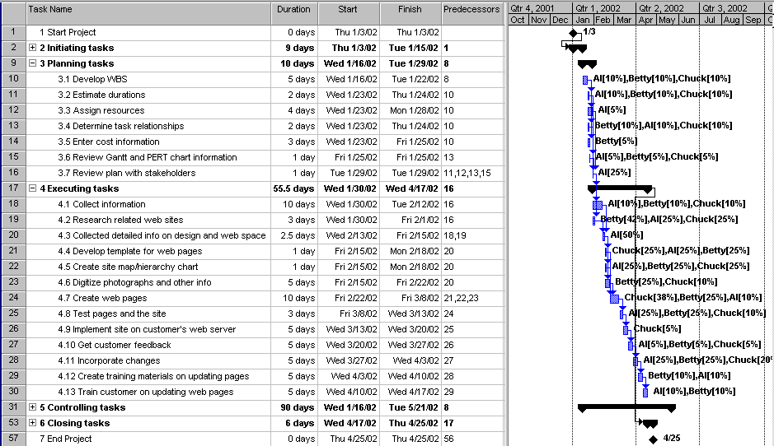
To run the budget report, open the file, then select Reports from the View menu. Double-click on Costs, and then double-click on Budget.

Below is the budget report based on the file 2eExA-1.mpp. Answers will vary, but the total amount should be between $4,000 and $5,000 based on 3 people working an average of 5 hours per week for 4 months at $20 per hour. Determining the resource allocations is probably the hardest part of this exercise. After entering initial resource estimates, you can see more clearly how many hours each person is assigned to each task by using the Resource Usage view. You can also adjust the hours in this view and then run the budget report until the numbers seem reasonable.

Budget report for Exercise A-1
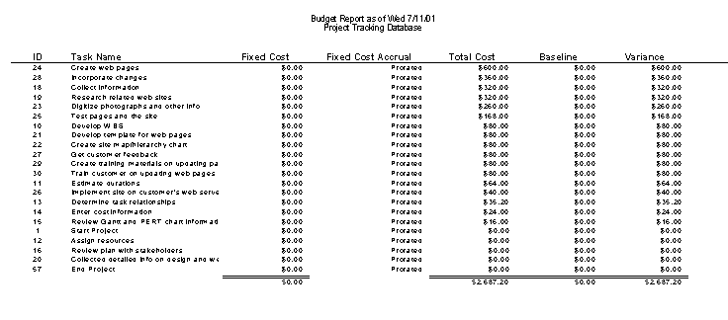

To see the Resource Usage View for this file, click the Resource Usage View on the View bar.

To run the To-do list report, select Reports from the View menu, double-click Assignments, then double-click on the To-do List report, and run it for each person on the project.

To create the Who Does What Report HTML document, select Save as HTML from the File menu, name the file, select Who Does What Report from the Import/export map list, then click the Save button.

Exercise A-2: Software Training Program

A possible solution, including the WBS, duration estimates, cost information, and human resource information for the project is provided in the file 2eExA-2.mpp, found on the Instructor’s Resource Kit CD.

Below is a possible Gantt chart for Exercise A-2 showing the WBS, duration estimates, and predecessors. Note that the project takes about six months, starting on 1/3/02 and ending 5/30/02. The resources and some fixed cost have been entered in this file, but allocations have not been made.

Gantt chart for Exercise A-2

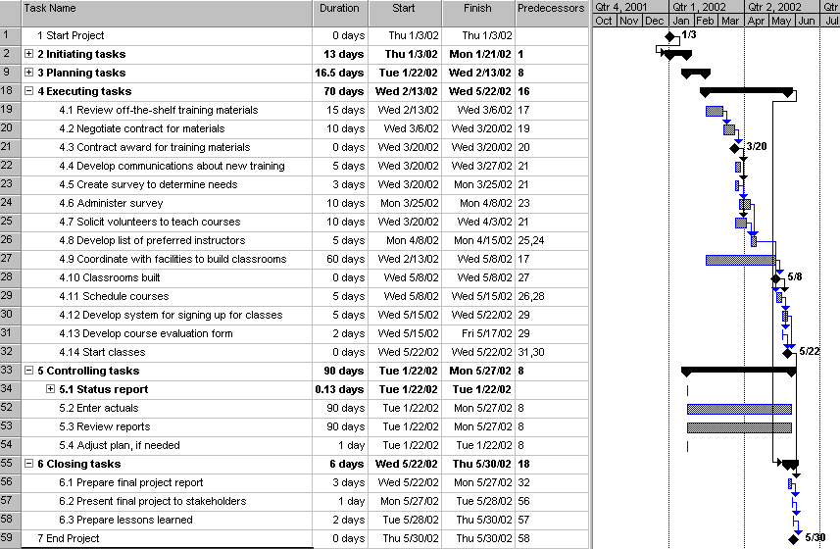

You can view the resource sheet, network diagram, schedule table, and run the desired reports by opening the file and using those views and reports. Answers will vary based on how students created the WBS, estimated durations and dependencies, and assigned resources.

Exercise A-3. Project Tracking Database

A possible solution, including the WBS, duration estimates, cost information, and human resource information for the project is provided in the file 2eExA-3.mpp, found on the Instructor’s Resource Kit CD.

Below is a possible Gantt chart for Exercise A-3 showing the WBS, duration estimates, and predecessors. Note that the project takes about six months, starting on 6/2/02 and ending 11/13/02. The total budget based on this file is about $53,000.

Gantt chart for Exercise A-3

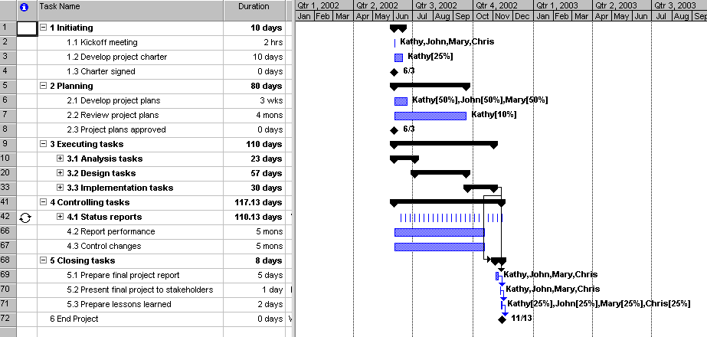
Open the file to see all of the tasks, predecessors, resource information, and so on. You can also run the reports after opening the file. Below is the Top Level Tasks report based on this file. To run this report, select Reports from the View menu, then double-click on Overview, then double-click on Top Level Tasks.

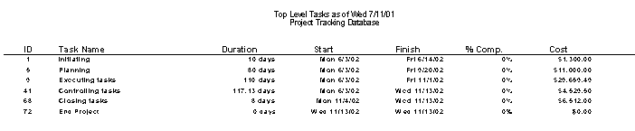
Exercise A-4: Real Project Application
Answers will vary based on the projects.

Appendix B
Advice for the PMP Exam and Related Certifications

Chapter Outline
What is PMP Certification?
What Are the Requirements for Earning and Maintaining PMP Certification?
What Other Certification Exams Related to Information Technology Project Management Are Available?
What Is the Structure and Content of the PMP Certification Exam?
How Should You Prepare for the PMP Exam?
Ten Tips for Taking the PMP Exam
Sample Questions
Final Advice on PMP Certification and Project Management in General

Teaching Tips

Since many students may not be interested in certification, especially traditional students, you might wish to have students read this appendix on their own and answer questions they might have in class. The information is very straightforward. Be sure to direct students to PMI's web site for the latest information on certification (www.pmi.org). Do let students know about new certification exams, like the CompTIA IT Project+ exam, which does not require any work experience and is less expensive than PMP certification. See www.comptia.org for more details.

